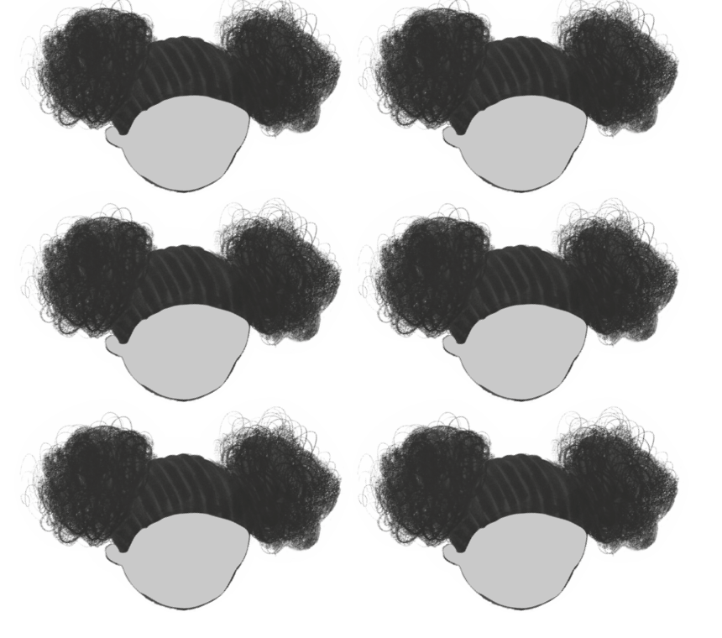
WALT: To recognise and explain which facial expressions represent the following feelings: happiness, sadness, stress, anger, loneliness and frustrations.

