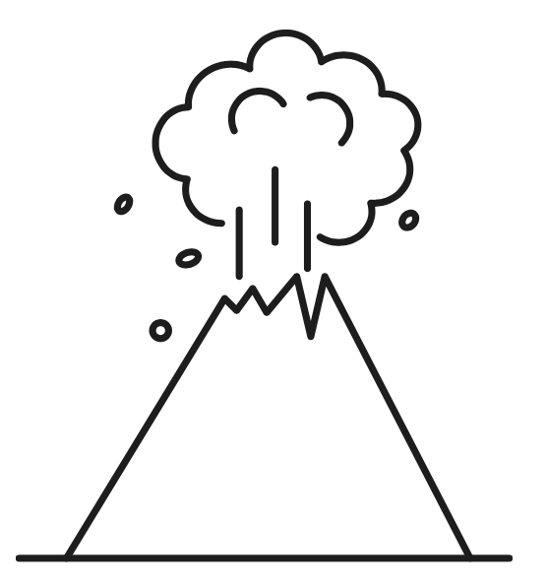
WALT: Identify ‘big feelings’. Can you colour-code the writing to show each emotion. Date:

