WALT: To make my mind strong! Date:

Commitment: I set goals and work hard to deliver them.
Control: I am pro-active and keep my emotions in check.
Challenge: I stretch myself and learn from everything.
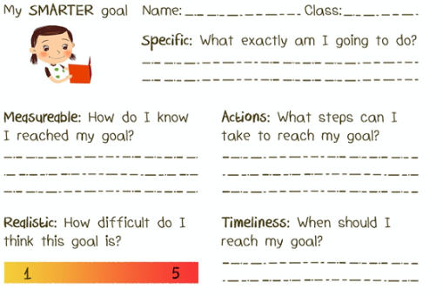
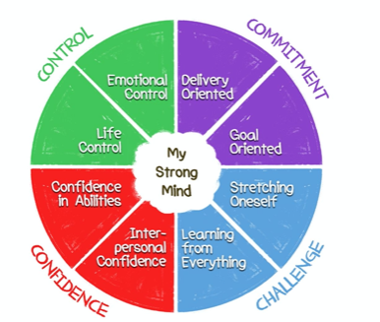
Confidence: I have the ability and can stand my ground.

