**HWB Classes**

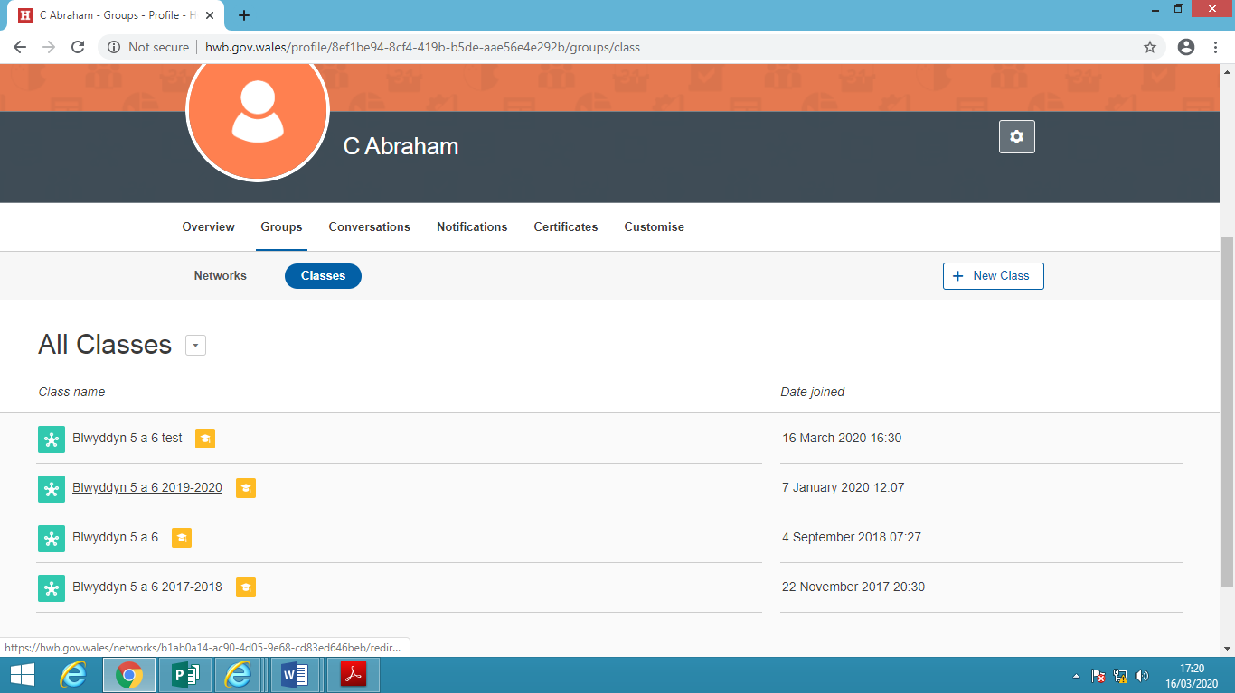

Dewiswch eich dosbarth – efallai mai dim ond un dosbarth fydd gennych.

*Choose your class - you may only have one class to choose from.*

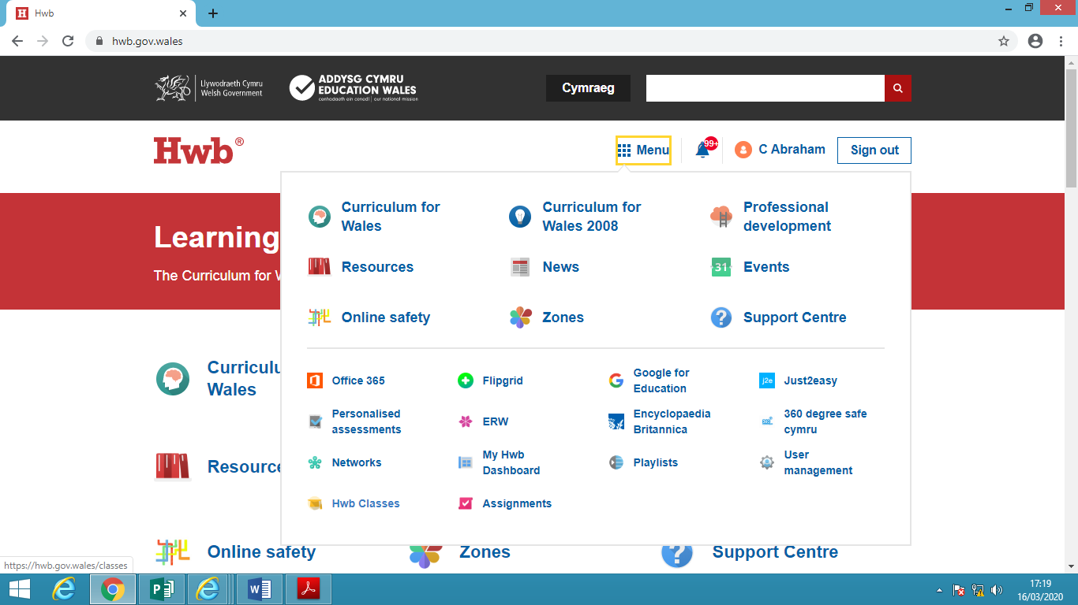

Ar ôl mewngofnodi i HWB, cliciwch ar fotwm ‘Menu’. Yna, dewiswch ‘HWB Classes’

*After logging in to HWB, click on the 'Menu' button. Then select 'HWB Classes'*

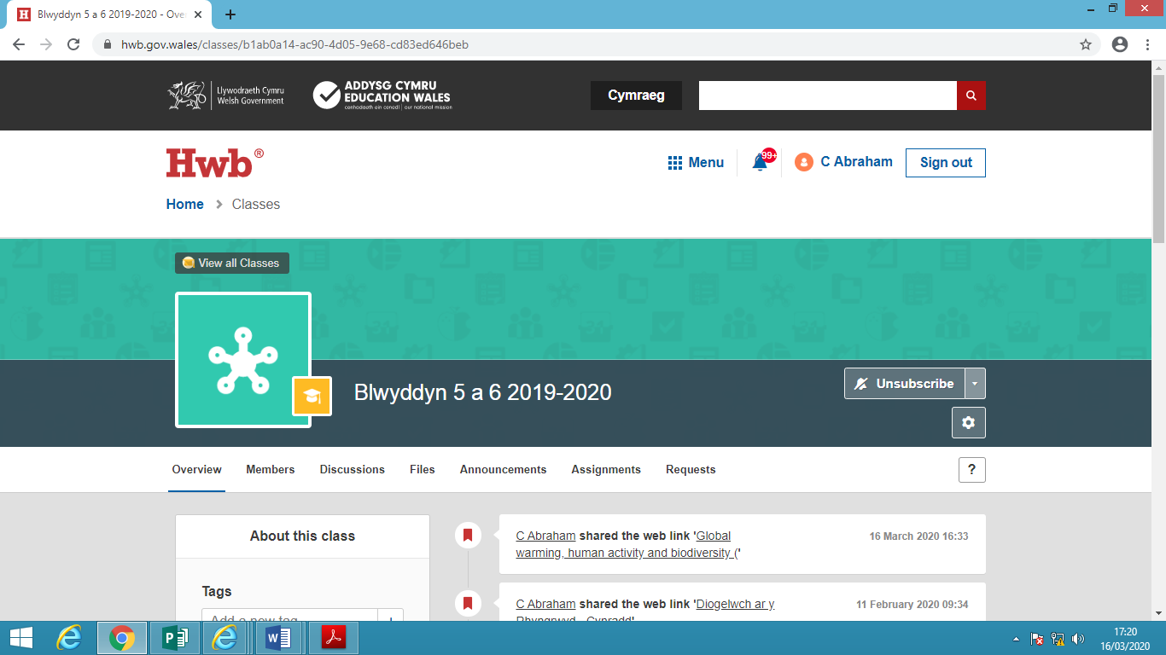

Cliciwch fotwm ‘Files’ i gael mynediad at y ffeiliau a fydd yn ddefnyddiol.

*Click the 'Files' button to access the files that will be useful.*

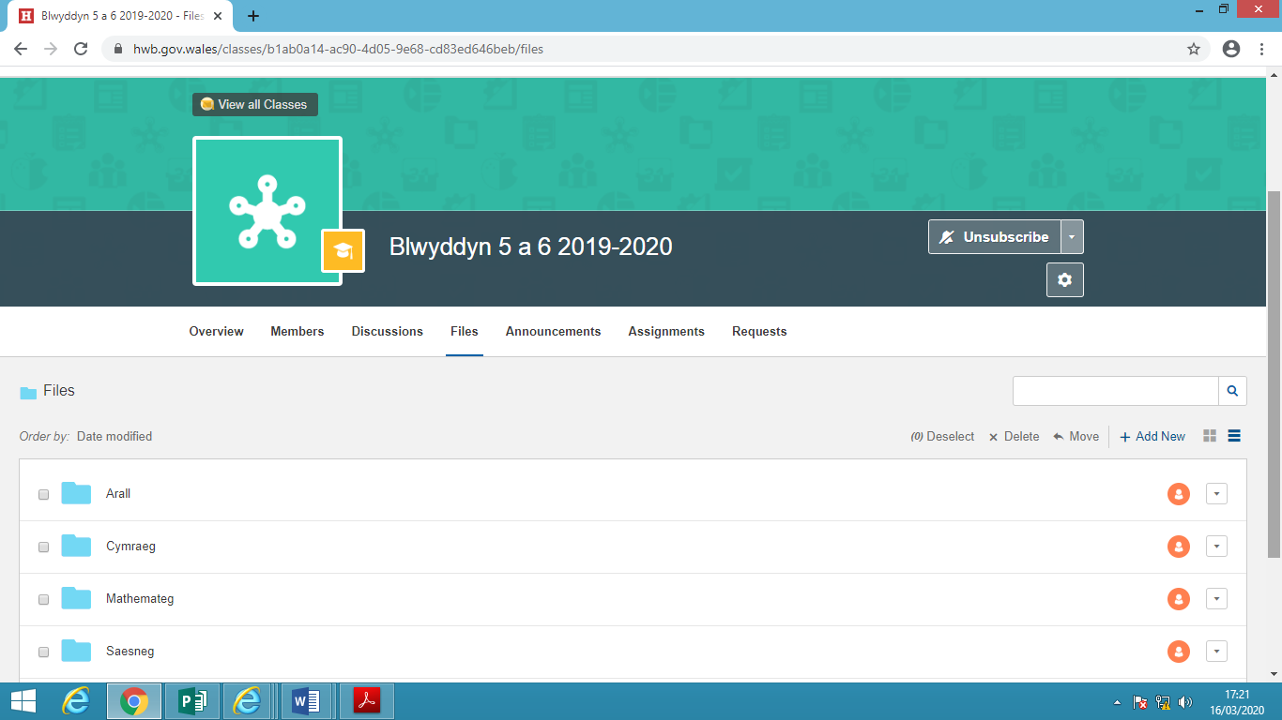

Dewiswch y ffolder perthnasol. Y tu mewn i bob un o'r rhain fe welwch y dogfennau i gefnogi'ch dysgu gartref.

*Select the relevant folder. Inside each of these you will find the documents to support your home learning.*