Activities to do at home
Foundation Phase – Year Two

Language
- Speak Welsh to your child at any given opportunity. There are some lovely Welsh speaking programmes on S4C during the day. Also, the ‘Cyw” website has some fun games, songs and activities to encourage their learning.
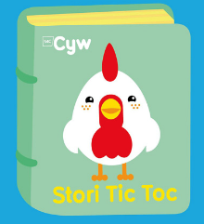
- Remember the importance of reading daily.
- Colouring
Handwriting.
- Spelling practice – copy words and sentences from books or dictionaries.
- Can you write 5 words out of a book / dictionary and they have to find the words within a specific time. Can they beat their previous time?
- Find and write as many words as they can in one minute.
- Find words that have the spellings… (these sounds / spellings are specifically Welsh)
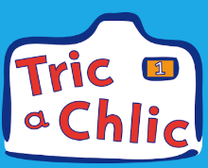
oi, oe, ou iw, yw, uw
wy ei, eu,
au, ai, ae
si

- Write a diary entry of your activities.
- Write a letter to Dwynwen back in school.

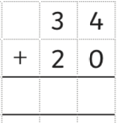
Numeracy
- Correctly form numbers to 100 / 1000
- Add and subtract using the column method
- Order random numbers from the highest to the lowest
- Write and recognise numbers to 1000
- Tables 2, 5 a 10. Remember to practice on TT Rockstars!
- Tell the time – o clock, half past, quarter past, quarter too
HWB
Also remember that you have access to HWB from home!
Please contact Mrs Owen for more ideas or information on
owenc196@hwbcymru.net
Gweithgareddau posib i wneud adref er mwyn parhau gydag addysg eich plant
Cyfnod Sylfaen – Blwyddyn 2
Iaith
- Siaradwch Cymraeg ar bob cyfle posib. Cofiwch am raglennu Cyw ar y teledu ac ar y we. Mae yna lwyth o weithgareddau, caneuon, storiau a raglennu Cymraeg yma i hybu’r iaith.
- Cofiwch ddarllen yn ddyddiol i’ch plenty
- Lliwio yn daclus

Ymarfer llawysgrifen.
- Ymarfer sillafu – Copian geiriau / brawddegau allan o lyfr darllen neu geiriadur.
- Oedolyn yn ysgrifennu 5 gair allan o lyfr ac yna’r plentyn yn darganfod y geiriau. Amseri pa mor gyflym ydy’r plentyn yn darganfod y geiriau.
- Darganfod 5 gair sy’n dechrau gyda’r lythyren… e.e. a
- Ysgrifennu cymaint ag eiriau a phosib mewn amser penodol.
- Darganfod geiriau sy’n cynnwys y sain…
oi, oe, ou iw, yw, uw
wy ei, eu,
au, ai, ae
si
- Ysgrifennu dyddiadur o’r hyn meant yn gwenud dros y cyfnod.
- Ysgrifennu llythyr i Dwynwen yn ôl yn yr ysgol.
Mathemateg
- Ffurfio rhifau hyd at 100 / 1000
- Adio a thynnu rhifau gan gynnwys adio a thynnu yn fertigol
- Trefnu rhifau o’r lleiaf i’r mwyaf 0 - 1000
- Adnabod rhifau hyd at 1000
- Adnabod tablau 2, 5 a 10. Cofiwch am TT Rockstars!
- Ymarfer dysgu’r amser ar y cloc, o’r gloch, hanner awr wedi, chwarter i, chwarter wedi
HWB
Cofiwch eich bod yn gallu cael mynediad i HWB o’r cartref!
Cysylltwch â Mrs Owen am fwy o syniadau neu gymorth owenc196@hwbcymru.net

