Derbyn / Reception
Helo!
Dyma eich gweithgareddau iaith a maths ar gyfer yr wythnos yma.
Rydyn ni'n gobeithio eich bod chi gyd yn iawn! Rydyn ni'n gweld eisiau chi gyd yn fawr iawn.
Danfonwch lun ohonoch chi'n gwneud y tasgau yma ar Twitter, byddwn ni'n ddwli gweld y lluniau!
Cadwch yn ddiogel!
Hello!
Here are your language and maths activities for this week.
We hope your all ok! We’re missing you all very much.
Send us a picture of you completing the activities on Twitter, we’d love to see pictures!
Stay safe!
Miss Law and Mrs Evans

Dyma weithgareddau i gadw chi’n prysur wythnos yma:
This Photo by Unknown Author is licensed under CC BY-ND
Ymarfer ysgrifennu y tywydd bob dydd: Heddiw mae hi’n heulog/dwym/oer/ braf/ bwrw glaw/ wyntog/gymylog

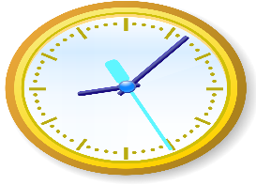
Ceisiwch ddysgu dweud yr amser ar gloc analog . Mae hi’n 1 or gloch/ hanner awr wedi. Cofiwch edrych ble mae’r bys byr i ddangos yr awr/ a’r bys hir i ddangos bys y munudau. Gofynnwch i'r plant Faint or gloch yw hi? yn ystod y dydd.
This Photo by Unknown Author is licensed under CC BY-SA

Gweithgaredd lles:

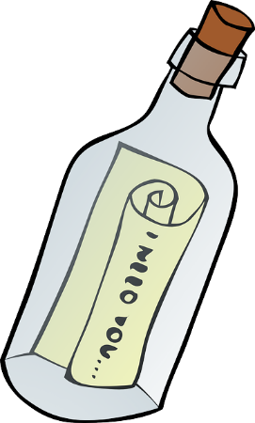
Ysgrifennwch neges i’w rhoi mewn potel gan gynnwys y llefydd hoffech chi fynd a’r pethau hoffech chi weld.

Llythyren yr wythnos / Letters of the week:
u j
Ewch ati i ymarfer y llythyren yma. Gallwch chi ei ysgrifennu a phaentio efallai! Beth yn eich tŷ chi sydd yn dechrau gyda'r llythrennau yma?

Go ahead and practice these letters. You can write and paint them maybe! What can you find in your house that begins with these letters?

Geiriau'r wythnos:
mul jar jwg
Ewch ati i ymarfer y geiriau yma. Gallwch hefyd tynnu llun!

Go ahead and practice these words. You could draw a picture of the words too!

Here are this week’s activities:
This Photo by Unknown Author is licensed under CC BY-ND
Practise writing the weather every day: Today it is sunny/warm/ cold / nice raining/ windy/ cloudy

Try learning to tell the time on an analogue clock. It’s 1 o clock / It’s half past. Remember to look where the small hand is pointing to show the hour, the long hand on the clock points to the minutes. Ask What time it is? during the day.
This Photo by Unknown Author is licensed under CC BY-SA

Well-being activity:

Write a message to go in a bottle including places you would like to go to and things you would like to see.

