Derbyn / Reception

Helo!
Dyma eich gweithgareddau iaith a maths ar gyfer yr wythnos yma.
Rydyn ni'n gobeithio eich bod chi gyd yn iawn! Rydyn ni'n gweld eisiau chi gyd yn fawr iawn.
Danfonwch lun ohonoch chi'n gwneud y tasgau yma ar Twitter, byddwn ni'n ddwli gweld y lluniau!
Cadwch yn ddiogel!
Miss Law a Mrs Evans.
Hello!
Here are your language and maths activities for this week.
We hope your all ok! We’re missing you all very much.
Send us a picture of you completing the activities on Twitter, we’d love to see pictures!
Stay safe!
Miss Law and Mrs Evans
Dyma weithgareddau i gadw chi’n prysur wythnos yma:

Cyn i'r ysgol cau, roedd plant y Derbyn yn ymarfer ei sgiliau adio.
Beth am ichi dal ati gydag ymarfer y sgil yma?

Gallwch chwarae gemau adio.
Beth am ddod o hyd i 2 dis. Taflwch y 2 dis ac yna adiwch y rhifau mae'r dis wedi glanio arno?
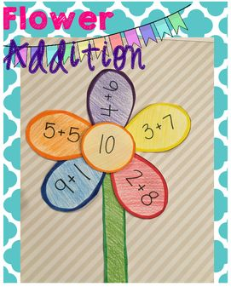
Gallwch greu 'blodyn adio'. Rhowch rif yn y canol, er enghraifft 10. Ac ar bob petal rhowch swm sydd yn adio i 10?
Ydych chi'n gallu meddwl am unrhyw gemau adio eraill?
Dechreuwch adio rhifau o dan 10. Wedyn ewch i fyny at 20 neu 30!

Her: Beth am roi cynnig ar dynnu o dan 10 neu 20?

Rydyn ni'n hoffi clywed newyddion ein gilydd yn y dosbarth!
Beth am i chi tynnu llun gan ddefnyddio jit5 ar HWB?

Dewch o hyd i jit5 ar HWB o dan 'just2easy'. Yna gwasgwch ar jit5.
Mae'r tudalen yn agor ar 'write' Gwasgwch ar 'paint' ar dop y tudalen.
Ewch ati i dynnu llun i mi! Rydw i'n edrych ymlaen at ei gweld!
Cofiwch wasgu 'publish' er mwyn i mi gael gweld eich gwaith!

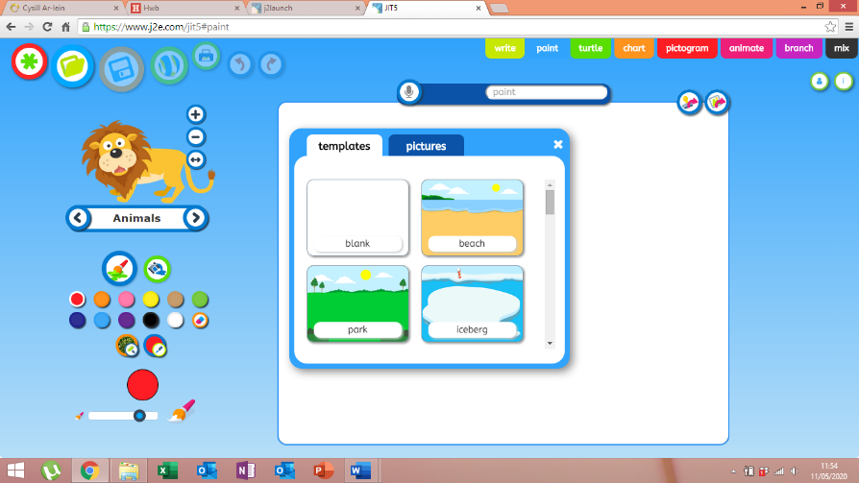

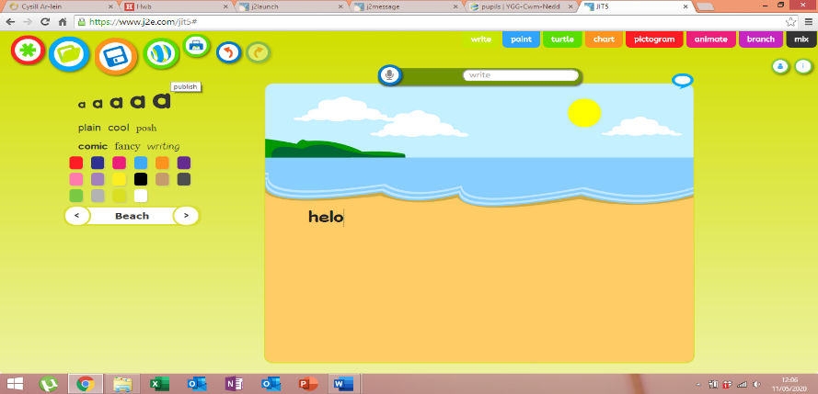

Rydyn ni'n mwynhau cael 'chat' yn y dosbarth a chlywed newyddion ein gilydd. Rydw i'n gweld eisiau clywed eich newyddion chi!
Beth am i chi creu fideo i mi? Hoffwn i glywed eich newyddion ac unrhyw beth arall sydd gyda chi i rannu gyda fi?
Gallwch ddefnyddio ffon neu iPad i recordio a gofyn i'ch rhieni rhannu'r fideo gyda fi!
Rydw i'n edrych ymlaen yn fawr iawn at weld eich fideos!

Here are your activities for this week:

Before school closed, Reception children had been practicing their addition skills.
What about continuing to practice these skills?
You could play addition games.
If you find two dice. Throw the dice and then add the numbers together that the dice have landed on.
You could create a ‘addition flower’. Put a number in the middle of the flower, for example, the number 10. Then put a sum that adds to 10 on each petal.
Can you think of any other addition games to play?
Start off adding numbers under 10. Then work up to numbers under 20 and then 30.
Challenge: What about giving subtraction under 10 or 20 a go?

We enjoy hearing each other news in the class!
What about you writing your news using jit5 on HWB?

If you open HWB and click on ‘just2easy’. Then the jit5 tab.
The page will open on ‘write’. Click on the ‘paint’ tab at the top of the page.
Go ahead and draw a picture for me! I’m looking forward to seeing them!
Remember to press ‘publish’ once you’ve finished so I can see your work!

We love a chat and hearing everyone’s news in class. I’m missing hearing your news and everything you all have to say.

Why don’t you create a video for me? I would love to hear our news and anything else you have to say.
You could record yourself on an iPad or phone and ask your parents to share it with me!
I can’t wait to watch your videos!

Llythyren yr wythnos / Letters of the week:
c r y
Ewch ati i ymarfer y llythyren yma. Gallwch chi ei ysgrifennu a phaentio efallai! Beth yn eich tŷ chi sydd yn dechrau gyda'r llythrennau yma?

Go ahead and practice these letters. You can write and paint them maybe! What can you find in your house that begins with these letters?

Geiriau'r wythnos:
cap het tar mat
Ewch ati i ymarfer y geiriau yma. Gallwch hefyd tynnu llun!

Go ahead and practice these words. You could draw a picture of the words too!

