Reception / Derbyn
Helo!
Dyma eich gweithgareddau iaith a maths ar gyfer yr wythnos yma.
Rydyn ni'n gobeithio eich bod chi gyd yn iawn! Rydyn ni'n gweld eisiau chi gyd yn fawr iawn.
Danfonwch lun ohonoch chi'n gwneud y tasgau yma ar Twitter, byddwn ni'n ddwli gweld y lluniau!
Cadwch yn ddiogel!
Miss Law a Mrs Evans.
Hello!
Here are your language and maths activities for this week.
We hope your all ok! We’re missing you all very much.
Send us a picture of you completing the activities on Twitter, we’d love to see pictures!
Stay safe!
Miss Law and Mrs Evans

Cyn i'r ysgol cau, roedden ni'n ymarfer ein sgiliau mesur. Roedden ni wedi dechrau trwy fesur gydag adnoddau o gwmpas y dosbarth. Er enghraifft, sawl darn lego mae angen i fesur ochr y bwrdd? Sawl pensil sydd angen i mesur llyfr?
Beth am i chi dal ati gydag ymarfer eich sgiliau mesur?
Gallwch chi ddefnyddio adnoddau o gwmpas y tŷ!
Beth am roi cynnig ar fesur:
Tegell?
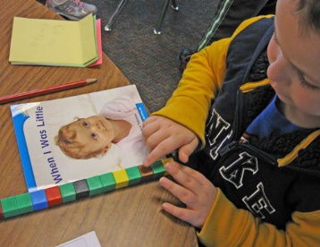
Teledu?
Eich hoff lyfr darllen?
Bowlen?
Llwy?
Deilen?
Beth arall gallwch chi fesur?

Rydw i'n gobeithio gallwn ni gyd mynd nôl i'r ysgol gyda'n gilydd cyn bo hir. Pan mae'n bosib i ni adael y tŷ eto, beth hoffech chi wneud?
Beth am greu 'Jar llawn heulwen'?
Gallwch addurno’r jar neu bot i ddechrau.
Ar ôl ei haddurno, ysgrifennwch beth hoffech chi wneud unwaith gallwn ni gadael y tŷ. Rhowch y nodyn yn y jar. Unwaith rydyn ni'n cael mynd allan eto, gallwch chi ddewis pethau allan o'r jar i wneud gyda'ch teulu neu yn yr ysgol.

Yn fy jar i, rydw i'r mynd i ysgrifennu:
Mynd am Joes ice cream!
Cael coffi gyda Mam-gu.
Rhoi cwtch mawr i blant dosbarth Dewi Sant!

Beth fyddwch chi'n ysgrifennu yn eich jar chi? Hoffwn i wybod!

Mae'r tywydd i fod i wella'r wythnos yma.
Beth am i chi greu llun natur?
Gallwch gasglu darnau o natur o'r ardd i greu eich llun.
Os ydych chi'n gallu, gadwch eich llun ar bapur a chadw'ch yn saff, gallwn ni rhoi'r lluniau i'r yn y dosbarth unwaith rydyn ni'n ôl yn yr ysgol.
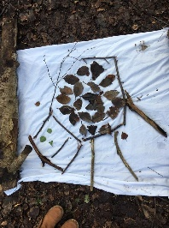
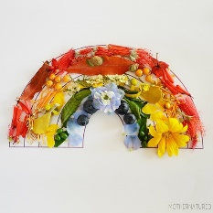
Rydw i'n edrych ymlaen at weld eich lluniau!

Bydd yn hyfryd gweld lluniau ar Twitter!

Llythyren yr wythnos / Letters of the week:
h t e
Ewch ati i ymarfer y llythyren yma. Gallwch chi ei ysgrifennu a phaentio efallai! Beth yn eich tŷ chi sydd yn dechrau gyda'r llythrennau yma?

Go ahead and practice these letters. You can write and paint them maybe! What can you find in your house that begins with these letters?

Geiriau'r wythnos:
pam ham tap
Ewch ati i ymarfer y geiriau yma. Gallwch hefyd tynnu llun!

Go ahead and practice these words. You could draw a picture of the words too!

Here are your activities for this week:
Before school closed, we were practicing our measuring skills. We started by using objects from around the classroom to measure. For example, how many pieces of Lego do we need to measure the table? How many pencils do we need to measure a book?
What about continuing to practice your measuring skills?
You could use different items from around the house to measure!
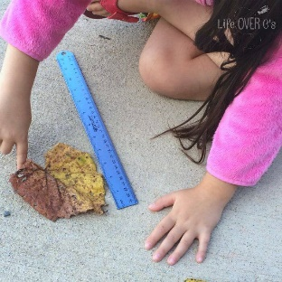
What about giving these a try:
Kettle?
Tv?
Your favourite book?
A bowl?
A spoon?
A leaf?
What else can you measure?

I hope we can return to school together soon. When its possible for us to leave the house again, what woul you like to do?
What about creating a ‘Jar full of sunshine’?
You could start by decorating the jar.
After decorating, on a piece of paper write what you would like to do when we can leave the house. Put the note in the jar. Once we can leave the house again, you can choose your things to do out of the jar to do with your family or at school.
In my jar, I’m going to write:
Go to Joes for an ice cream!
Have a coffee with Mamgu.
Give all the children in Dewi Sant a huge hug!
What will you write in your jar? I’d love to know!

The weather is supposed to be better this week.
What about creating a nature picture?
You could collect pieces of nature from around your garden to create your picture.
If you can, you could glue your picture onto paper and keep it safe, we can hang them in the class once we are back in school.
I’m looking forward to seeing your pictures!

It would be great to see your pictures on Twitter!

