Helo!
Dyma eich gweithgareddau iaith a maths ar gyfer yr wythnos yma.
Rydyn ni'n gobeithio eich bod chi gyd yn iawn! Rydyn ni'n gweld eisiau chi gyd yn fawr iawn.
Danfonwch lun ohonoch chi'n gwneud y tasgau yma ar Twitter, byddwn ni'n ddwli gweld y lluniau!
Cadwch yn ddiogel!
Miss Law a Mrs Evans.
Hello!
Here are your language and maths activities for this week.
We hope your all ok! We’re missing you all very much.
Send us a picture of you completing the activities on Twitter, we’d love to see pictures!
Stay safe!
Miss Law and Mrs Evans

Dyma eich tasgau ar gyfer yr wythnos hon
Beth am wneud ychydig bach o wyddoniaeth?
Dyma rhai syniadau gewch chi wneud yn y tŷ!

Here are your tasks for this week:
What about doing a bit of science?
Here are some ideas you could do in the house!

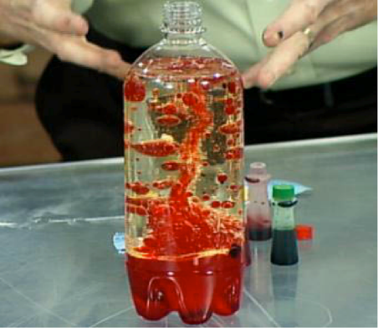
Create your ow Lava Lamp!
You will need:
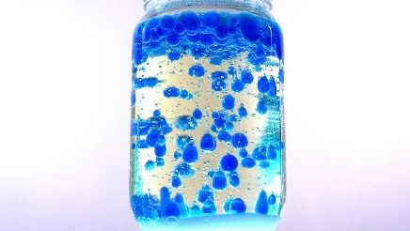
Water
Vegetable oil
Clear plastic bottle or jar
Food colouring
Salt

- Fill each bottle or jar with two-thirds full with water.
- Add a couple of drops of food colouring to the water.
- Fill the bottle / jar with oil. Leave a gap at the top of the bottle/jar.
- Add the salt.
- Watch to see what happens!

Magic Milk!
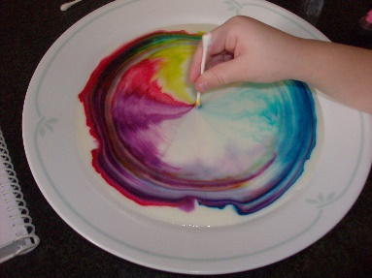
You will need:
Full fat milk
Food colouring
Washing up liquid
Shallow bowl or plate

- Pour some milk into a shallow bowl or plate until the milk covers the bottom.
- Add some drops of food colouring on the milk. You can use more than once colour, just make sure you add 3-4 drops of each colour.
- Add a drop of washing up liquid into the centre of the milk. You can use cotton buds to mix.
- What happens?

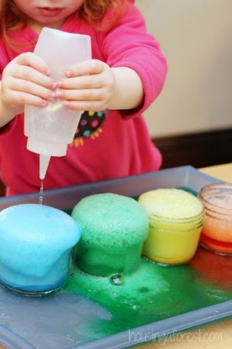
Baking soda volcano!
You will need:
Baking soda
Vinegar
A container to hold everything and avoid a mess!
A cloth – just in case!

- Place some of the baking soda into your container
- Pour in some of the vinegar
- Watch what happens!

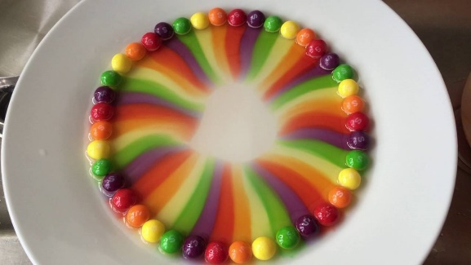
M&M or Skittle Rainbow!
M&M’s/Skittles
Water
White plate

- Arrange the M&M’s/Skittles in a circle around the plate.
- Carefully pour water into the centre of the plate, until it just covers the M&M’s/Skittles.
- Watch the colours stretch and blend!

Bydd yn hyfryd gweld lluniau o'ch arbrofion ar Twitter!
It would be lovely to see pictures of your experiments on Twitter!

