Aberdare Town Church in Wales Primary School
Ysgol Gynradd Eglwys y Dref Aberdâr
Summer Term – Newsletter – Friday 30th April

Dear Parents,

The weeks are rushing by and school is extremely busy! There is a great atmosphere everywhere you go, with pupils and staff enjoying a sense of ‘normality’ in learning once more. Everyone has settled back to school very well indeed and we hope that as the term progresses we may see some more restrictions eased to allow us to do some of the things that we love to do at Town Church. We are looking forward to a time when we can sing together, worship together and play together. I’m sure that time is not too far away! Here are some reminders and information for you:
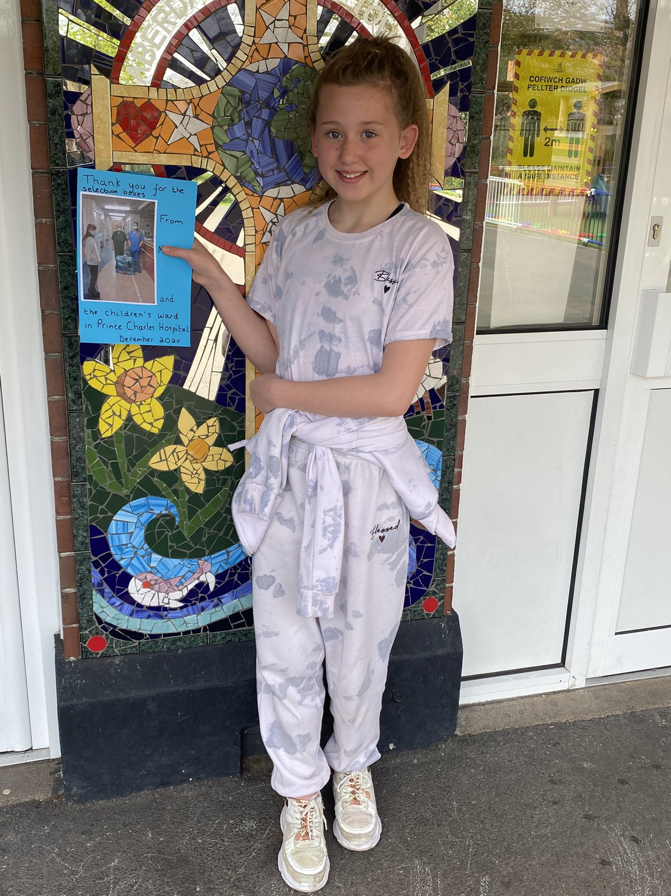
INSET DAYS
Here is a reminder of the remaining INSET days this year, when school will be closed for training purposes. FRIDAY 11TH JUNE
FRIDAY 2ND JULY
MONDAY 19TH JULY
TUESDAY 20TH JULY

MAY DAY BANK HOLIDAY
MONDAY MAY 3RD

HALF TERM
MONDAY 31ST MAY – FRIDAY 4TH JUNE
END OF TERM
FRIDAY 16TH JULY

One of our generous pupils collected over 40 selection boxes for the children’s ward at the hospital! We are so proud of her!
MAY DAY BANK HOLDAY – MONDAY 3RD MAY
Please remember that Monday is a bank holiday for May Day and school will be closed. School will resume as usual on Tuesday 4th May.
NEW CURRICULUM
As many of you are aware, there is to be a new curriculum for Wales which is very exciting. We are already working towards this at school and have changed some of the ways in which we do things. We have a whole school topic at the moment – ‘Big Blue Planet.’ Please ask your children what they are learning about - they have so much to share. Soon all schools will be grouped into progression steps as follows (this replaces key stages):
Progression Step 1 : Nursery and Reception
Progression Step 2: Years 1, 2 and 3
Progression Step 3: Years 4, 5 and 6
There will be no more infants and juniors. It’s all very interesting and there’s lots to find out about. We are hoping, should restrictions ease further, to hold parent workshops around the new curriculum towards the end of term. If we are unable to do this in person, we will hold Teams sessions for parents so we are able to meet remotely to explain the changes to you and to answer any questions. More information to follow.
UPDATE - SCHOOL GUIDELINES RE: COVID 19
Many of you will have seen the updated information from RCT that was posted on Dojo and Twitter this week. Here is some further clarification from RCT:
The Welsh Government are making Covid-19 testing available to people with a wider range of symptoms such as fatigue, muscle ache or pain, a sore throat, a headache, a runny nose, nausea, vomiting or diarrhoea. This is because some variants and young children do not display the classic three Covid-19 symptoms initially.

For children displaying wider symptoms parents / carers can book a test online by selecting the ‘book a test if advised by a Public Health adviser’ option.
Parents/carers can also ring 01443 443151 to book a PCR test if their child has wider symptoms.

Parents / carers will only be requested to urgently collect children from school if:
- they are too unwell to remain in school; or
- they have one of the three classic covid symptoms (i.e. a new continuous cough, or a high temperature or loss of or change to their sense of taste or smell); or
- there are significant concerns

It is a parent / carer’s decision whether to take the child for a test. Children can return to school if they are feeling well enough (unless they are displaying one of the three classic covid symptoms and/or are completing a required self-isolation period).

Individuals and their households who take a test because of these other wider symptoms are not required to isolate while they await their test result. This includes learners, who can continue to attend their school or setting while they await a test result.

If individuals receive a positive Covid-19 result, they and their household must then isolate. Households must also isolate if anyone develops any of the three classic Covid-19 symptoms while waiting for a test result taken on wider symptoms to come back.
Children and adults with diarrhoea and/or vomiting should not attend their school/setting until they are symptom-free for 48 hours, even if their Covid-19 test result is negative.
We have had several queries about tests. The above information refers to the PCR Covid tests, not lateral flow tests. Those displaying symptoms should have a PCR test. Lateral flow tests are used to identify asymptomatic carriers of COVID-19. We realise that this can be quite confusing. If you are at all unsure, please contact us and we will be able to help. Thank you.

HOLIDAYS DURING TERM TIME
We have had a few questions about holiday request forms. At the moment we are not sending out any forms and we politely request that you email the school if your child is going to be absent due to a holiday. All holidays are unauthorised absence apart from those deemed as ‘special circumstances.’ More information about what classes as special circumstances may be found on the RCT website. Thank you.
REMINDER FROM THE ‘FRIENDS’ ASSOCIATION
Our Dragon Bags Bin is still open near the front entrance of the school. You are welcome to use this and it is being collected as usual. By doing so, you help us to raise money for the school!
The Friends of Aberdare Town Church Primary School Lottery!
• Tickets cost just £1 per ticket, per week and 40% of all ticket sales are donated to our school.
• A GUARANTEED cash prize to someone on our supporter list every week.
• A further chance of winning £25,000 in a separate draw EVERY WEEK!
• Draws are every Saturday at 8pm and results are posted online.
To start supporting, visit www.yourschoollottery.co.uk/play and search for Aberdare Town Church Primary School.

Finally, thank you for your continued support. Although we are not seeing you as much as usual please feel welcome to contact us at any time if you have any concerns or queries. Have a great weekend and enjoy the bank holiday!
Mrs. M.C.Werrett
Headteacher

