Aberdare Town Church in Wales Primary School
Ysgol Gynradd Eglwys y Dref Aberdâr
Spring Term – Newsletter – Friday March 12th

Dear Parents,

We are all very excited here and getting ready to welcome our Key Stage 2 pupils back. It will be wonderful to have the school together again and we can’t wait. Along with this newsletter we will post the arrangements for Key Stage 2 pupils and I respectfully ask that you read these arrangements thoroughly and carefully before Monday morning. The arrangements remain the same as the Autumn Term but I’m sure a reminder is helpful. If you have any queries about the arrangements please let us know.
STAGGERED START / END TO THE SCHOOL DAY
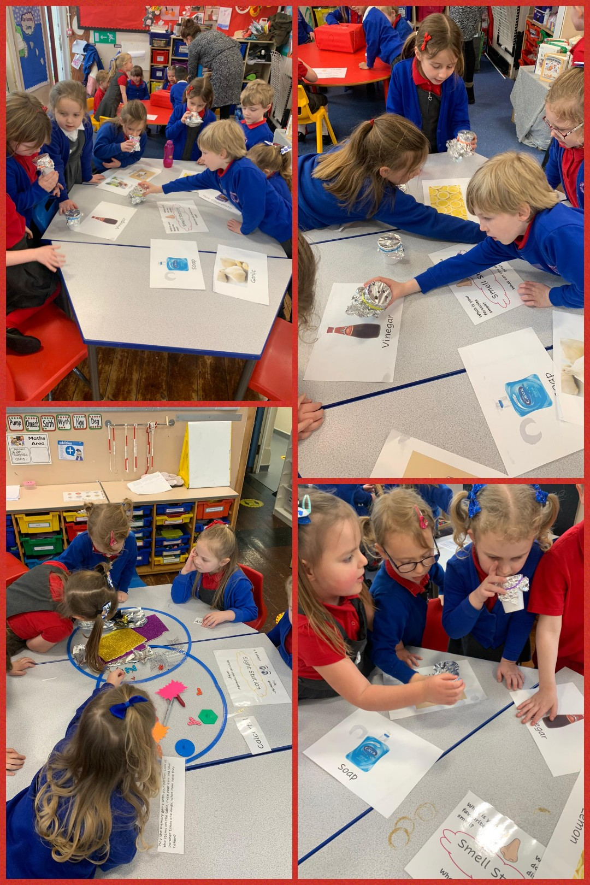
At present we are still following the Welsh Government and Local Authority guidance on staggered start and end times to school. You are all aware that this is for safety reasons and to avoid too much ‘footfall’ around the school. I fully realise that the times may not be the most convenient for some of you but it is very difficult to please everyone when everyone’s situation and requirements are different. Therefore the arrangements will remain the same as the Autumn Term and we hope that the next academic year will bring a return to normality. I am very grateful for your understanding and for supporting us by following the guidance.
BREAKFAST CLUB
We have heard from several of you who are distressed that you have not been allocated a place in Breakfast Club for next term. The application process is entirely handled by the local authority and not the school. I am, however, aware that there is no specific criteria, therefore no preference given to key workers etc. The local authority have measured the Breakfast Club space and have allocated places based on safety and the ability to keep contact groups safe and socially distanced. I completely understand your frustrations. Hopefully we will be able to return to normal next year and be able to accommodate as many as possible.
NB: Those of you who have been allocated a place, please remember that this is for after Easter and not the next two weeks. Breakfast club for those children who have been in emergency provision will cease from Monday. Thank you.

INSET DAY – FRIDAY 26TH MARCH 2021
A reminder that we have an INSET day on Friday 26th March. The school will be closed to all pupils as there will be essential onsite training for all staff. (This is the last day of the Spring Term).
WELSH WEEK AT TOWN CHURCH
We had a great week last week celebrating all things Welsh! Thank you to all of you at home for taking part in the competitions. It was all a bit different to how we usually do things at Town Church but we had a lot of fun and it was great to see lots of musical videos on the Teams pages as well as lots of art and craft. I particularly liked the variety of leeks that the children made, some of which you can see in the picture opposite! A great effort was made by one and all and I hope that you enjoyed the week’s activities!
WELCOME
We have recently welcomed Miss Hollie Jones to school as she is leading Miss Walstow’s class at present. Now, I would like to welcome Mr. Paul Holland who will be leading Squirrels Class until Mrs. Haughty returns. Mr. Holland visited school several times before Christmas and it is a pleasure to have him here with us again.

EASTER WORSHIP - REMINDER
As most of you are aware, we mark the events of Holy Week during the last week of the Spring Term. Last year, we were unable to share these special times together and we really missed doing so. Therefore, this year, will be recording a number of services during the week beginning Monday March 22nd (such as Worship for Palm Sunday, Stations of the Cross etc). These will be shown privately on Youtube – you will be sent the secure link so that you may experience the Worship.
NB: Father Robert is now live streaming Worship in the Parish of Aberdare. This can be accessed on Facebook – St Elvan’s Community Heritage Project page. Mass every Sunday at 11.00a.m is streamed live from St. John’s Church.
INSET DAY – FRIDAY 26TH MARCH 2021
A reminder that we have an INSET day on Friday 26th March. The school will be closed to all pupils as there in essential on-site training for staff. (This is the last day of the Spring Term). The Summer Term will commence on Monday 12th April.

Finally, I would once again like to thank you for your support and understanding during these difficult and challenging times. Your willingness to engage with us in all that we have been trying to do over the last year has been inspiring. I have received nothing but support from our Town Church families and for that I am so very grateful. My thanks also to the staff who have worked tirelessly, many juggling teaching in school, teaching and supporting online and coping with home-schooling their own children. They have all done so with a smile and a quiet determination to do everything they can to ensure the wellbeing and happiness of their pupils.
I think we all feel a renewed sense of hope for the future. The ease of restrictions is slow and cautious, but necessary. I am sure many of you are rather fed up of seeing me out on the playground, encouraging you to stay apart and distance yourselves from each other. I do this with one thing in mind – to keep us all safe and to keep our school open. Please continue to follow the guidelines, however, hard and frustrating it might be. If we all do so together then we will have a very good chance of fully opening our gates, and our arms, in the near future.
Have a wonderful weekend – enjoy the rugby and………..SEE YOU ON MONDAY!!!!!!!
Yours sincerely,
Mrs. M.C.Werrett
Headteacher

‘Alone we can do so little: together we can do so much’
(Hellen Keller)

