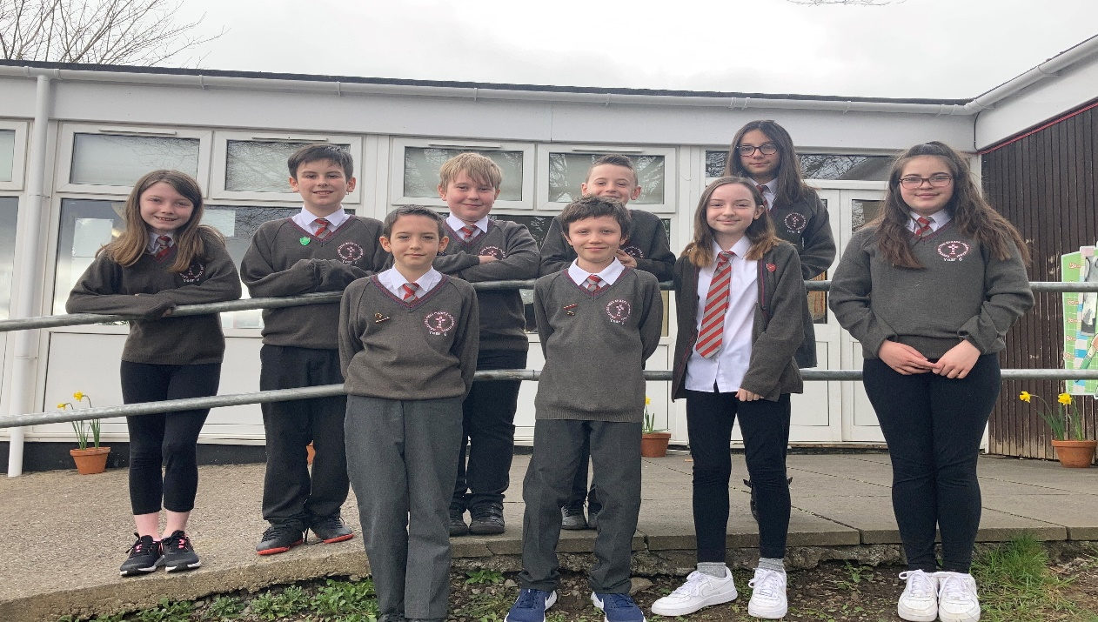

Welcome Back! Croeso Nol!
Welcome back everyone! It is wonderful to see everyone back at school. Everyone is so happy and excited. Seeing our friends, being in the school environment with our teachers, learning with our friends instead of learning at home is exactly what we want!
We hope that you have been able to watch our first ‘briefing’ earlier this week. It includes some useful advice for helping us to keep our school open. If you haven’t seen it, please visit Twitter or click on the following link:
https://t.co/3bWT3ZO8GX?amp=1
We wish to thank all our parents and everyone who has supported us during these hard times. It really has been a challenge. Parents have been amazing with home schooling and teachers have been supporting us all the way through. Our Town Church family is wonderful and it is so nice to be back together again.

Worship for Holy Week
Although next week is not Holy Week (which begins with Palm Sunday on 28th March), it is the last week before the Easter holidays so we will be remembering the events of Holy Week in a very special way. Our Worship will be recorded and shared via a link on Twitter and the school website.
- On Monday, Miss Price’s class (Badgers) will lead us in Worship for Palm Sunday.
- On Tuesday, Mrs. Reynolds’ class (Grasshoppers) will lead us in a Taize reflection service for Lent.
- On Thursday, Mrs. Evans’ class (Owls) will lead us in the Stations of the Cross around the school grounds.

Please look out for the notifications – we would so much like for you to be part of this with us, even if we cannot be together as we usually would.

Our Values Day – Thursday 25th March
Next Thursday we will be holding a special ‘Values’ day with a focus of Perseverance. This has been the school value over the last half term. We would like to invite everyone to wear rainbow colours / bright colours to school on that day. We would also like to support our local food bank. We invite you to send in any food items you are willing to donate for the food bank (tins, packets, dry foods). Boxes will be placed at the school entrances for these items and your children may also give them to the class teacher. As Friday is an INSET day, this will be our last day before the holidays and we want it to be really special.

If you have any questions for the Senedd, please submit them on your child’s teams page. We will do our very best to answer. We will hopefully continue with our ‘briefings’ once a month and regular newsletters.

Thank you all and have a great Easter!

Evie Lucas Rya
Head Girl Head Boy First Minister

