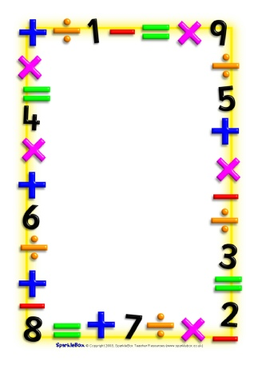

Name___________________________

Date___________________________

Maths Homework Challenges – Time

Think about things you do every day such as cleaning your teeth or getting dressed, which activities take longer?

Find out how long it takes you to do things e.g. reading your book, walking to school.

What can you do in 1 minute? E.g. how many times can you go down the slide at the park/ how many star jumps?

Find out how many seconds are in 1 minute, how many minutes are in 1 hour, how many hours are in a day?

Make up time problems e.g. if I left the house at 2 o’clock and it took me 2 hours to walk the dog, what time did I get home?

Ask someone to ask you time problems to solve.

Record some of your challenges.