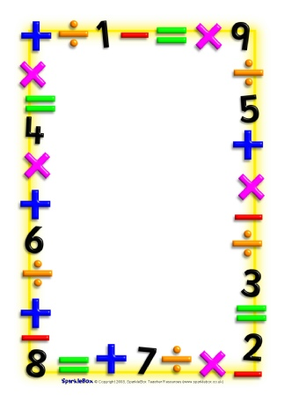

Name___________________________

Date___________________________

Maths Homework Challenges - Patterns

Copy a pattern made by someone else e.g. spoon fork, spoon, fork, spoon, fork.

Make a repeating pattern using your body e.g. stomp, stomp, clap, stomp, stomp, clap.

Create your own repeating pattern using objects from the house or outdoors e.g. stick, stone, leaf, stick, stone, leaf.

Make a more complicated pattern and repeat it.

Continue a pattern someone else has started.

Make a number pattern. E.g. 2,4,6,8,10 or 4,8,12,16,20 (try using the times tables/ odd and even numbers)

Record some of your patterns. Say the patterns out loud.