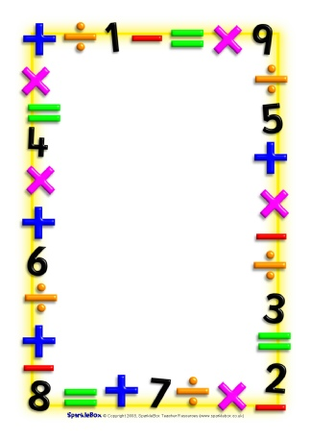

Name___________________________

Date___________________________

Maths Homework Challenges – Number order

Ask a grown-up to write numbers 1 to 5 or 1 to 10 or 1 to 20 on small pieces of paper. Muddle them up.

How long does it take you to put them back in order? Try again to see if you can be quicker or race against somebody

Try ordering them from biggest to smallest.

Write a few numbers between 0 - 100 or 0 - 1000 on small pieces of paper. Muddle them up. Time how long it takes you to put them in order from smallest to largest. Try this a few times and record how quickly you do it each time.

Say how many thousands, hundreds, tens and units are in each number.

Record what you did/ what you know.