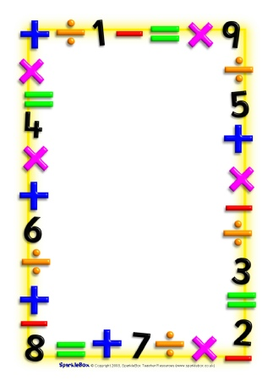

Name___________________________

Date___________________________

Maths Homework Challenges – Money coins

Make a collection of different coins. How many of each coin do you have?

If you could keep 1 coin which one would you choose? Why?

Make some coin rubbings of your favourite coins.

Sort the coins by value or colour or shape.

Order the coins from worth the least to worth the most. Is this the same as ordering them by the size of the coin?

Learn the names of the coins.

Make a ‘shop’ using things from around the house. Make price labels using only the numbers found on coins e.g. 1p, 2p, 5p, 10p. Pay for items using the correct coin.