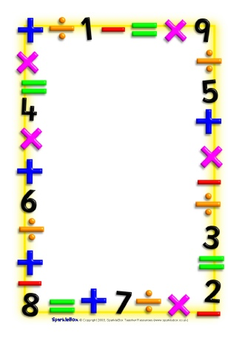

Name___________________________

Date___________________________

Maths Homework Challenges – Measure capacity

You need a plastic jug and some different sized cups/ containers (maybe a bath-time/ outdoor activity)

Fill and empty the containers, use language such as full, empty, half full, nearly full, nearly empty

Guess how many cups of water will fill the jug?

Find out if you were right?

Try for other containers, which holds most/ least water?

Use the scales on the measuring jug to find out how much water each container holds in ml. Order the containers by how much they hold.

Record some of your activities/ findings.