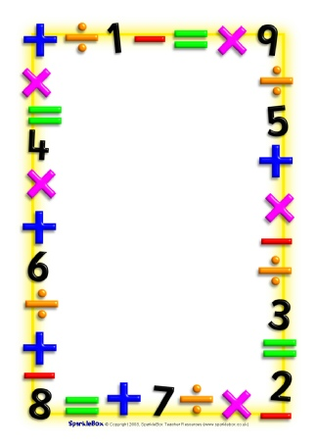

Name___________________________

Date___________________________

Maths Homework Challenges – Guess my number

**Guess my number? A game to play.**

I think of a number, then add 1.

The answer is 7.

What was my number?

I think of a number, then take away 6.

The answer is 12.

What was my number?

Can you do some more? Try asking and answering questions with a grown up. You can play it anywhere!

You can make this game as simple or as difficult as you like to suit your child’s ability.

Use objects, pictures or a number line to make it easier.

Try doubling, halving, adding, subtracting, dividing, multiplying to make it more difficult.

Record how many you got right.