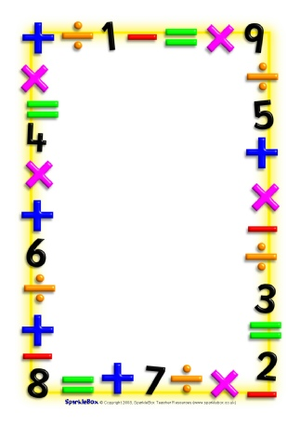

Name___________________________

Date___________________________

Maths Homework Challenges – data handling

Make a food chart – draw/ write how many pieces of fruit (or other food) is in the kitchen.

Create a chart to record the fruit (or other food) your family eats on the weekend.

Count the number of pieces of each fruit eaten.

How many more of one kind of fruit were eaten than another?

What was the least/ most favourite fruit?

You could draw pictures, write numbers, make a table, draw a pictogram or make a graph to record what you found.