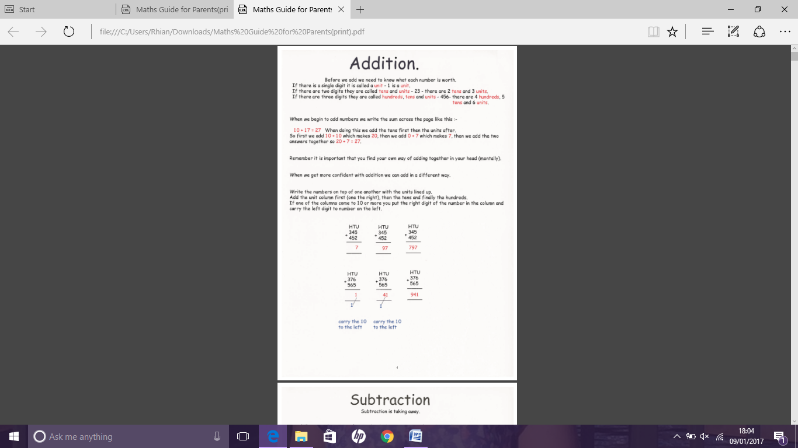

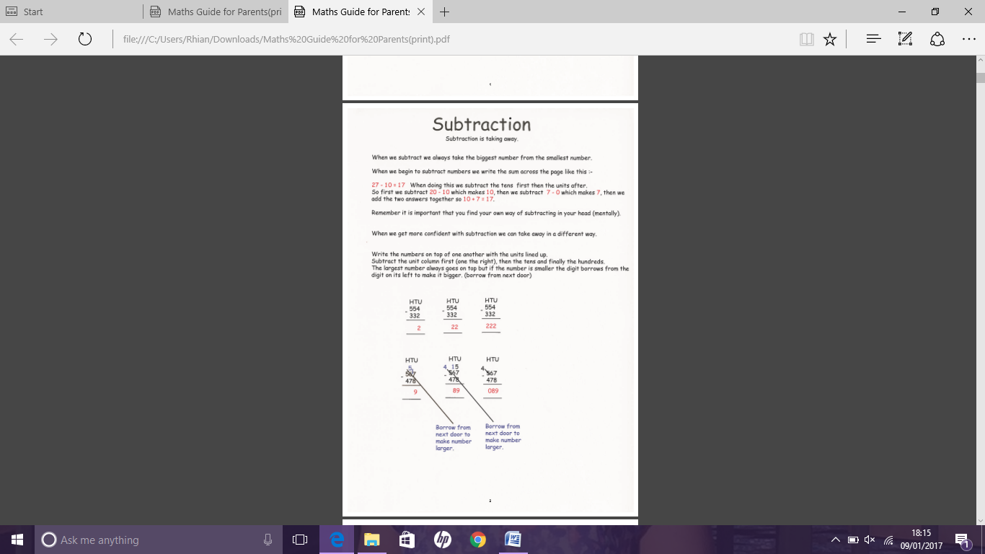

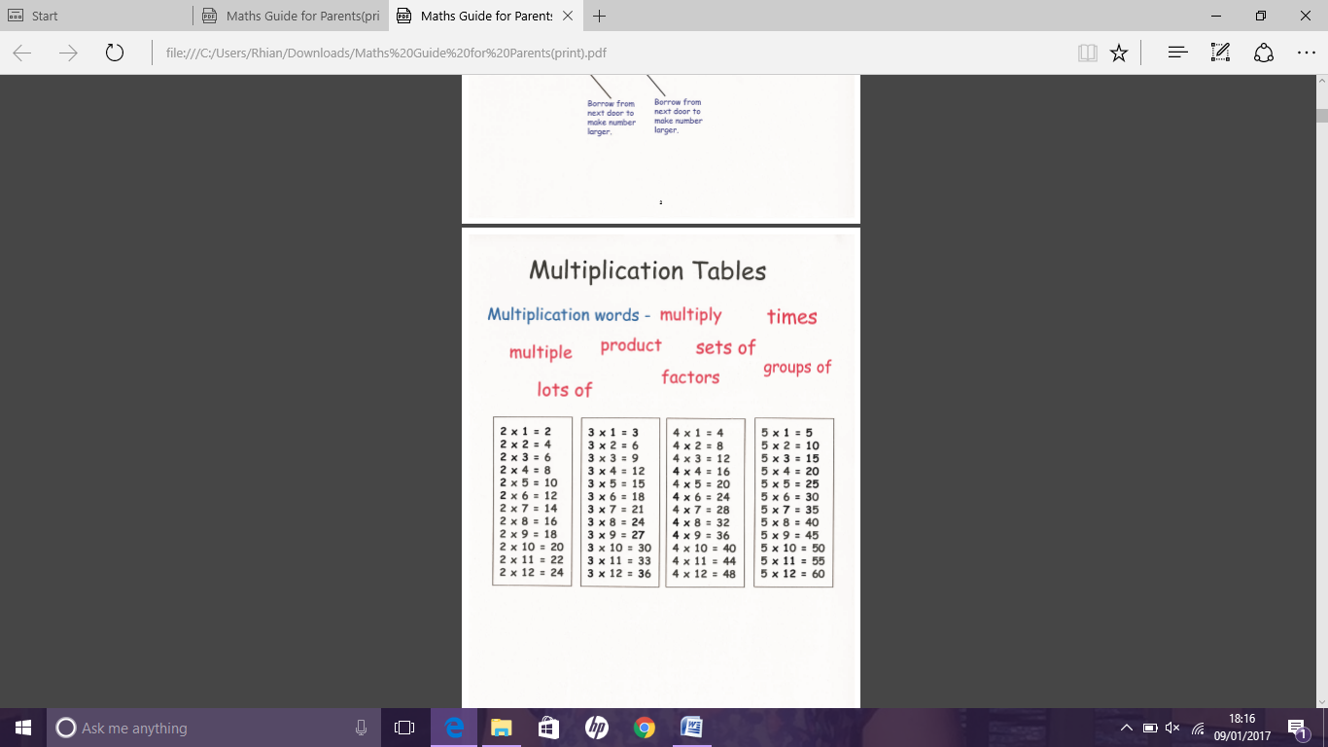

1x2=2

2x2=4

3x2=6

4x2=8

5x2=10

6x2=12

7x2=14

8x2=16

9x2=18

10x2=20

11x2=22

12x2=24

1x5=5

2x5=10

3x5=15

4x5=20

5x5=25

6x5=30

7x5=35

8x5=40

9x5=45

10x5=50

11x5=55

12x5=60

1x4=4

2x4=8

3x4=12

4x4=16

5x4=20

6x4=24

7x4=28

8x4=32

9x4=36

10x4=40

11x4=44

12x4=48

1x3=3

2x3=6

3x3=9

4x3=12

5x3=15

6x3=18

7x3=21

8x3=24

9x3=27

10x3=30

11x3=33

12x3=36

1x9=9

2x9=18

3x9=27

4x9=36

5x9=45

6x9=54

7x9=63

8x9=72

9x9=81

10x9=90

11x9=99

12x9=108

1x8=8

2x8=16

3x8=24

4x8=32

5x8=40

6x8=48

7x8=56

8x8=64

9x8=72

10x8=80

11x8=88

12x8=96

1x7=7

2x7=14

3x7=21

4x7=28

5x7=35

6x7=42

7x7=49

8x7=56

9x7=63

10x7=70

11x7=77

12x7=84

1x6=6

2x6=12

3x6=18

4x6=24

5x6=30

6x6=36

7x6=42

8x6=48

9x6=54

10x6=60

11x6=66

12x6=72

1x12=12

2x12=24

3x12=36

4x12=48

5x12=60

6x12=72

7x12=84

8x12=96

9x12=108

10x12=120

11x12=132

12x12=144

1x11=11

2x11=22

3x11=33

4x11=44

5x11=55

6x11=66

7x11=77

8x11=88

9x11=99

10x11=110

11x11=121

12x11=132

1x10=10

2x10=20

3x10=30

4x10=40

5x10=50

6x10=60

7x10=70

8x10=80

9x10=90

10x10=100

11x10=110

12x10=120

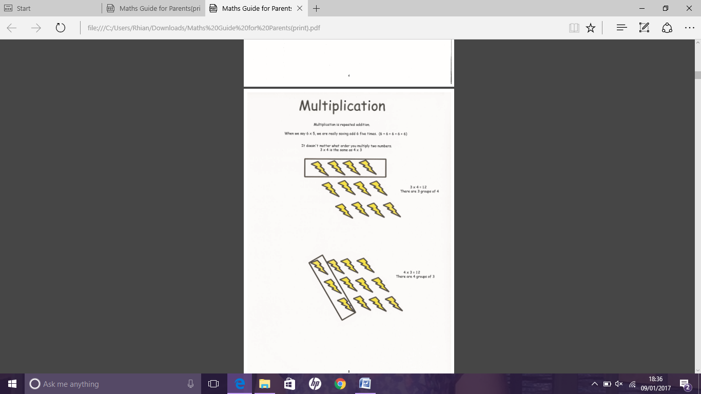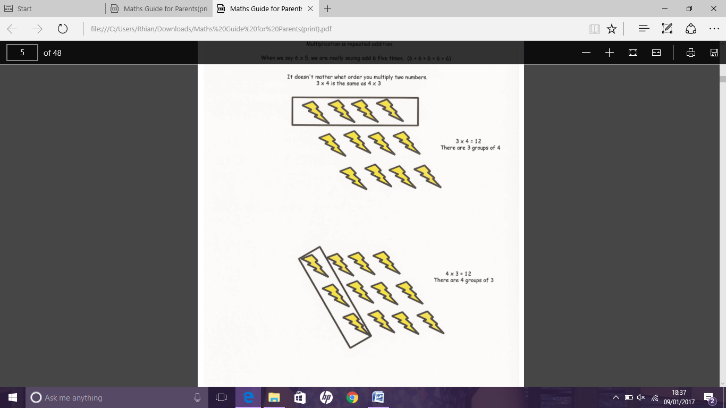

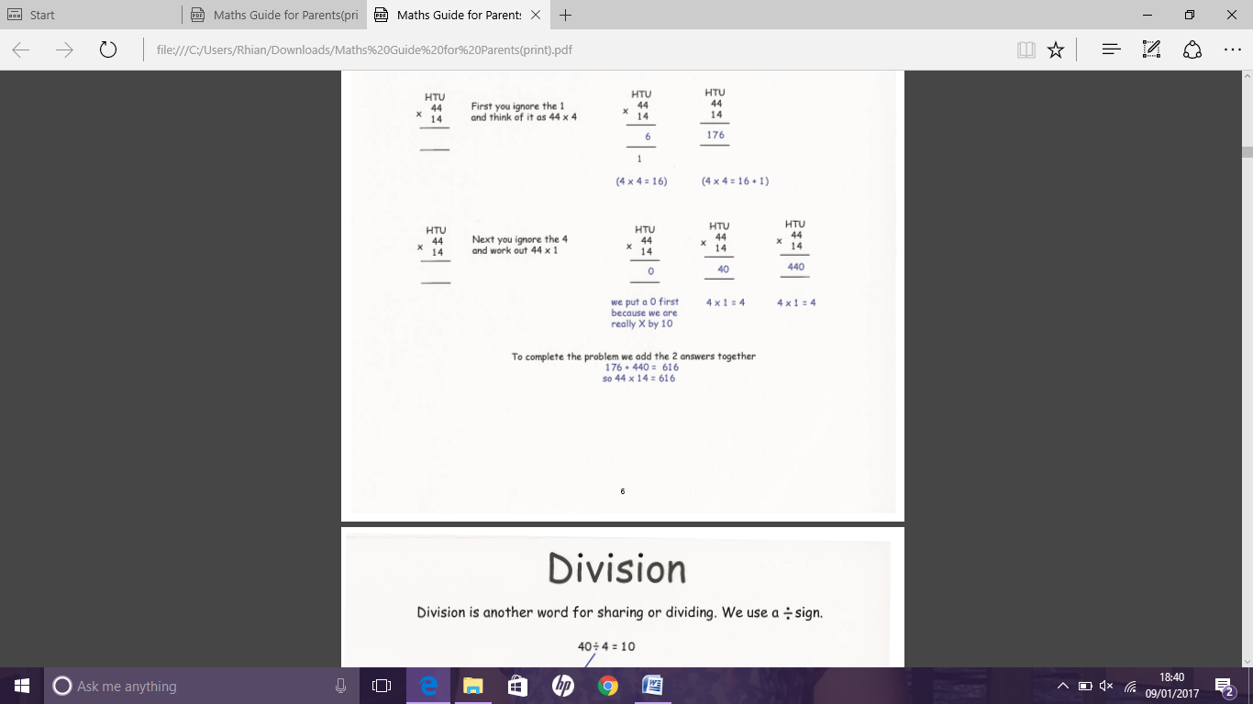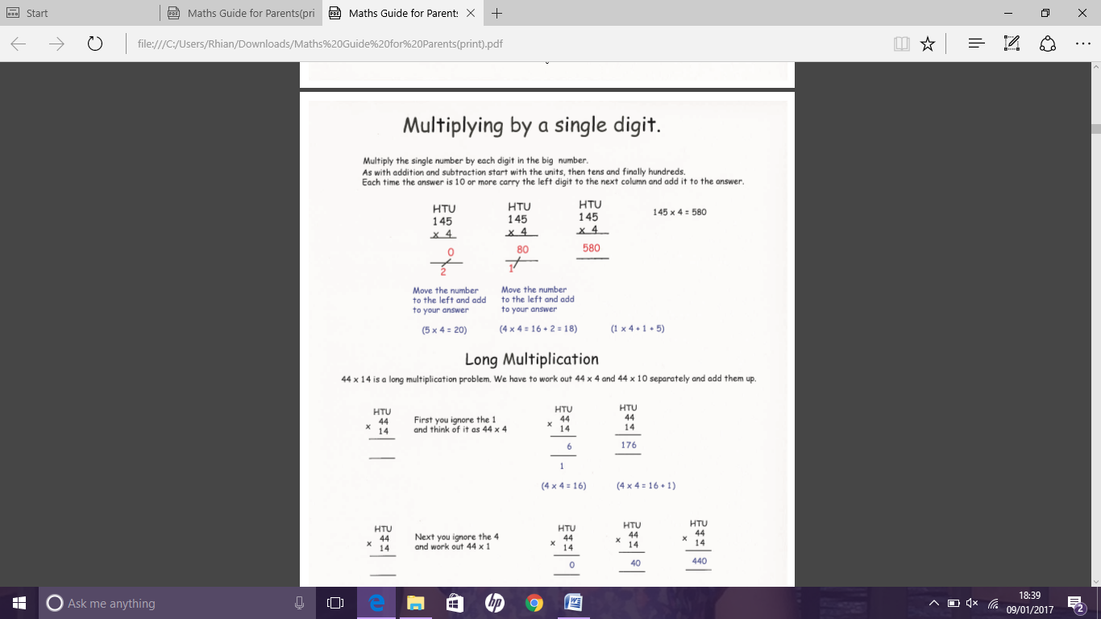

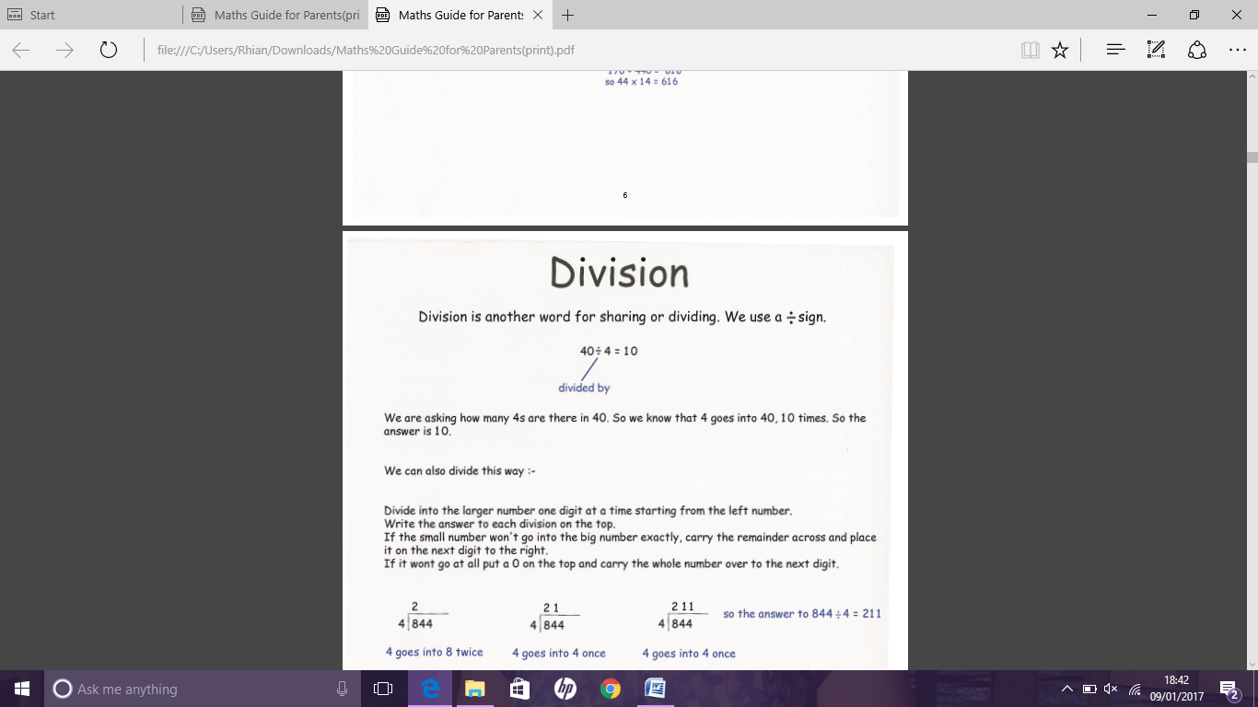

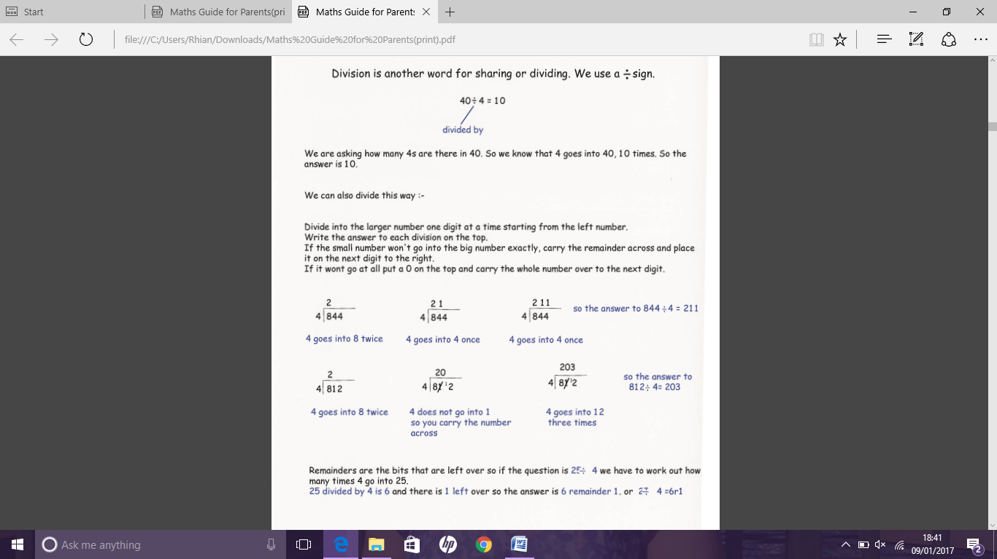

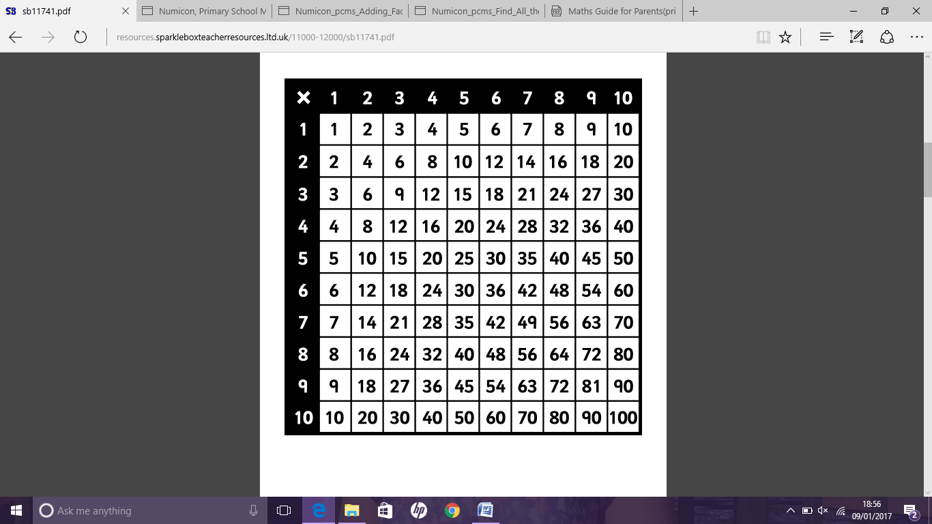**Multiplication square**

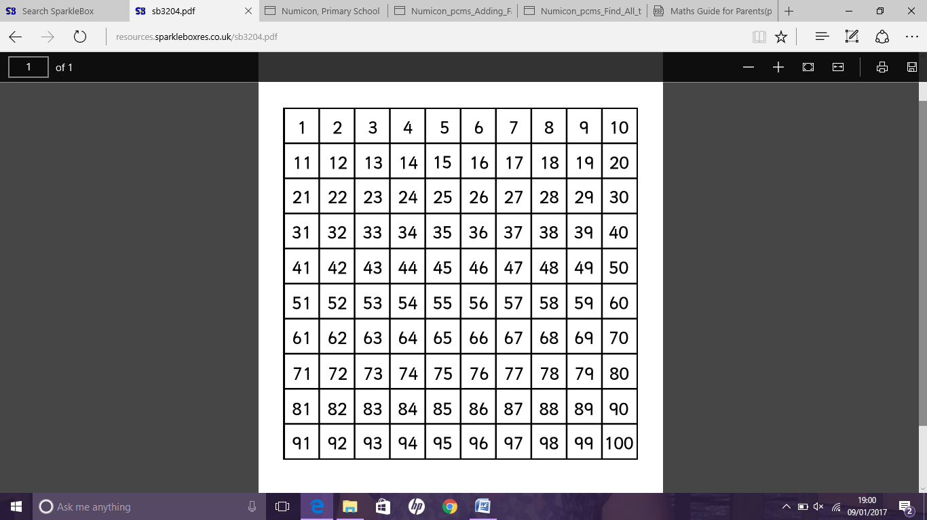

**Number square**

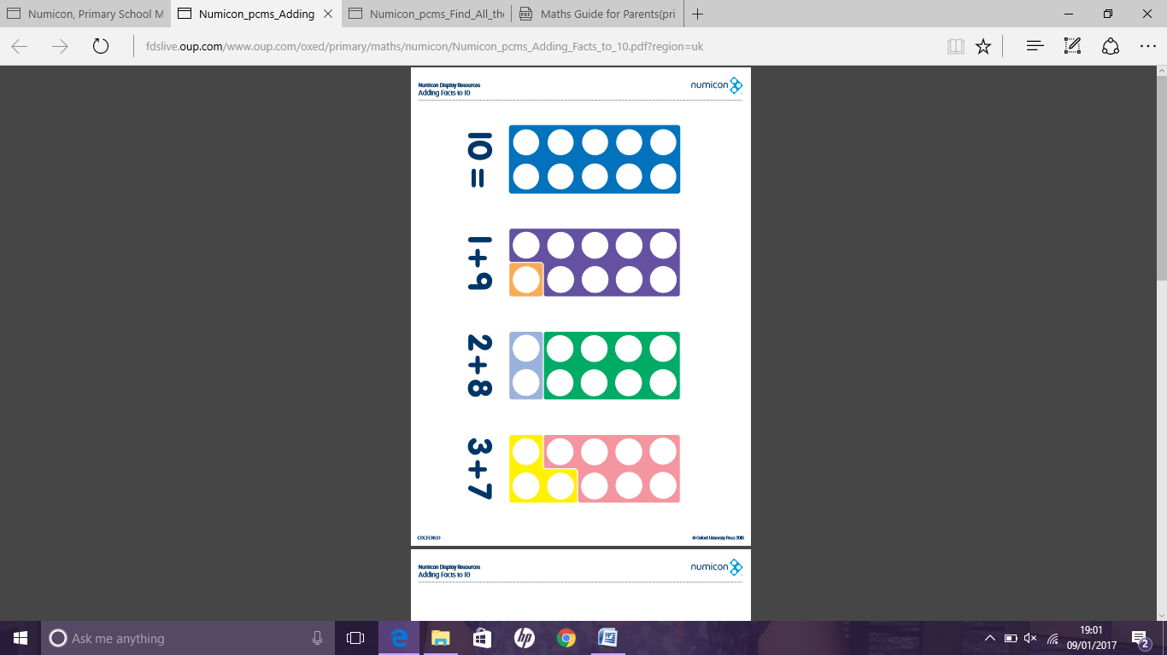**Number bonds to 10**

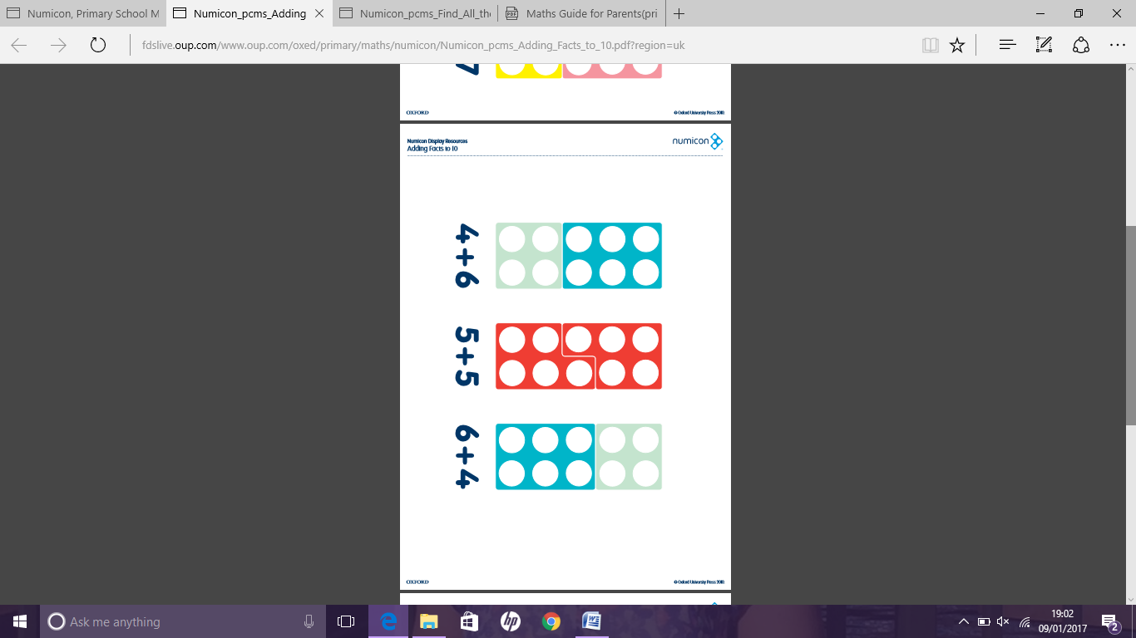

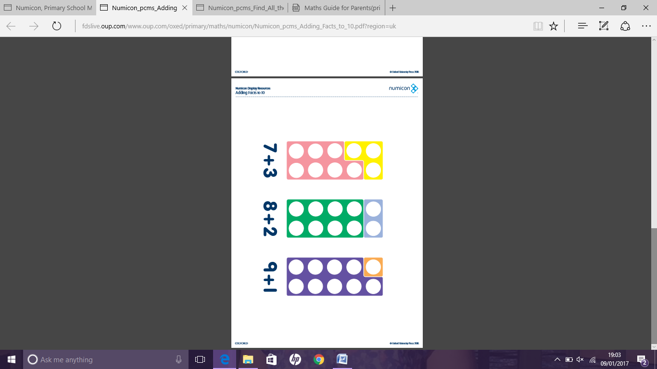

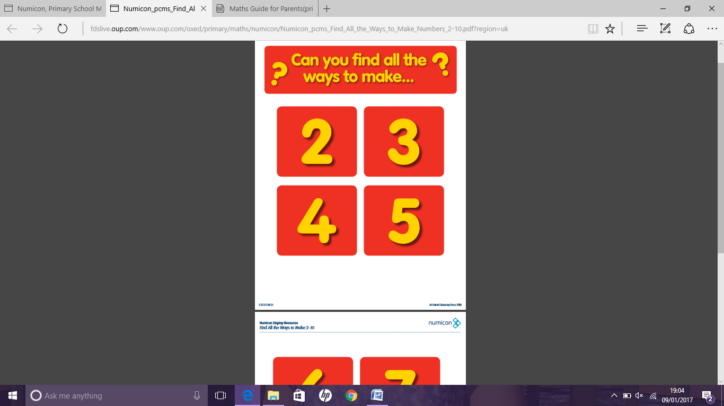**Problem solving - finding possibilities**

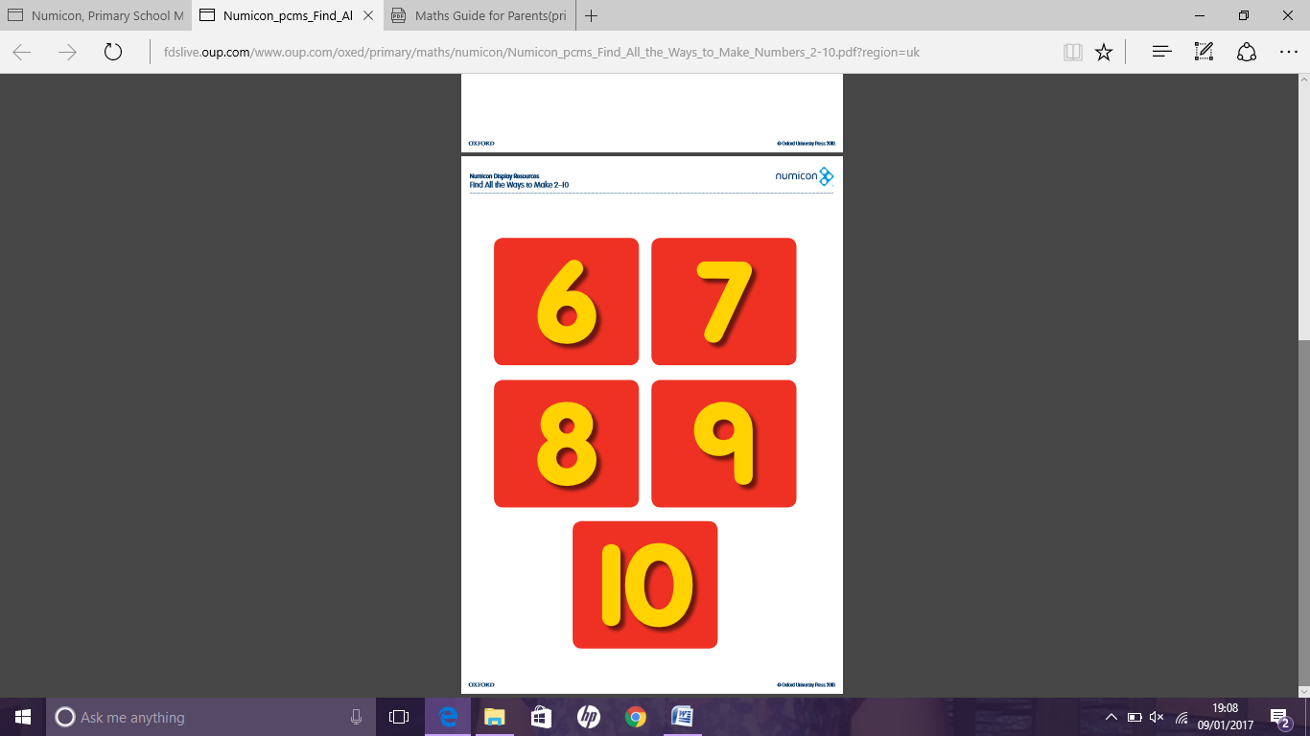

**Useful numeracy apps/websites**

[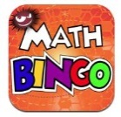](http://www.google.co.uk/url?sa=i&rct=j&q=&esrc=s&source=images&cd=&cad=rja&uact=8&ved=0ahUKEwiL64zK1NvKAhVGuBQKHUHxBrsQjRwIBw&url=http://www.newyorkfamily.com/?attachment_id=79917&psig=AFQjCNFiWdMc0z1hdnQLFw2JEQ_utCIcPg&ust=1454591126905772) [](http://www.google.co.uk/url?sa=i&rct=j&q=&esrc=s&source=images&cd=&cad=rja&uact=8&ved=0ahUKEwi9yNfu1NvKAhUHnRoKHY9DCV4QjRwIBw&url=http://www.sumdog.com/&psig=AFQjCNGJNLldLGxdCU2UqBPbFXnxsZeLcw&ust=1454591224356884) [](http://www.google.co.uk/url?sa=i&rct=j&q=&esrc=s&source=images&cd=&cad=rja&uact=8&ved=0ahUKEwiKpoLG1dvKAhWCaRQKHfgiBL4QjRwIBw&url=http://www.teacherswithapps.com/operation-math/&psig=AFQjCNGcYdWlJETsL7fl-Py6HOMkzqrzwA&ust=1454591302792047)

Maths Bingo Sumdog Operation Math

[](http://www.google.co.uk/url?sa=i&rct=j&q=&esrc=s&source=images&cd=&cad=rja&uact=8&ved=0ahUKEwiatZni1dvKAhWCOhQKHfAcB5EQjRwIBw&url=http://ipadapps4school.com/2013/10/01/ixl-math-practice-elementary-school-math-practice-ipad-app/&psig=AFQjCNHpBa08_gARUxwgkHQFRyr92kntAw&ust=1454591505653319) [](http://www.google.co.uk/url?sa=i&rct=j&q=&esrc=s&source=images&cd=&cad=rja&uact=8&ved=0ahUKEwiH0v_z1dvKAhVCWRoKHYnsBToQjRwIBw&url=http://www.itouchapps.net/6-numbers-game-answers-solutions-levels-1-100/&psig=AFQjCNG7C7FWcHF6y1kJSOKRqaKwRT7L5A&ust=1454591541713239) [](http://www.google.co.uk/url?sa=i&rct=j&q=&esrc=s&source=images&cd=&cad=rja&uact=8&ved=0ahUKEwiXlKej19vKAhXDMBoKHWnLDcsQjRwIBw&url=http://hwb.wales.gov.uk/&psig=AFQjCNGHlHLxkzMYq-1LOPRMdXQ5-zw_ew&ust=1454591906484200)

IXL Six numbers HWB

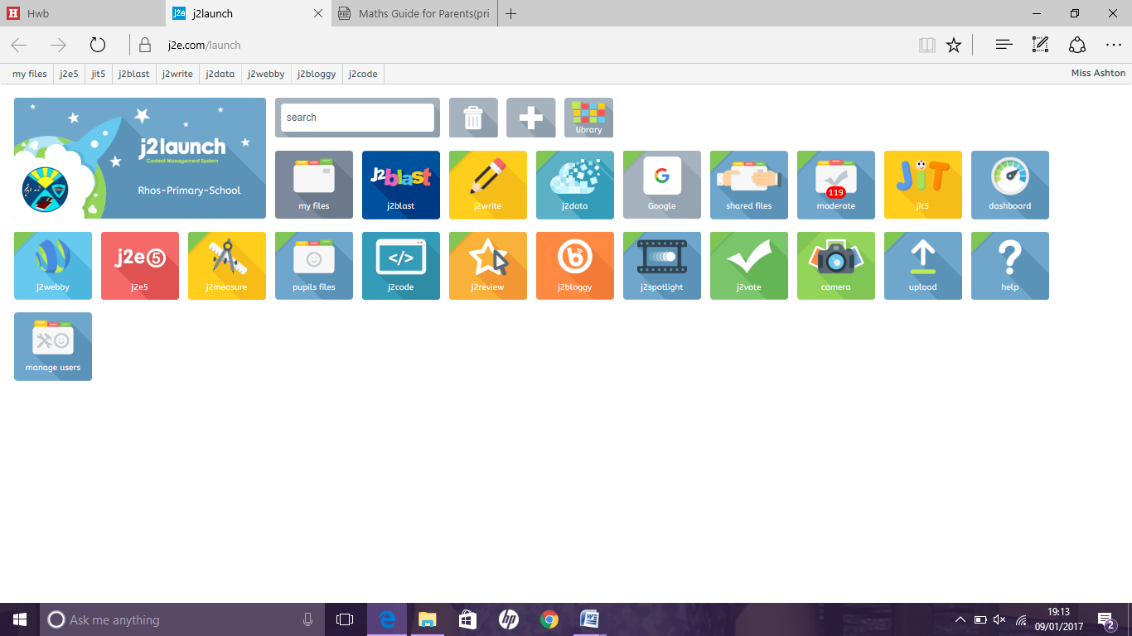

[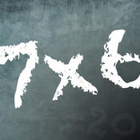](https://www.google.co.uk/url?sa=i&rct=j&q=&esrc=s&source=images&cd=&cad=rja&uact=8&ved=0ahUKEwj8j8fW19vKAhWGzxQKHYagD1UQjRwIBw&url=https://itunes.apple.com/gb/app/times-tables-quiz!-multiplication/id441001315?mt=8&psig=AFQjCNHU1ONz62vCBJjcx6JuZ2h61YVTPQ&ust=1454591998754698) [](http://www.google.co.uk/url?sa=i&rct=j&q=&esrc=s&source=images&cd=&cad=rja&uact=8&ved=0ahUKEwirs6K62NvKAhUK0hoKHTIHD7wQjRwIBw&url=http://uk.pearson.com/primary.html&psig=AFQjCNGR29MoCkF5aoGXejdDjMi6oA29Jw&ust=1454592192796949)

Times table Abacus J2blast

Quiz

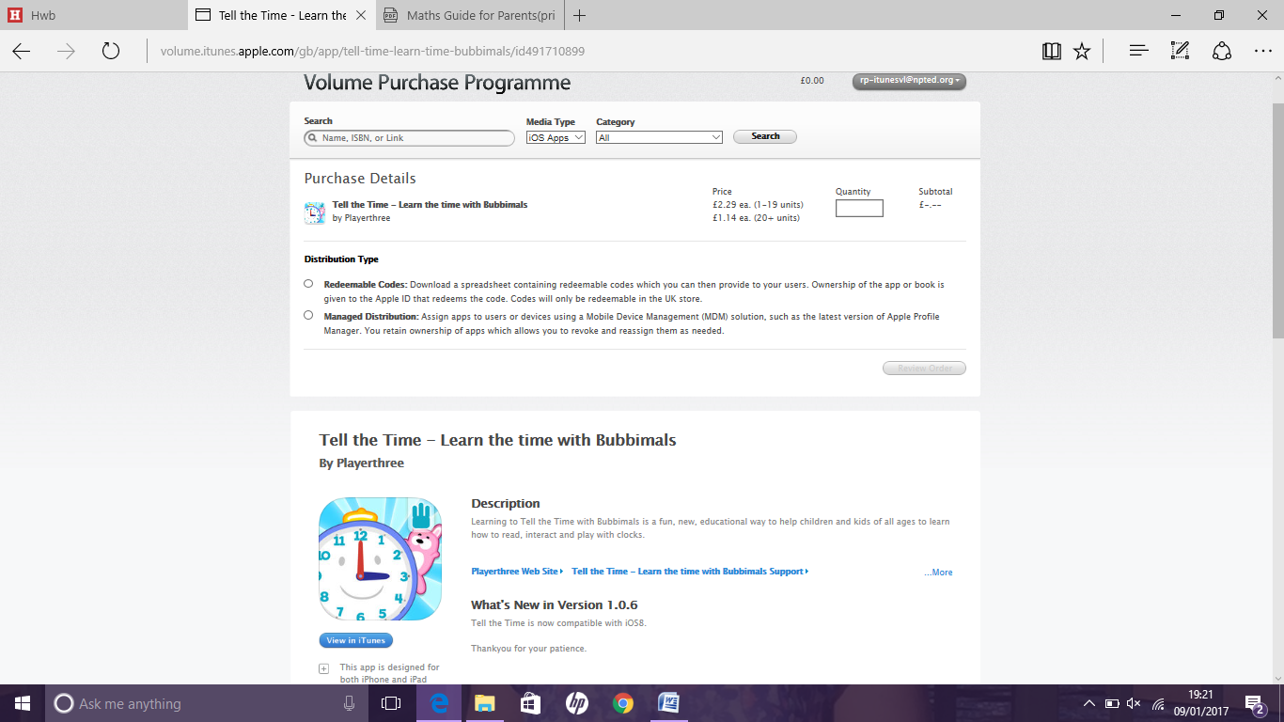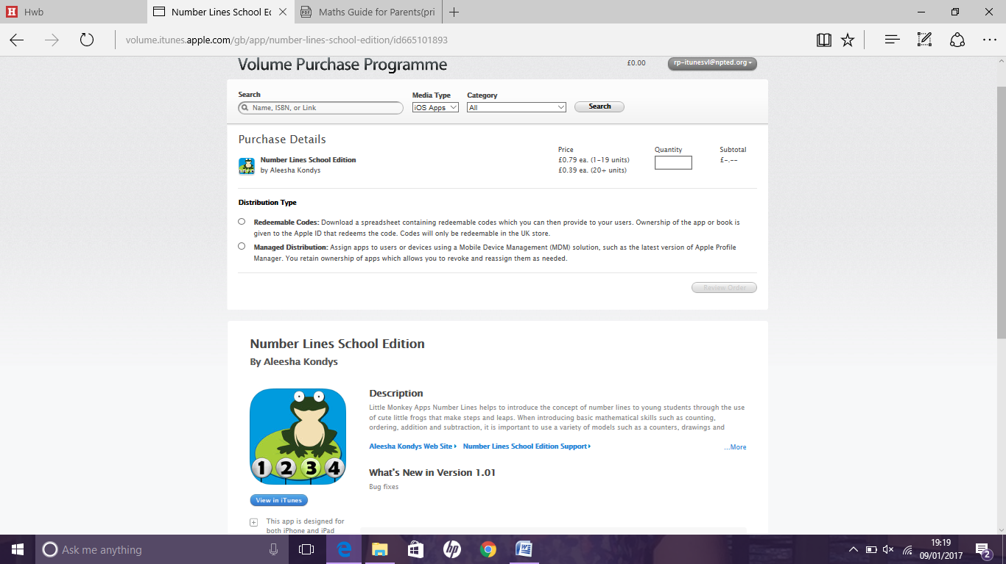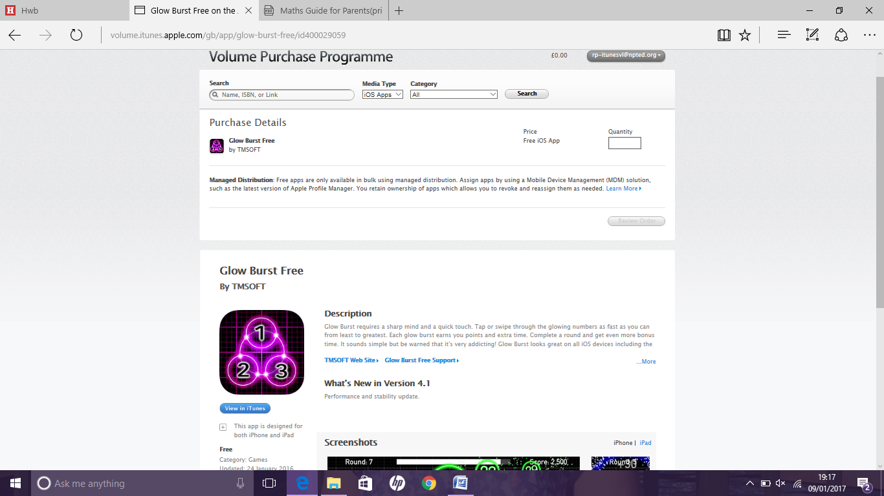

Glow burst number lines tell the time

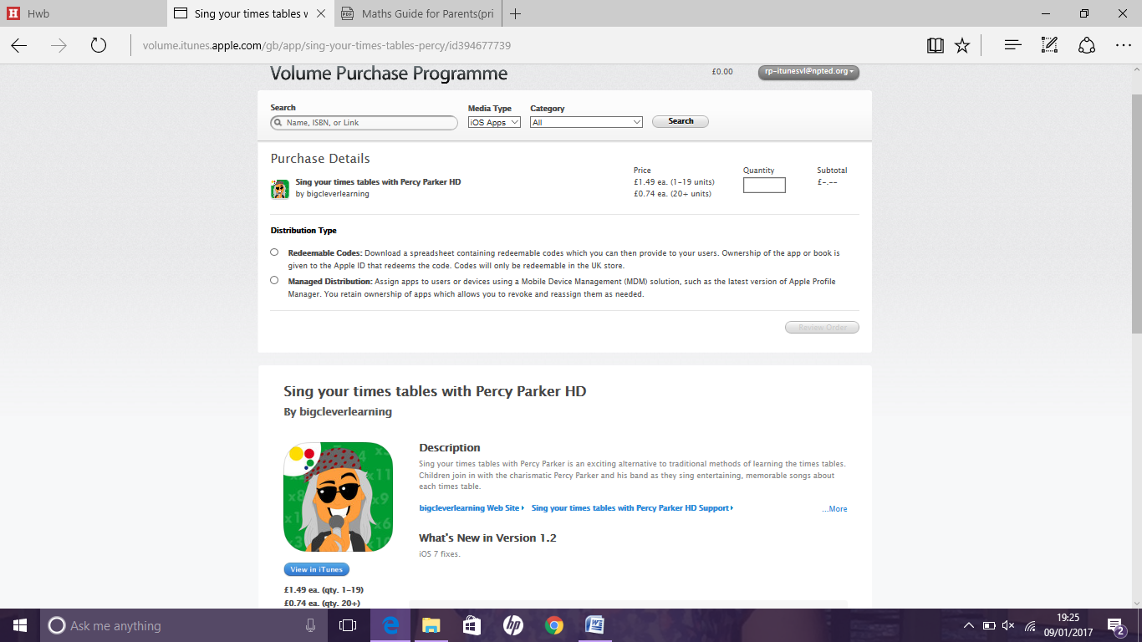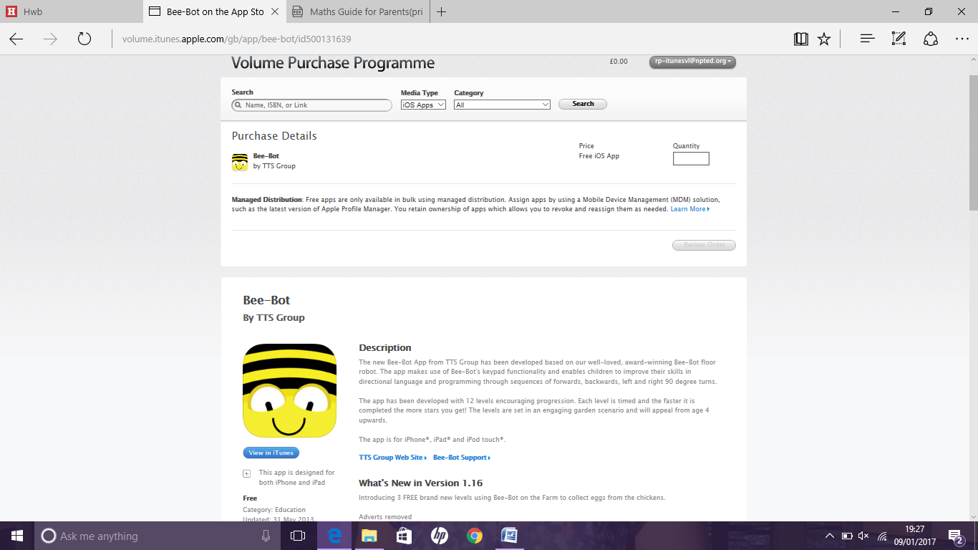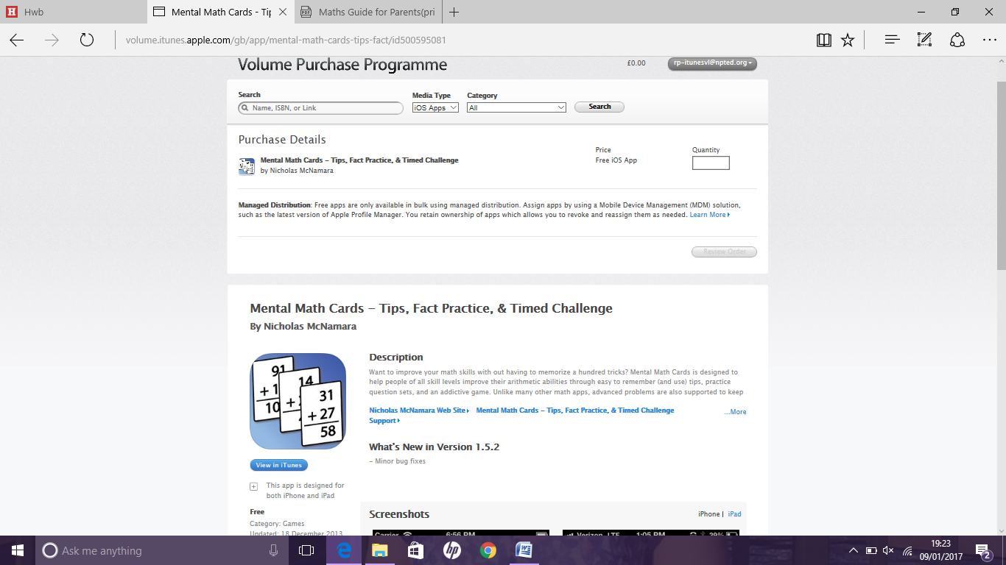

mental maths Percy Parker Bee Bot

cards

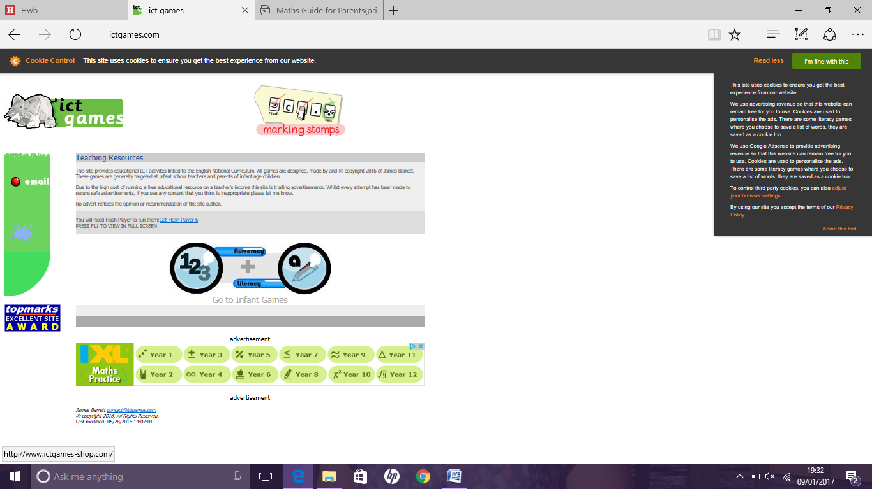

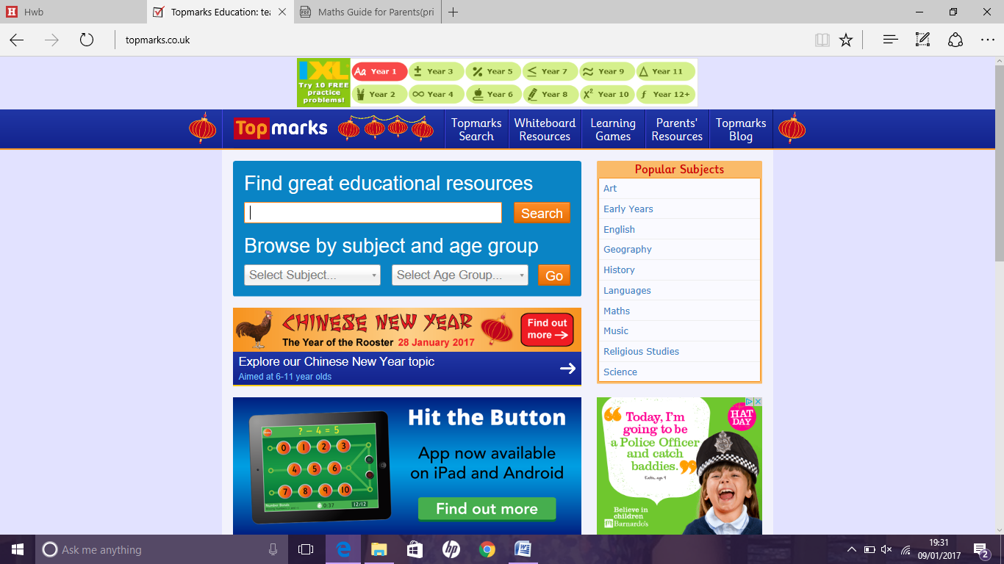

www.topmarks.co.uk www.ictgames.com