Useful Apps
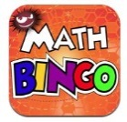
Maths Bingo Sumdog Operation Math

IXL Six numbers HWB
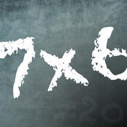
Times table Abacus
Quiz

Useful websites:
www.activelearnprimay.co.uk
www.bbc.co.uk/bitesize
www.resources.woodlands-junior.kent.sch.uk/maths
www.uk.ixl.com/Maths
www.mathszone.co.uk

National Tests
Your child’s numeracy and reading skills will be tested. These tests will take place between 3rd and 10th May 2017. Children in Year 2 to Year 6 will take 3 tests:
- Reading (focused solely on reading skills)
- Numerical Reasoning (using and applying numeracy skills)
- Procedural Numeracy (number skills)

Reporting to parents
The results of these tests will be reported to parents at the end of the Summer Term.

For further information:
LNF link http://learning.gov.wales/resources/?lang=en#/resources/?lang=en
Test link
http://learning.wales.gov.uk/news/sitenews/readingnumeracy/?lang=en

Year 6

The Numeracy
Framework

What is Numeracy?
Numeracy is the use of Mathematical skills in other areas of the curriculum.

The Literacy and Numeracy Framework
The Literacy and Numeracy Framework (LNF) has been introduced by the Welsh Assembly Government to improve the literacy and numeracy skills of children in Wales.

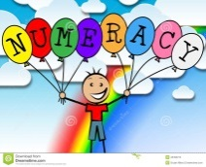
Numerical Reasoning:
The Numerical reasoning skills below are what a typical Year 6 pupil is expected to achieve

Identify processes and connections
- I can use and apply my maths skills in different everyday situations
- I can identify the appropriate steps and information I need to finish a task or find the answer.
- I can select the appropriate math and methods to use.
- I can select and use suitable instruments and units of measurement.
- I can choose a suitable mental or written strategy and know when it is appropriate to use a calculator.
- I can estimate and visualise size when measuring and use the correct units.
Represent and communicate
- I can explain results and procedures clearly using mathematical language.
- I can improve the way I write down my calculations
- I am beginning to use more suitable ways of recording calculations.
- I can use appropriate notation, symbols and units of measurement.
- I can select and construct appropriate charts, diagrams and graphs with suitable scales.
Review
- I can select from an increasing range of checking strategies to decide if answers are reasonable.
- I can interpret answers and decide whether answers, including calculator analogue and digital displays, are sensible.
- I can draw conclusions from data.
- I can recognise that some conclusions may be misleading or uncertain.

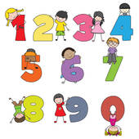
Number Skills:
The number skills below are what a typical Year 6 pupil is expected to achieve.
Use number facts and relationships
- I can read and write numbers to 1 million and numbers to 3 decimal places.
- I can use mental strategies to recall multiplication tables to 10 x 10 and use to solve division problems.
- I can multiply numbers and decimals by a multiple of 10, e.g. 15x30, 1.4cmx20.
- I can use my understanding of simple fraction, decimal and percentage equivalences e.g. find 25% of 60cm and know that this is equivalent to ¼ of 60cm.
- Calculate percentage quantities based on 10%, e.g. 20%, 5%, 15%
- I can use simple ratio and proportion.
Fractions, decimals, percentages and ratio
- I can use my understanding of simple fraction and decimal equivalences when measuring and calculating, e.g. ½ = 0.5
- I can calculate fractional quantities,e.g. 1/6 of 24=3
- I can use doubling and halving strategies when working with simple proportions.
Calculate using mental and written methods
- I can add and subtract numbers using whole numbers and decimals.
- I can multiply 2 and 3 digit numbers by a 2 digit number.
- I can divide a 3 digit number by a 2 digit number.
Estimate and check
- I can check my answers using inverse operations.
- I can estimate by rounding to the nearest 10, 100 or 1000 or whole number.
Manage Money
- I can use the terms profit and loss in buying and selling activities and make calculations for this.
- I can understand the advantages and disadvantages of using bank accounts.
- I can make comparisons between prices and understand which is best value for money.
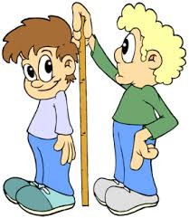
Measuring Skills:
The measuring skills below are what a typical Year 6 child is expected to achieve.

Length, weight/mass, capacity
- I can read and interpret scales or divisions on a range of measuring instruments.
- I can record measurements in different ways, e.g. 1.3kg=1kg300g.
- I can use the language of imperial units in daily use, e.g. miles, pints
Time
- I can use timetables and schedules to plan events and activities.
- I can interpret timetables and schedules to plan events and activities.
- I can make calculations as part of the planning process.
- I can estimate how long a journey takes.
Temperature
- I can read and record temperatures involving positive and negative readings.
- I can calculate temperature differences including those involving temperature rise and fall across 0˚C
Area and volume angle and position
- I can calculate the area of squares and rectangles.
- I can use grid references to specify location.
Data Skills:
The data skills below are what a typical Year 6 child is expected to achieve
Collect and record data, present and analyse data
- I can represent data using:
- Lists, tally charts, tables, diagrams and frequency tables
- Bar charts, grouped data charts, line graphs and conversion graphs
- I can extract and interpret information from an increasing range of diagrams, timetables and graphs (including pie charts)
- I can use mean, median, mode and range to describe a data set.

