Useful Apps
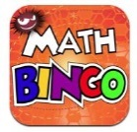
Maths Bingo Sumdog Operation Math

IXL Six numbers HWB
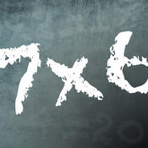
Times table Abacus
Quiz

Useful websites:
www.activelearnprimay.co.uk
www.bbc.co.uk/bitesize
www.resources.woodlands-junior.kent.sch.uk/maths
www.uk.ixl.com/Maths
www.mathszone.co.uk

National Tests
Your child’s numeracy and reading skills will be tested. These tests will take place between 3rd and 10th May 2017. Children in Year 2 to Year 6 will take 3 tests:
- Reading (focused solely on reading skills)
- Numerical Reasoning (using and applying numeracy skills)
- Procedural Numeracy (number skills)

Reporting to parents
The results of these tests will be reported to parents at the end of the Summer Term.

For further information:
LNF link http://learning.gov.wales/resources/?lang=en#/resources/?lang=en
Test link
http://learning.wales.gov.uk/news/sitenews/readingnumeracy/?lang=en

Year 4

The Numeracy
Framework

What is Numeracy?
Numeracy is the use of Mathematical skills in other areas of the curriculum.

The Literacy and Numeracy Framework
The Literacy and Numeracy Framework (LNF) has been introduced by the Welsh Assembly Government to improve the literacy and numeracy skills of children in Wales.

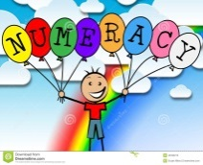
Numerical Reasoning:
The Numerical reasoning skills below are what a typical Year 4 pupil is expected to achieve

Identify processes and connections
- I can use and apply my maths skills in different everyday situations.
- I can work out the appropriate steps and information I need to finish a task or find the answer.
- I can choose the right maths and methods to use.
- I can choose and use suitable instruments and units of measurement.
- I can choose a suitable mental or written strategy and know when it is appropriate to use a calculator.
- I can estimate and think about size when measuring and use the correct units.
Represent and communicate
- I can use mathematical language to explain my methods and results.
- I can improve the way I write down my calculations.
- I am beginning to use more suitable ways of recording calculations.
- I can use appropriate symbols and units of measurement.
- I can choose and draw charts, diagrams and graphs correctly with the right scales.
Review
- I can choose from lots of checking strategies to decide if answers are sensible.
- I can understand my answers and decide whether answers, including calculator, analogue and digital displays, are sensible.
- I can draw conclusions from data.
- I can recognise that some conclusions may be false or unclear.

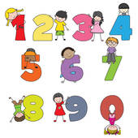
Number Skills:
The number skills below are what a typical Year 4 pupil is expected to achieve.
Use number facts and relationships
- I can read numbers to 10,000.
- I can compare and estimate with numbers up to 1,000.
- I can use mental strategies to recall multiplication tables for 2,3,4,5,6 and 10 and use to solve division problems.
- I can multiply and divide by 10 and 100.
Fractions, decimals, percentages and ratio
- I can halve 3-digit numbers when working with numbers, money and measures.
- I can use my knowledge of tables to find fractions of amounts.
- I can recognise fractions that are several parts of a whole e.g. 2/3
Calculate using mental and written methods
- I can find differences within 1,000.
- I can add a 2-digit number to a 3-digit number using a suitable mental or written method.
- I can subtract a 2-digit number from a 3-digit number using a suitable mental or written method.
- I can use mental strategies to multiply a 2-digit number by a single digit number.
- I can use mental strategies to divide 2-digit numbers by a single digit number.
Estimate and check
- I can check my answers using inverse opposite
- I can estimate by rounding to the nearest 10 or 100.
Manage Money
- I can use money to pay for items up to £10 and calculate the change.
- I can order and compare items up to £100.
- I can add and subtract totals less than £10 using correct notation e.g. £6.85 - £2.76.
- I can manage money, compare costs and work out what can be bought with a given amount.

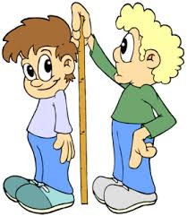
Measuring Skills:
The measuring skills below are what a typical Year 4 child is expected to achieve.

Length, weight/mass, capacity
- I can measure and calculate the perimeter of squares and rectangles.
- I can use a ruler to measure to the nearest mm and record using a mixture of cm and mm e.g. 1cm and 3mm
- I can weigh objects using measuring scales to the nearest 5g, 10g, 25g, or 100g.
- I can measure capacities to the nearest 50ml or 100ml.
- I can change cm to mm, m to cm, km to m.
Time
- I can tell the time to the nearest minute on analogue clocks.
- I can read hours and minutes on a 24-hour digital clock.
- I can time and order events in seconds.
- I can use calendars to plan events.
Temperature
- I can use thermometers to take readings and understand readings above and below 0˚C.
Area and volume angle and position
- I can recognise volume in practical situations.
- I can use eight compass points to describe direction.
Data Skills:
The data skills below are what a typical Year 4 child is expected to achieve
Collect and record data, present and analyse data, interpret results
- I can represent data using:
- Lists, tally charts, tables and diagrams.
- Bar charts and bar line graphs labelled in 2s, 5s and 10s.
- Pictograms where one symbol represents more than one unit using a key.
- Venn and Carroll diagrams.
- I can pick out and make sense of information from charts, timetables, diagrams and graphs.

