Useful Apps
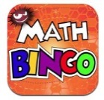
Maths Bingo Sumdog Operation Math

IXL Six numbers HWB
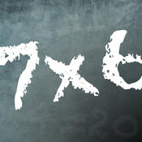
Times table Abacus
Quiz

Useful websites:
www.activelearnprimay.co.uk
www.bbc.co.uk/bitesize
www.resources.woodlands-junior.kent.sch.uk/maths
www.uk.ixl.com/Maths
www.mathszone.co.uk

National Tests
Your child’s numeracy and reading skills will be tested. These tests will take place between 3rd and 10th May 2017. Children in Year 2 to Year 6 will take 3 tests:
- Reading (focused solely on reading skills)
- Numerical Reasoning (using and applying numeracy skills)
- Procedural Numeracy (number skills)

Reporting to parents
The results of these tests will be reported to parents at the end of the Summer Term.

For further information:
LNF link http://learning.gov.wales/resources/?lang=en#/resources/?lang=en
Test link
http://learning.wales.gov.uk/news/sitenews/readingnumeracy/?lang=en

Year 3

The Numeracy
Framework

What is Numeracy?
Numeracy is the use of Mathematical skills in other areas of the curriculum.

The Literacy and Numeracy Framework
The Literacy and Numeracy Framework (LNF) has been introduced by the Welsh Assembly Government to improve the literacy and numeracy skills of children in Wales.

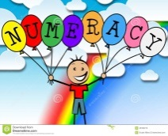
Numerical Reasoning:
The Numerical reasoning skills below are what a typical Year 3 pupil is expected to achieve

Identify processes and connections
- I can use and apply my maths skills in different everyday situations.
- I can work out the right steps and information I need to finish a task or find the answer.
- I can choose the right maths and methods to use.
- I can choose and use suitable instruments and units of measurement.
- I can choose a suitable mental or written strategy and know when it is appropriate to use a calculator.
- I can estimate and think about size when measuring and use the correct units.
Represent and communicate
- I can use mathematical language to explain my methods and results.
- I can improve the way I write down my calculations.
- I am beginning to use more suitable ways of recording calculations.
- I can use appropriate symbols and units of measurement.
- I can choose and draw charts, diagrams and graphs correctly with the right scales.
Review
- I can choose from lots of checking strategies to decide if answers are sensible.
- I can understand my answers and decide whether answers, including calculator, analogue and digital displays are sensible.
- I can draw conclusions from data,
- I can recognise that some conclusions may be false or unclear.

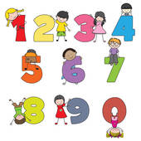
Number Skills:
The number skills below are what a typical Year 3 pupil is expected to achieve.
Use number facts and relationships
- I can read and write numbers to 1,000.
- I can compare and estimate with numbers up to 100.
- I can use mental strategies to recall number facts up to 20.
- I can recall 2,3,4,5 and 10 multiplication tables and use them to solve multiplication and division problems.
- I can multiply numbers by 10.
Fractions, decimals, percentages and ratio
- I can use halves and quarters
- I can halve 2-digit numbers when working with number, money and measure.
- I know how to use my multiplication facts to find fractions of amounts.
Calculate using mental and written methods
- I can find differences within 100.
- I can use mental strategies to add and subtract 2 digit numbers.
- I can partition to double or halve numbers.
Estimate and check
- I can check subtraction using addition.
- I can check halving using doubling.
- I can check multiplication using repeated addition.
Manage Money
- I can use different coins to pay for things up to £2 and calculate the change.
- I can order and compare items up to £10.
- I can record money spent and saved.

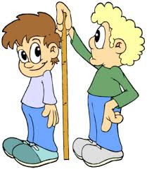
Measuring Skills:
The measuring skills below are what a typical Year 3 child is expected to achieve.

Length, weight/mass, capacity
- I know that perimeter is the distance around a shape.
- I can measure length, height and distance to nearest ½ cm.
- I can use 5g, 10g, and 100g weights when measuring weight/mass.
- I can use litres and half litres when measuring to nearest 100ml.
Time
- I can tell the time to the nearest 5 minutes on an analogue clock.
- I can calculate how long it is to the next hour.
- I can read hours and minutes on a 12-hour digital clock using am/pm.
Temperature
- I can read the temperature on a thermometer and work out the readings above and below 0˚C.
Area and volume angle and position
- I can find areas by counting squares
- I can use the four compass points to describe directions.
Data Skills:
The data skills below are what a typical Year 3 child is expected to achieve

Collect and record data, present and analyse data, interpret results
- I can show information using:
- Lists, tally charts, tables and diagrams.
- Bar charts and bar line graphs labelled in 2s, 5s and 10s.
- Pictograms where one symbol represents more than one unit using a key.
- Venn and Carroll diagrams.
- I can take out and make sense of information from charts, timetables, diagrams and graphs.

