Useful Apps
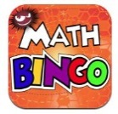
Maths Bingo Sumdog Operation Math

IXL Six numbers HWB
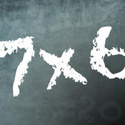
Times table Abacus
Quiz

Useful websites:
www.activelearnprimay.co.uk
www.bbc.co.uk/bitesize
www.resources.woodlands-junior.kent.sch.uk/maths
www.uk.ixl.com/Maths
www.mathszone.co.uk

National Tests
Your child’s numeracy and reading skills will be tested. These tests will take place between 3rd and 10th May 2016. Children in Year 2 to Year 6 will take 3 tests:
- Reading (focused solely on reading skills)
- Numerical Reasoning (using and applying numeracy skills)
- Procedural Numeracy (number skills)

Reporting to parents
The results of these tests will be reported to parents at the end of the Summer Term.

For further information:
LNF link http://learning.gov.wales/resources/?lang=en#/resources/?lang=en
Test link
http://learning.wales.gov.uk/news/sitenews/readingnumeracy/?lang=en

Year 2

The Numeracy
Framework

What is Numeracy?
Numeracy is the use of Mathematical skills in other areas of the curriculum.

The Literacy and Numeracy Framework
The Literacy and Numeracy Framework (LNF) has been introduced by the Welsh Assembly Government to improve the literacy and numeracy skills of children in Wales.

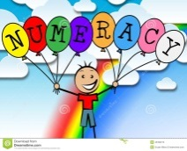
Numerical Reasoning:
The Numerical reasoning skills below are what a typical Year 2 pupil is expected to achieve

Identify processes and connections
- I can use my maths skills in play and also in classroom activities.
- I can work out the steps to finish a task or find the answer.
- I can choose the best maths and methods to use.
- I can use number facts I already know.
- I can work things out in my head.
- I can choose the right equipment and resources.
- I can estimate using what I already know.
Represent and communicate
- I can use my own words and maths vocabulary to talk about my ideas and choices.
- I can talk, draw a picture and write about my work.
- I can use different ways to show lots of information.
- I can write about maths in my own way.
- I can think of ways of making it better.
- I sometimes use words and symbols to write number sentences.
Review
- I know how to check whether my answer makes sense.
- I can read answers to a problem and work out if they make sense.
- I can read information shown in different ways and work out what it is telling me.

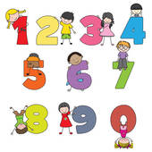
Number Skills:
The number skills below are what a typical Year 2 pupil is expected to achieve.

Use number facts and relationships
- I can count objects by grouping in 2’s, 5’s or 10’s.
- I can read and write numbers to 100.
- I can compare and order 2-digit numbers.
- I can remember number facts to 10 and use them to work out other facts, double and halving, e.g. work out 40 + 40 from knowing 4+4. – bonds of 10, e.g. work out 60+40 from knowing 6+4.
- I can remember and use 2,5 and 10 multiplication tables.
Fractions, decimals, percentages and ratio
- I can find halves and quarters in real-life situations
Calculate using mental and written methods
- I can find small differences within 20 by using ‘counting on’
- I can remember and use number facts to 10 and place value to add or subtract larger numbers, e.g. 24-4, 30+5, 34+10
Estimate and check
- I can use checking strategies: - repeat addition in a different order - use halving and doubling within 20
Manage Money
- I can use different combinations of money to pay for items up to £1.
- I can find totals and give change from multiples of 10p.

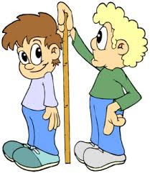
Measuring Skills:
The measuring skills below are what a typical Year 2 child is expected to achieve.

Length, weight/mass, capacity
- I can measure, length, height and distance in ‘metres’ or ‘centimetres’
- I can use ‘kilogram’ or 10 ‘grams’ when measuring weight/mass.
- I can use ‘litres’ when measuring capacity.
Time
- I can read ‘half past’, ‘quarter past’ and ‘quarter to’ on an analogue clock.
- I can read hours and minutes on a 12-hour digital clock.

Temperature
- I can compare daily temperatures using a thermometer (˚C).
Area and volume angle and position
- I recognise half and quarter turns, clockwise and anti-clockwise.
- I recognise that a quarter turn is a right angle.

Data Skills:
The data skills below are what a typical Year 2 child is expected to achieve

Collect and record data, present and analyse data
- I can collect and write about information from:
- Lists and tables
- diagrams

