Useful Apps
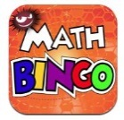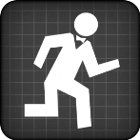
Maths Bingo Sumdog Operation Math

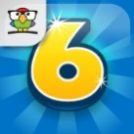
IXL Six numbers HWB
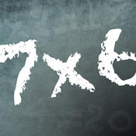
Times table Abacus
Quiz

Useful websites:
www.activelearnprimay.co.uk
www.bbc.co.uk/bitesize
www.resources.woodlands-junior.kent.sch.uk/maths
www.uk.ixl.com/Maths
www.mathszone.co.uk

National Tests
Your child’s numeracy and reading skills will be tested. These tests will take place between 3rd and 10th May 2016. Children in Year 2 to Year 6 will take 3 tests:
- Reading (focused solely on reading skills)
- Numerical Reasoning (using and applying numeracy skills)
- Procedural Numeracy (number skills)

Reporting to parents
The results of these tests will be reported to parents at the end of the Summer Term.

For further information:
LNF link http://learning.gov.wales/resources/?lang=en#/resources/?lang=en
Test link
http://learning.wales.gov.uk/news/sitenews/readingnumeracy/?lang=en

Year 1

The Numeracy
Framework

What is Numeracy?
Numeracy is the use of Mathematical skills in other areas of the curriculum.

The Literacy and Numeracy Framework
The Literacy and Numeracy Framework (LNF) has been introduced by the Welsh Assembly Government to improve the literacy and numeracy skills of children in Wales.

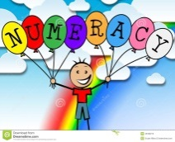
Developing Numerical Reasoning: The Numerical reasoning skills below are what a typical Year 1 pupil is expected to achieve

Identify processes and connections
- I can use my maths skills in play and also in classroom activities.
- I can work out the steps to finish a task or find the answer.
- I can choose the best maths and methods to use.
- I can use number facts I already know.
- I can work things out in my head.
- I can choose the right equipment and resources.
- I can make good guesses using what I already know.
Represent and communicate
- I can use my own words and maths words to talk about my ideas and choices.
- I can use different ways to show lots of information.
- I can write about maths in my own way.
- I can think of ways of making it better.
- I sometimes use words and symbols to write number sentences.
Review
- I know how to check whether my answer makes sense.
- I can read answers to a problem and work out if they make sense.
- I can read information shown in different ways and work out what it is telling me.
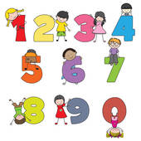
Using Number Skills:
The number skills below are what a typical Year 1 pupil is expected to achieve.

Use number facts and relationships
- I can count up to 20 and get it right every time.
- I can read and write numbers to at least 20.
- I can look at different numbers and know how to put them in order to at least 20.
- I can use number facts up to 10 i.e. bonds of 10, e.g. 6+4, doubling and halving 4+4.
Fractions, decimals, percentages and ratio
- I can find halves in real-life situations.
Calculate using mental and written methods
- I can add and subtract numbers when working with up to 10 objects.
- I can use ‘counting on’ to add 2 groups, starting with the larger number, e.g. 8+5.
Estimate and check
- I can make sensible guesses of a number of objects.
- I can check by counting.
Manage Money
- I can use different coins to pay for things up to 20p.
- I can work out how much has been spent and give change from 10p.

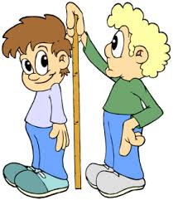
Measuring Skills:
The measuring skills below are what a typical Year 1 child is expected to achieve.

Length, weight/mass, capacity
- I can use different things to measure:
Length, height and distance, weight/mass capacity
Time
- I can read ‘o’ clock using an analogue clock.
- I can read ‘o’ clock using 12-hour digital clocks.
- I can use words to do with time when I talk about my
Daily activities
Weekly activities
Seasons of the year
Temperature
- I can use words like cooler/warmer when I describe different temperatures.
Area and volume angle and position
- I can make whole turns and half turns.

Data Skills:
The data skills below are what a typical Year 1 child is expected to achieve

Collect and record data, present and analyse data
- I can sort and group things using more than one reason.
- I can collect information by voting r sorting and show this in pictures, objects or drawings.
- I can make lists and tables using information I’ve collected.

