**Useful numeracy apps/websites**

[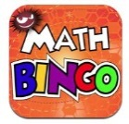](http://www.google.co.uk/url?sa=i&rct=j&q=&esrc=s&source=images&cd=&cad=rja&uact=8&ved=0ahUKEwiL64zK1NvKAhVGuBQKHUHxBrsQjRwIBw&url=http://www.newyorkfamily.com/?attachment_id=79917&psig=AFQjCNFiWdMc0z1hdnQLFw2JEQ_utCIcPg&ust=1454591126905772) [](http://www.google.co.uk/url?sa=i&rct=j&q=&esrc=s&source=images&cd=&cad=rja&uact=8&ved=0ahUKEwi9yNfu1NvKAhUHnRoKHY9DCV4QjRwIBw&url=http://www.sumdog.com/&psig=AFQjCNGJNLldLGxdCU2UqBPbFXnxsZeLcw&ust=1454591224356884) [](http://www.google.co.uk/url?sa=i&rct=j&q=&esrc=s&source=images&cd=&cad=rja&uact=8&ved=0ahUKEwiKpoLG1dvKAhWCaRQKHfgiBL4QjRwIBw&url=http://www.teacherswithapps.com/operation-math/&psig=AFQjCNGcYdWlJETsL7fl-Py6HOMkzqrzwA&ust=1454591302792047)

Maths Bingo Sumdog Operation Math

[](http://www.google.co.uk/url?sa=i&rct=j&q=&esrc=s&source=images&cd=&cad=rja&uact=8&ved=0ahUKEwiatZni1dvKAhWCOhQKHfAcB5EQjRwIBw&url=http://ipadapps4school.com/2013/10/01/ixl-math-practice-elementary-school-math-practice-ipad-app/&psig=AFQjCNHpBa08_gARUxwgkHQFRyr92kntAw&ust=1454591505653319) [](http://www.google.co.uk/url?sa=i&rct=j&q=&esrc=s&source=images&cd=&cad=rja&uact=8&ved=0ahUKEwiH0v_z1dvKAhVCWRoKHYnsBToQjRwIBw&url=http://www.itouchapps.net/6-numbers-game-answers-solutions-levels-1-100/&psig=AFQjCNG7C7FWcHF6y1kJSOKRqaKwRT7L5A&ust=1454591541713239) [](http://www.google.co.uk/url?sa=i&rct=j&q=&esrc=s&source=images&cd=&cad=rja&uact=8&ved=0ahUKEwiXlKej19vKAhXDMBoKHWnLDcsQjRwIBw&url=http://hwb.wales.gov.uk/&psig=AFQjCNGHlHLxkzMYq-1LOPRMdXQ5-zw_ew&ust=1454591906484200)

IXL Six numbers HWB

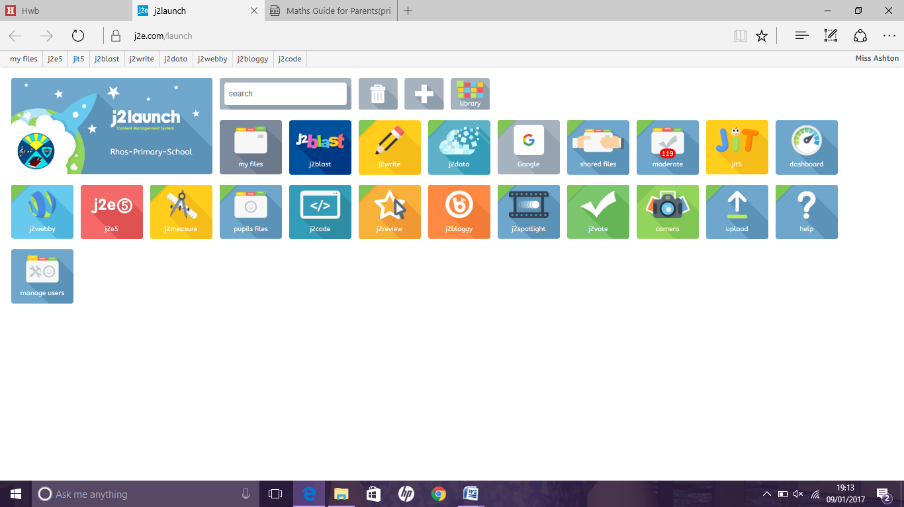

[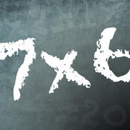](https://www.google.co.uk/url?sa=i&rct=j&q=&esrc=s&source=images&cd=&cad=rja&uact=8&ved=0ahUKEwj8j8fW19vKAhWGzxQKHYagD1UQjRwIBw&url=https://itunes.apple.com/gb/app/times-tables-quiz!-multiplication/id441001315?mt=8&psig=AFQjCNHU1ONz62vCBJjcx6JuZ2h61YVTPQ&ust=1454591998754698) [](http://www.google.co.uk/url?sa=i&rct=j&q=&esrc=s&source=images&cd=&cad=rja&uact=8&ved=0ahUKEwirs6K62NvKAhUK0hoKHTIHD7wQjRwIBw&url=http://uk.pearson.com/primary.html&psig=AFQjCNGR29MoCkF5aoGXejdDjMi6oA29Jw&ust=1454592192796949)

Times table Abacus J2blast

Quiz

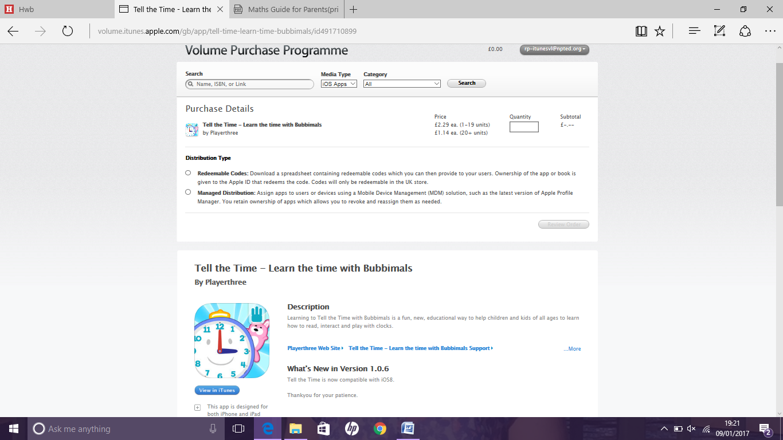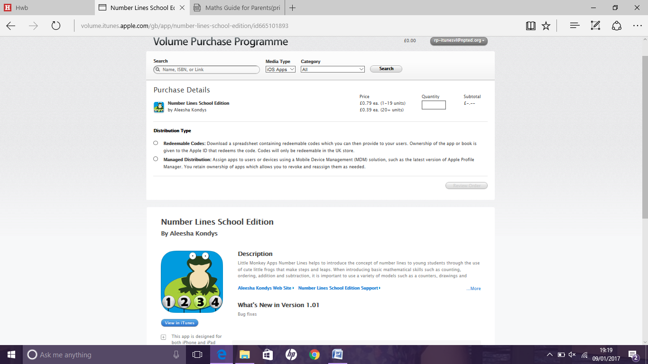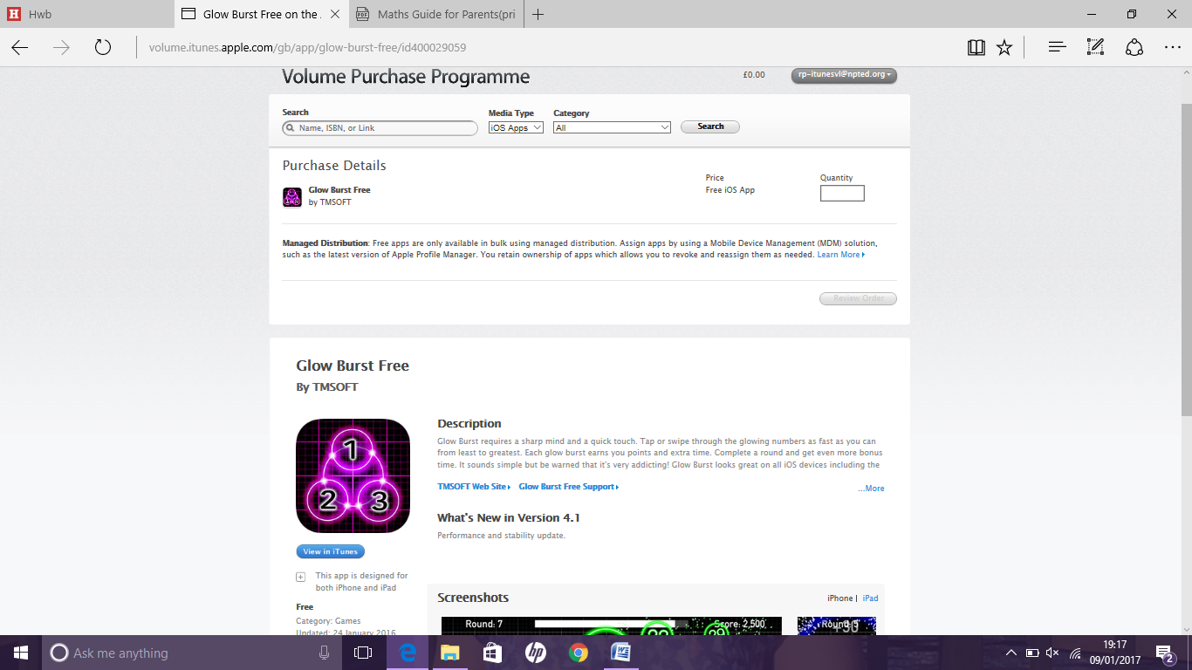

Glow burst number lines tell the time

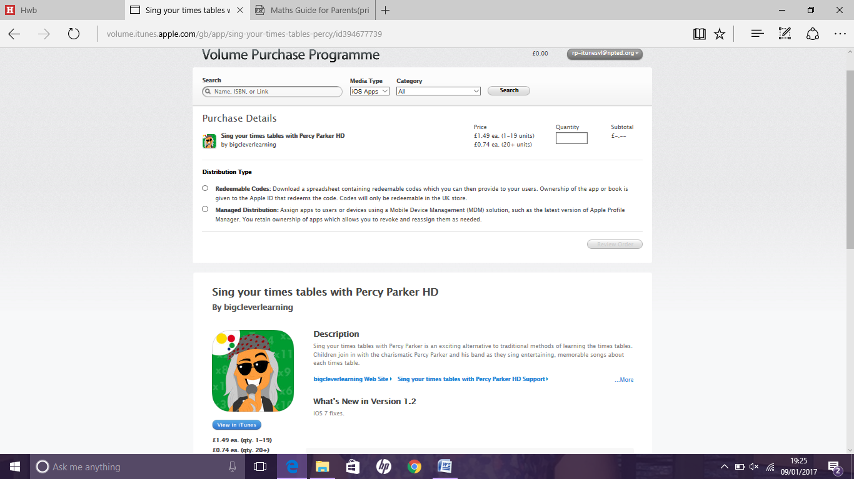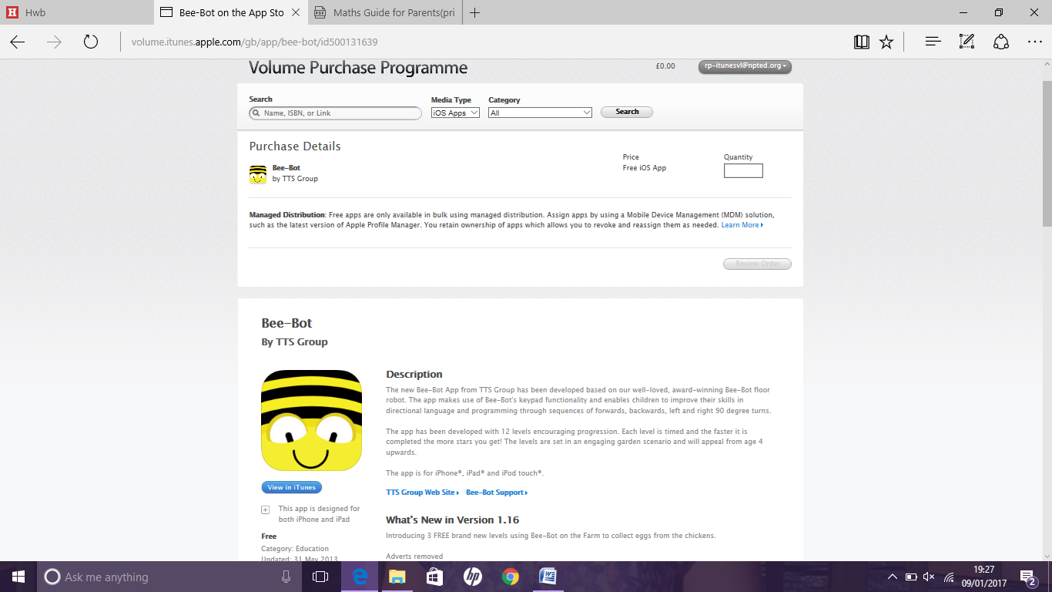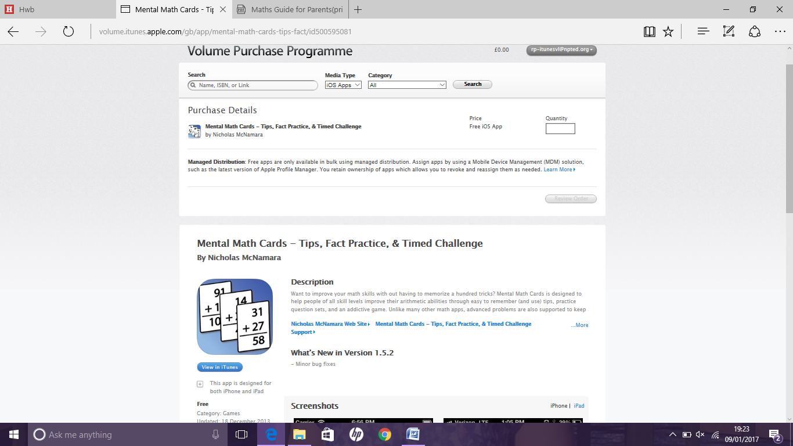

mental maths Percy Parker Bee Bot

cards

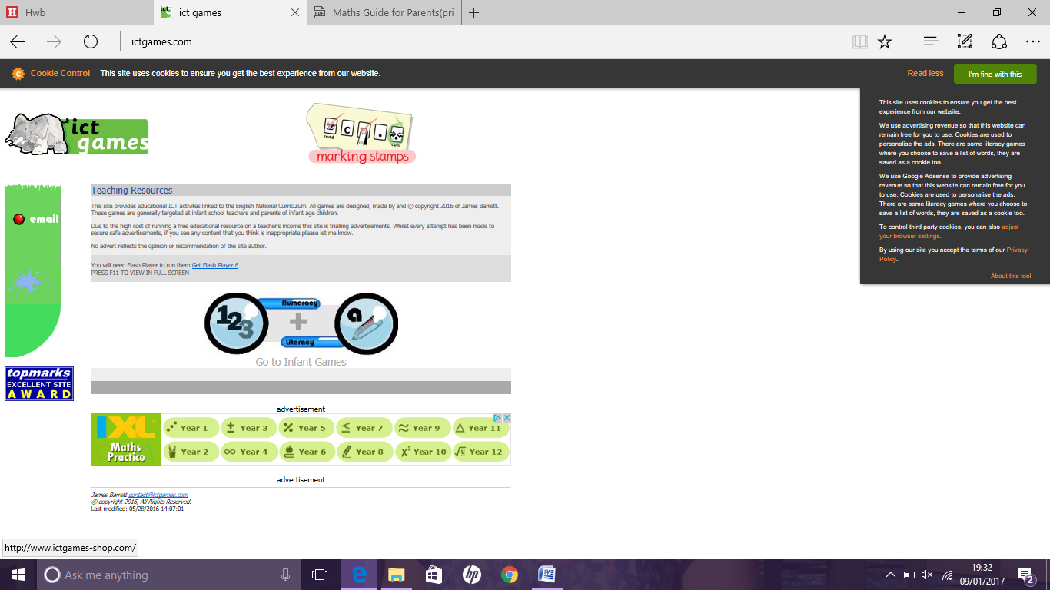

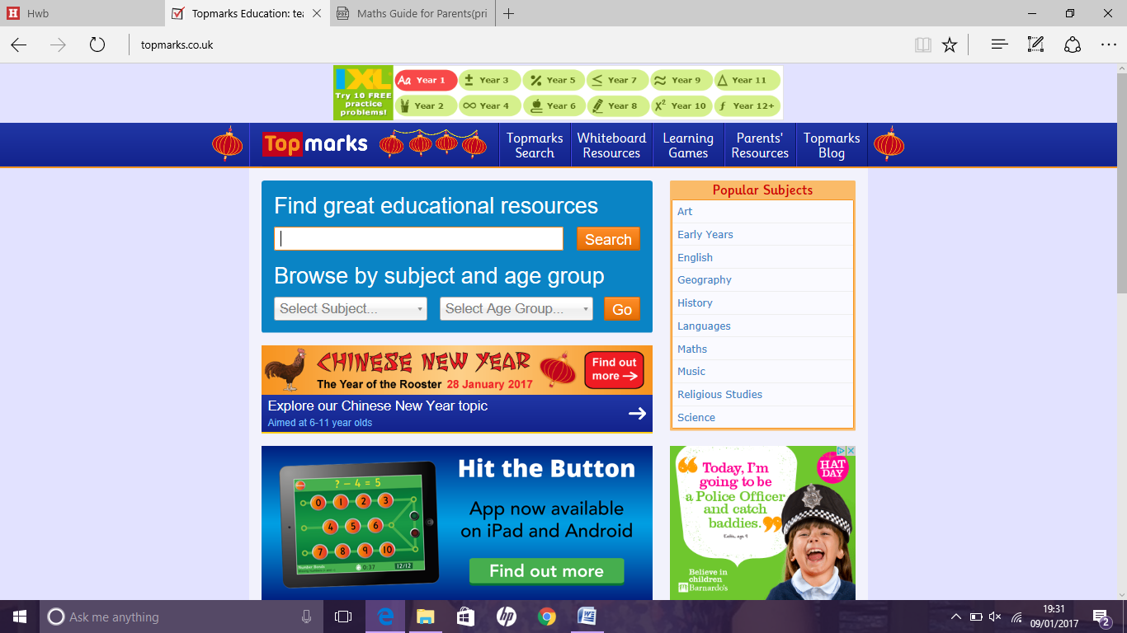

www.topmarks.co.uk www.ictgames.com