Useful Apps
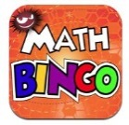
Maths Bingo Sumdog Operation Math

IXL Six numbers HWB
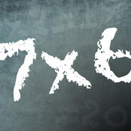
Times table Abacus
Quiz

Useful websites:
www.activelearnprimay.co.uk
www.bbc.co.uk/bitesize
www.resources.woodlands-junior.kent.sch.uk/maths
www.uk.ixl.com/Maths
www.mathszone.co.uk

National Tests
Your child’s numeracy and reading skills will be tested. These tests will take place between 3rd and 10th May 2016. Children in Year 2 to Year 6 will take 3 tests:
- Reading (focused solely on reading skills)
- Numerical Reasoning (using and applying numeracy skills)
- Procedural Numeracy (number skills)

Reporting to parents
The results of these tests will be reported to parents at the end of the Summer Term.

For further information:
LNF link http://learning.gov.wales/resources/?lang=en#/resources/?lang=en
Test link
http://learning.wales.gov.uk/news/sitenews/readingnumeracy/?lang=en

Reception

The Numeracy
Framework

What is Numeracy?
Numeracy is the use of Mathematical skills in other areas of the curriculum.

The Literacy and Numeracy Framework
The Literacy and Numeracy Framework (LNF) has been introduced by the Welsh Assembly Government to improve the literacy and numeracy skills of children in Wales.

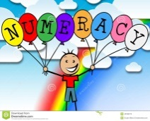
Developing Numerical Reasoning: The Numerical reasoning skills below are what a typical Reception pupil is expected to achieve

Identify processes and connections
- I can use my maths skills in play and also in classroom activities
- I can work out the steps to finish a task or find the answer.
- I can choose the best maths and methods to use.
- I can use number facts I already know.
- I can work things out in my head.
- I can choose the right equipment and resources.
- I can make good guesses using what I already know.
Represent and communicate
- I can use my own words and maths words to talk about my ideas and choices,
- I can talk, draw a picture and write about my work.
- I can use different ways to show lots of information.
- I can write about maths in my own way.
- I can think of ways of making it better
- I sometimes use words and symbols to write number sentences.

Review
- I know how to check whether my answer makes sense.
- I can read information shown in different ways and work out what it is telling me.
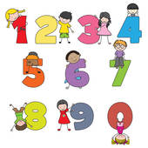
Using Number Skills:
The number skills below are what a typical Reception pupil is expected to achieve.

Use number facts and relationships
- I can count up to 10 and get it right every time.
- I can read and write numbers up to at least 10.
- I can compare and order numbers up to at least 10.

Calculate using mental and written methods
- I can join two groups of things to find ‘how many altogether?’
- I can take away objects to find ‘how many are left?’
Manage Money
- I can use 1p, 2p, 5p and 10p coins to pay for objects.

Measuring Skills:
The measuring skills below are what a typical Reception child is expected to achieve.

Length, weight/mass, capacity
- I can use words like Longer/shorter than Heavier/lighter than holds more/less than
Time
- I can show that I understand how long tasks and everyday activities take.
- I can use time to explain my daily activities.

Temperature
- I can use words like hot and cold when talking about temperature.
Area and volume angle and position
- I can move in the direction I am told.
Data Skills:
The data skills below are what a typical Year 1 child is expected to achieve

Collect and record data, present and analyse data
- I can sort and order objects using one reason.
- I can show a set of objects using marks, numbers or pictures.

