How to set up and use your twitter account
Go to the website http://twitter.com and click sign up. You will have to create a username and enter a phone number or email address. You will be sent confirmation of your account when completed.
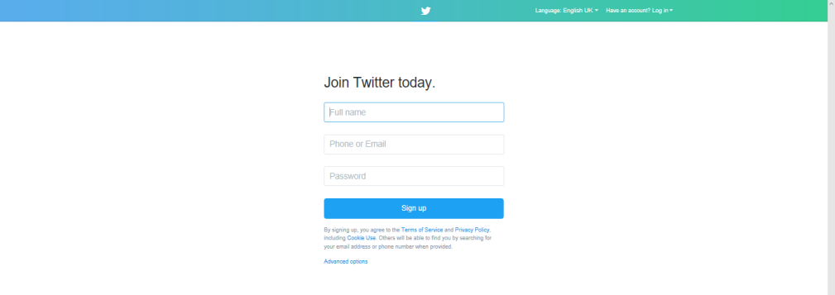

Twitter basics

You will see a navigation tool bar at the bottom of the page. This will allow you to move around Twitter, search for people and receive your notifications and private messages. The 'Me' section of the tool bar allows you to personalise your twitter account as well as set security levels.

Your top tool bar allows you to search for people/groups on Twitter and write a post/upload a photo or video (the quill symbol).

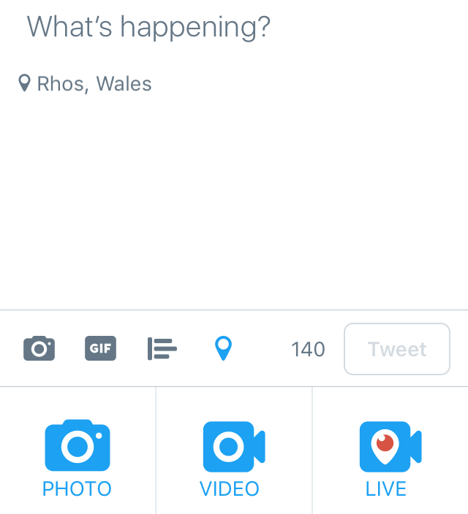
When you select the 'quill' symbol, it will direct you to a 'post page'. You can type a message (up to 140 characters) or upload a photo/video or take a live recording.
If you would like to 'tag' someone or a group in your post you must use the@ symbol before their user name, for example @rhosprimary
If you would like to categorise your tweet you can use the '#' symbol before your caption, for example #education

Your tweets and those of the people groups you are following will be displayed on the home page (news feed page)
Accessing Rhos Primary twitter account
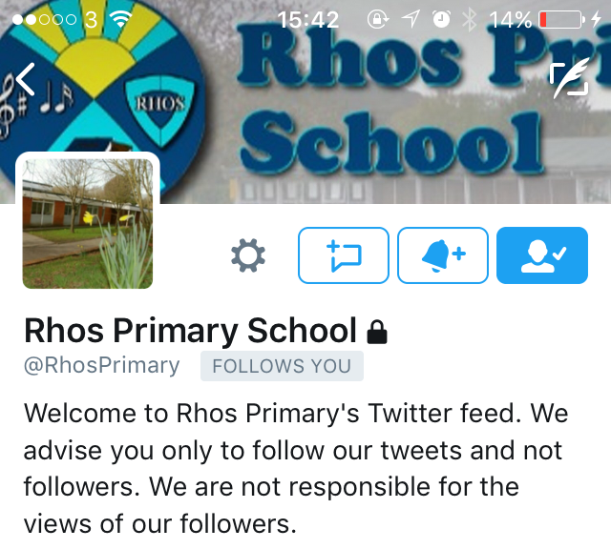
Using the search tool - type the address @RhosPrimary. You will need to select the option 'request to join'.
It is vital that you then give your username information into the school office so that the school can accept your request.

