St. Joseph’s Cathedral Primary School
Following Jesus as we Live and Learn Together

Welcome to Nursery

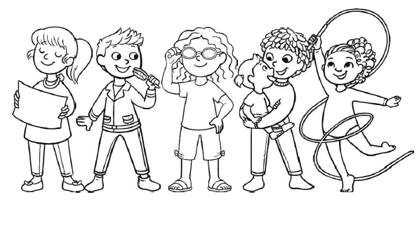

All about me
(Please attach a photo/or a drawing)

My name is __________ .
I am ________ years old.
My birthday is ______________.

I live with
(please add photographs or drawings )

These people are also very special to me.

I will usually be brought to Nursery by:

I will usually be collected by:
______________________________________________________________

Getting to know you
Favourite toys and games

My favourite stories, songs and rhymes are:

Words to describe my child!
(Please circle and add any other descriptive words about your child onto the hands)

sociable
dreamy confident adventurous
active strong willed anxious talkative
independent kind sensitive
likes routine
nervous

Getting to know you

At Nursery my child is looking forward to eg painting, riding a bike etc .............

Places and things my child likes to go to, talk about, do or explore.

Objects or things to do which comfort, soothe or calm my child
.
Things which can upset, frighten or worry my child.

To help your child.
How does your child separate from you?

What experience does your child have of playing with other children?
Does your child have any allergies or medical conditions?

What stage of toilet training is your child at?
We do ask that your child is toilet trained before beginning school unless there is a medical condition.

How does your child tell you that they need the toilet?

Please share any other information that you feel is important regarding your child.

We look forward to meeting you in September.

