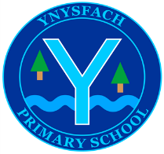
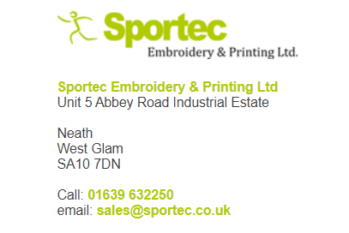
Sportec is our new uniform distributor.
You can order the following school uniform from the shop in Neath.

Or on the website (link below)
School Uniform / PE Kits / Sports Kits / Teamwear / Work Uniforms / Embroidery / Printing (sportec.co.uk)

There is also a link on our school website.

Please click on the tab school uniform and then on the Ynysfach logo.

The Uniform you can order is.. (please see website for sizes)
School jumper | School cardigan | Poloshirt
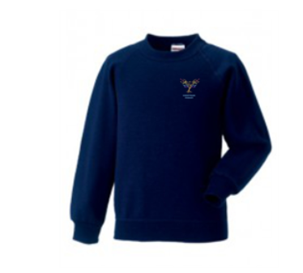 | 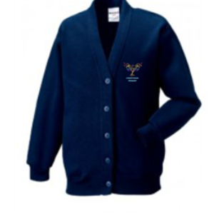 | 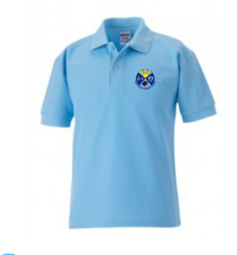

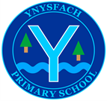

THIS FORM TO BE RETURNED TO SCHOOL WITH PAYMENT
Ynysfach PE uniform
From September pupils will be expected to wear navy / black shorts and a coloured t-shirt (depending on what colour they are in for Sports day) for their PE sessions.
You can order these along with gym bags and book bags using the order form below. Please send payment through parent pay or with the correct money in an envelope. Please indicate in the box the number of items you would like.
-----------------------------------------------------------------------------------------------
Name _________________________________________
class_________________________________________

 | Age 3/4 | Age 5/6 | Age 7/8 | Age 9/11 | Age 12/13
Red PE T-Shirt (round-neck) badged £4.50
Green PE T-Shirt (round-neck) badged £4.50
Blue PE T-Shirt (round-neck) badged £4.50
Yellow PE T-Shirt (round-neck) badged £4.50
Navy PE shorts
£5.50
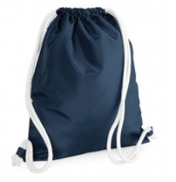  Drawstring PE bag with logo £5.00 |  |  | 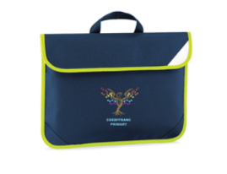  Hi Viz school book bag with logo £6.00
Total amount enclosed

