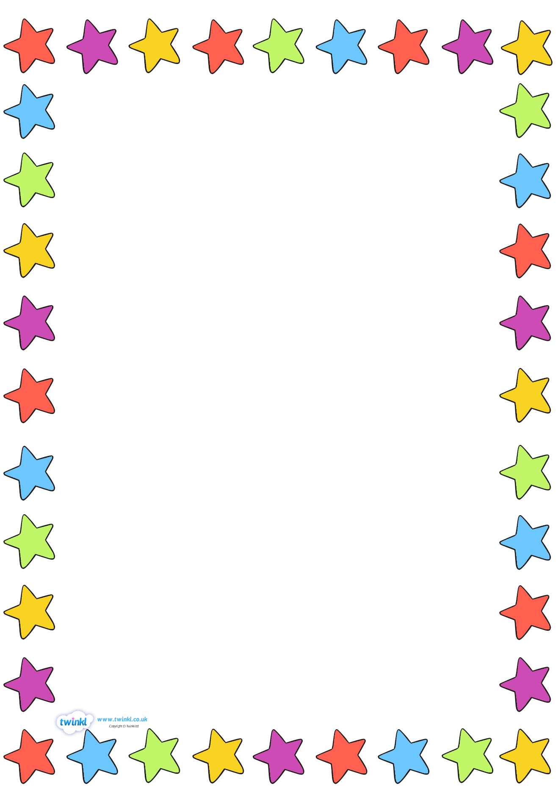
Class 7 - Tips for reading at home with your child.
Making reading fun…
- Do short bursts of reading, try and avoid times when your child may be tired.
- Take turns- YOU read, then your child reads.
- Share a book they choose – this encourages your child’s interest in a range of books, stories and topics.
- Look at different types of reading materials- magazines, comics, Argos and Smyths catalogues, newspapers.
- Make puppets/masks of characters and create models to help your child act out events in the stories you read.

Strategies…
- Look at the front cover. Make sure your child knows the title of the story / article / book.

- Break down each word, by sounding out each letter and blending the letters together i.e. c-a-t, cat.

- With larger words, encourage your child to break down or ‘chunk’ them into smaller words.

- Encourage your child to use their ‘reading finger’ when reading to track words carefully.

- Tricky words will be sent home as flashcards, please learn these over and over again with your child until he/she can read them correctly.

- Ask your child to point at words particularly ones they cannot decode such as the, said, they etc

- Encourage your child to read to the end of the sentence and come back to the difficult word, they may be able to read it now from the context.
- Point out punctuation – full stops and commas where they must stop to take breaths, and question marks, exclamation marks and speech marks, where they need to change the tone/volume of their voice.

- Ask your child regular questions about the book to check that they understand what they have read. There are some great ideas on the back page of each book to help you. There are also some ideas on our class website page and a list below –
- Look at the cover, what do you think the book is about?
- Who is the author? What is an author?
- Who is the illustrator? What is an illustrator?
- What does this word mean?
- Can you spell this word?
- What do you think will happen next?
- Can you name some objects in the picture?
- Point to something that begins with (a sound)
- Point to something that is (colour)
- Tell me what is on top / under / next to (an object)
- Who is the main character?
- Name some characters in the story.
- Who is your favourite character?
- How do you think the character feels here?
- Why do they feel like this?
- What would you do in this situation?
- What do you think will happen in the end?
- Can you think of a different ending?
- What happened first / after that / in the end?
- What was your favourite part of the story? Explain why?
Please read with your child as often as possible- we hope you understand that reading is a very important part of every child’s learning, so regular reading both at home and in school will result in an increase in confidence and fluency. Please remember - reading books, reading records and flashcard pots need to be in school every day. Additional reading resources can be found here- https://oxfordowl.co.uk/
If you have any queries or concerns please contact me on 01639 630816 or via email– WilliamsN875@hwbcymru.net.
Thank you for your support and for reading this information

Mrs Williams & Miss Jones (Class 7)

