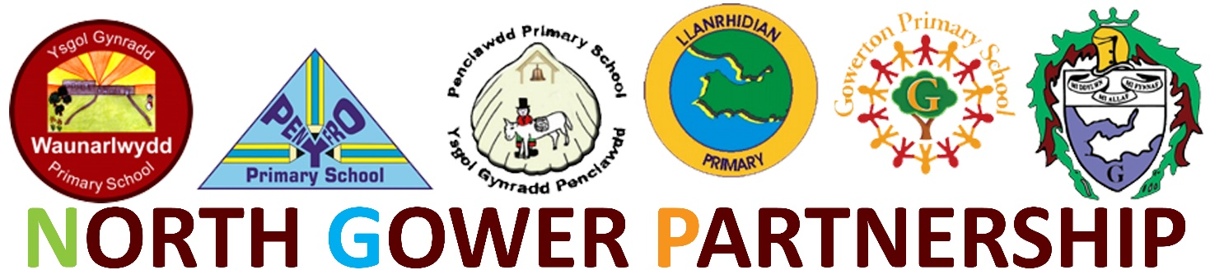

Dear Parent/Carer,

The North Gower Partnership Schools, Gowerton Comprehensive and the Primaries of Gowerton, Llanrhidian, Penclawdd, Penyfro, and Waunarlwydd have met to agree the following.

We hope that everyone is aware from Friday 20th March at 3pm schools will close and be repurposed as emergency childcare settings.

The latest Government guidelines state that the safest option for children is to remain at home.
The most recent scientific advice on how to further limit the spread of COVID-19 is clear. If children can stay safely at home, they should, to limit the chance of the virus spreading.
That is why the government has asked parents to keep their children at home, wherever possible, and ask schools to remain open only for those children who absolutely need to attend.

Access for the emergency childcare settings will initially be prioritized for the following groups: NHS staff and/or blue light emergency services.
In the first instance, this select group of children will be accepted in their own primary school for the week of Monday 23rd - Friday 27th. (Penclawdd Primary school is an exception as this school will be closed due to a shortage of staff. The select group of pupils from this school can attend Gowerton Primary.)

For this week of March 23rd - 27th schools will be open from 8am - 5pm. Food will be provided for the identified group of pupils. Pupils will not need to wear school uniform as this is not formal education.

The plan for the NGP cluster is to develop hub centres to ensure a sustainable model for the forthcoming weeks in the ever developing national crisis. You will be informed of any changes to the model when it is necessary and appropriate. This will obviously rely on the availability of healthy staff.

Parents, who are entitled to this emergency childcare provision must adhere to Government guidelines which emphasize the need for social distancing outside the childcare setting.

This national emergency is unprecedented. The situation is changing on a daily basis and we are committed to providing this support for as long as we safely can during the crisis.

If you are an employee of the NHS staff and / or blue light emergency services please complete the attached consent form.

The North Gower Partnership thank you all for your continued support in this difficult time. We will continue to do our very best for all our pupils, staff, governors and the wider community.

Mrs S. Ralph – Gowerton Primary
Mrs D. Caswell – Llanrhidian Primary
Mrs L. Reynolds-Milns – Penclawdd Primary
Mrs R. Lewis – Pen-Y-Fro Primary
Mrs R. Davies – Waunarlwydd Primary
Mr N. Jones – Gowerton School

