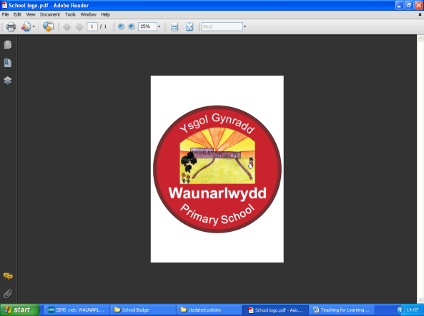**Waunarlwydd Risk Assessment Form**

|  |  |  |  |  |  |  |  |  |  |  |  |  |  |  |
| --- | --- | --- | --- | --- | --- | --- | --- | --- | --- | --- | --- | --- | --- | --- |
| Activity to be Assessed | | | | | | | | | | | Assessment Number | | | |
| Ks2 Playground | | | | | | | | | | | July 19 | | | |
| Persons undertaking or affected by the activity | | | | | | | | | | | | | | |
|  | | | | | | | | | | | | | | |
|  | | x | Employees |  | Contractor | x | Public | | x | Pupil | |  | Service User | |
|  | | | | | | | | | | | | | | |
|  | |  | Other ……………………………………………………………………………………………. | | | | | | | | | | | |
|  | | | | | | | | | | | | | | |
| Identified Hazards and Associated Risks | | | | | | | | Likelihood | | | Severity | | | Risk Level |
| 1 | Leaf litter/ Loose twigs | | | | | | | 3 | | | 2 | | | 6 |
| 2 | Slippery surface, e.g. ice | | | | | | | 3 | | | 3 | | | 9 |
| 3 | Uneven surfaces | | | | | | | 3 | | | 2 | | | 6 |
| 4 | Climbing equipment | | | | | | | 3 | | | 4 | | | 12 |
| 5 | Pedestrian access/ security | | | | | | | 4 | | | 3 | | | 12 |
| 6 | Emergency arrangements | | | | | | | 4 | | | 3 | | | 12 |
| 7 | Acorn – Highlighted by the Senedd Safety Pupils | | | | | | | 3 | | | 2 | | | 6 |
| Existing Control Measures / Additional Control Measures Required | | | | | | | | | | | | | | |
| 1 | Make pupils aware of possible hazards through assembly and general awareness through the general class activities. The school have a general maintenance planner and highlights the need for daily inspections and manage leaf fall. This is also collected daily/ weekly depending on fall and quantity. | | | | | | | | | | | | | |
| 2 | The school have a grit plan in place and this is directly linked to the school business continuity plan. During adverse weather conditions restriction will apply to accessing the yard and regular inspections will be undertaken where needed. This arrangement also applies during heavy rainfall and activities are dynamically assessed. Restrictions will also apply to any trip trails or timber decking/ structures and the risk of slips and trips is increased significantly. | | | | | | | | | | | | | |
| 3 | All teaching staff undertake visual inspections of the yard prior to activities being undertaken. The caretaker undertaken daily inspections of the area as part of the opening up and closed down activities and any remedial work required is discussed and agreed with the head teacher. | | | | | | | | | | | | | |
| 4 | Adult supervision; pupil reminders about safe use and closely monitored. The area is restricted out of school time, I.e. before 8.50am, after 3.30pm and pupils and parents are advised that these facilities are not used through communications on the school newsletter and communications.  All play equipment is subject to visual inspections by the caretaker and formally recorded. Any defects are highlighted and the equipment taken out of use until remedial work is completed. Checks include the checking and replenishing of bark. Pre user checks in place and all staff are fully aware of their responsibilities with this.  All fixed external play equipment is subject annual inspection by the approved contractor. | | | | | | | | | | | | | |
| 5 | Following a review of the site security procedures, the main pedestrian gate is locked during playtimes and this is now fully embedded into the schools procedures. All staff wear hi vis jacket allowing them to be clearly visible to staff and pupils. | | | | | | | | | | | | | |
| 6 | All staff are fully aware of the emergency procedures within the school that include fire, lock down and first aid. First aid provisions are located in reception and within most area of the building. School staff have adequate first aiders and this training is maintained. | | | | | | | | | | | | | |
| 7 | The school’s Senedd Safety Pupil team have highlighted that acorns can be a hazard and are providing monitoring during play time. The pupils voice is paramount and will always reflect policy change. All staff to be extra vigilant during autumn and collect offending acorns. | | | | | | | | | | | | | |
| He | | | | | | | | Likelihood | | | Severity | | | Risk Level |
| 1 | Leaf litter/ Loose twigs | | | | | | | 1 | | | 1 | | | 1 |
| 2 | Slippery surface, e.g. ice | | | | | | | 1 | | | 1 | | | 1 |
| 3 | Uneven surfaces | | | | | | | 2 | | | 1 | | | 2 |
| 4 | Climbing equipment | | | | | | | 1 | | | 1 | | | 2 |
| 5 | Pedestrian access/ security | | | | | | | 2 | | | 1 | | | 2 |
| 6 | Emergency arrangements | | | | | | | 3 | | | 2 | | | 6 |
| 7 | Acorn – Highlighted by the Senedd Safety Pupils | | | | | | | 2 | | | 2 | | | 4 |

|  |  |  |  |  |  |  |  |  |  |  |  |  |  |  |  |  |
| --- | --- | --- | --- | --- | --- | --- | --- | --- | --- | --- | --- | --- | --- | --- | --- | --- |
| Name R Davies  Position HT | | Date: May15 2017 | | | | | | |  | | | | | | | |
| Reviews |  | | |  | | | | | | | | | | | | |
| Review Date : May 2017 | Likelihood | | Severity | Severity of Injury | | 5 | 5Y | | | 10R | | 15 | | 20 | | 25 |
| Reviewed by: RD | 1 very unlikely  2 unlikely  3 likely  4 very likely  5 certainty | | 1 nuisance  2 minor  3 medical treatment  4 major  5 fatal | 4 | 4 | | | 8 | | 12 | | 16 | | 20 |
| Review Date : July 19 | 3 | 3 | | | 6G | | 9 | | 12 | | 15 |
| Reviewed by: RD | 2 | 2 | | | 4 | | 6Y | | 8 | | 10Y |
| Review Date : July 21 | 1 | 1 | | | 2 | | 3 | | 4 | | 5G |
| Reviewed by: | 0 | 1 | | | 2 | | 3 | | 4 | | 5 |
| Review Date : |  | | | Likelihood of Injury | | | | | | | | | |
| Reviewed by: |  | Low Risk | | |  | | | Medium Risk | |  | | High Risk | |