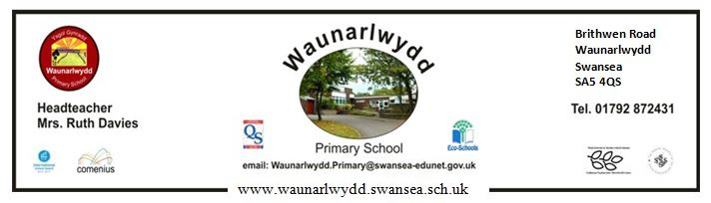
18th October 2018
Dear Parents,

The Children In Need Appeal is taking place on Friday, 16th November. The school Sennedd ‘Enterprise’ group have decided on a ‘pyjama themed day’ where children can pay £1 to wear pyjamas to school on the day.
Colour change wrist bands, glow LED key rings and pin badges are on sale in school for £1 each. On the day, children will be able to buy spotty biscuits at 20p each and will participate in class activities relating to Children in Need. Please note that payment for these items must be made in cash and not via SQUID.
Also, we would be grateful if you would send in any spare copper coins on November 16th and we will hold a class competition to see which class can fill a bottle with the most copper coins.
Also , if any parents would like to donate cakes, we will be holding a cake sale after school on Thursday 15th November with all proceeds going to Children in Need.

Yours sincerely,

L.R. Davies
Head Teacher

