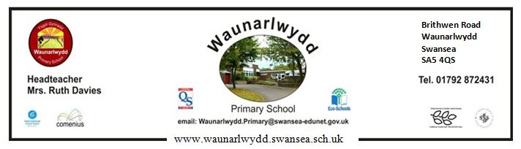
4th February 2019
Breakfast Club
Dear Parent,
Please find attached your booking form for Breakfast Club for the first half of the Spring term. We will continue to provide a Breakfast Club from 7.50am to 8.50am at a charge of £1 per session to be paid half termly in advance. Children should arrive at school by 8.30am to receive a breakfast.
Breakfast Club is free for children whose parents are in receipt of free school meals. The booking form should still be completed so we can organise staff.
As we need to organise staffing well in advance, payment must be made for a full half term and received at school by the required date in order to use the service.
The cost of using the Breakfast Club every day during the next half term (4th March – 11th April) will be £29. Parents have the option of paying for up to 5 days per week for the full half term. (Payment for additional days may not be made an ad hoc basis)
If you wish to use the school’s Breakfast Club facility for the next half term, please make your payment by Friday, 15th February online via sQuid – School Pay.

