St Joseph's Catholic Junior School
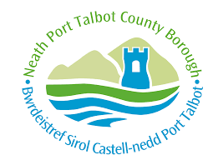
Headteacher: Mrs C May B.A. (Hons), PGDE, NPQH
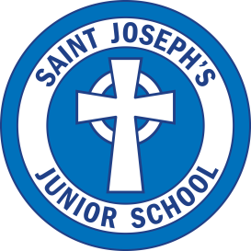
Deputy Headteacher: Mrs A Brady Saunders
Nobel Avenue
Port Talbot
SA12 6YN
Tel: 01639 769743

e-mail stjosephsjunior@npt.school
http://st-josephs-catholic-junior-school2.j2bloggy.com/

Live Sessions Safeguarding Protocols

‘Live sessions’ may be offered by staff where they feel it is appropriate to use to deliver materials for distance learning. There has been a number of guidance documents released by the Welsh Government and Local Authority to support schools and teachers in delivering these aspects safely.

The document below summarises the current guidance released by or included in:
- Welsh Government
- Neath Port Talbot Local Authority Education Safeguarding Officer
- St Joseph’s Safeguarding and Child Protection Policy

The Welsh Government released an update to previous guidance that was originally issued in May 2020 that reflects a change to enable decision-making at a school level about the most appropriate approach to live-streaming or video-conferencing. The section which had previously outlined numbers of practitioners required for live-streaming has been removed to enable this local decision-making. In developing their approach to live-streaming and video-conferencing, the updated guidance asserts that schools must undertake a risk assessment and review their safeguarding processes and procedures (including reporting mechanisms) to ensure the safety and security of their learners and staff.

The expectations below form the risk assessment for live-streaming and video-conferencing during distance learning:

Teachers must:
- ensure a professional manner is maintained at all times (including appropriate appearance).
- only conduct a ‘live-stream’ lesson using a school issued device and via Microsoft Teams.
- be aware of the background they are using. This could be a virtual background, blurred background or plain wall.
- only use approved channels to communicate with students (Teams, e-mail, approved social media use).
- ensure that, if streaming from home, any other members of the household are aware of the sessions and are not present during live sessions.
- Remove any inappropriate or disruptive pupils immediately from a call if necessary and follow up the incident as they would in a classroom – the pupil’s parents are to be notified at the end of the session. Both members of staff are authorised to remove pupils immediately as required.
- Prevent a one-to-one situation at the end of an online class by disconnecting all participants at the close of the lesson/session.
- Discuss any queries or concerns about the running of the sessions with senior leaders prior to the next session.
- Report any safeguarding concerns to the Designated Safeguarding Lead.
- Ensure that they keep themselves up-to-date with all relevant policies and procedures, including online safety, safeguarding and data protection policies.
- Teachers are able and allowed to record any sessions they wish as long as all participants are informed of this before recording begins.

Teachers are able to use their camera (switched on) and microphone during the live-sessions following the updated Welsh Government and LA advice. This is a matter for teacher choice and preference.

Students should agree to:
- be punctual for all sessions.
- make sure they have all power adaptors and laptops/devices ready.
- show respect for everyone in the online classroom. This includes muting audio when not speaking and using the ‘raised hand’ feature to seek attention.
- seek to contribute to the class in a positive manner and not be disruptive at any time.
- not share images of the class.
- Not have distractions such as pets, other siblings in the frame.
- Not use any other device at the same time e.g. a mobile phone or other tablet.

Parents and other family members are not permitted to participate in the live session, but may assist their child with any technology issues.

