Campaign seeks to unite a million children in praying the Rosary

21

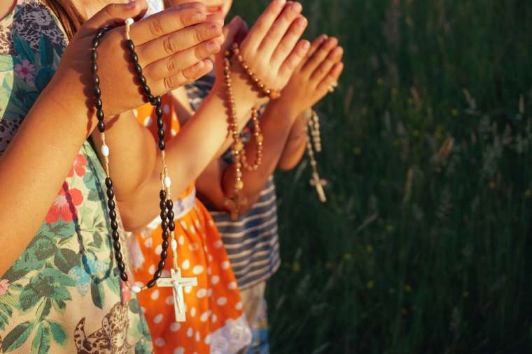

Last Sunday Pope Francis invited children to participate together in a very special initiative. A Catholic charity hopes to bring together a million children worldwide to pray the rosary this Sunday.
Aid to the Church in Need (ACN) is seeking to unite the children Oct. 18 in praying for peace and the end of the coronavirus pandemic, which has killed more than a million people around the world.
A spokeswoman for ACN International said that the “One Million Children Praying the Rosary” campaign was “going very well.”
She said that in the past week alone almost 75,000 more people had registered their intention to join in the event on the official website.
She added that ACN had sent information about the prayer initiative to 80 countries in 23 languages. She highlighted an online map that shows that children from Iceland to New Zealand have registered to take part. Many people who were preparing to join in had not yet registered on the website, she explained.
Pope Francis offered his support for the event after the Angelus last Sunday: “Next Sunday, Oct. 18, the Aid to the Church in Need Foundation promotes the ‘One Million Children Praying the Rosary’ campaign for unity and peace. I encourage this beautiful event that involves children throughout the world, who will pray especially for critical situations caused by the pandemic.”
Imagine what would happen if one million children asked for the same thing at the same time. We want peace! This initiative began in 2005 in Caracas. They wanted to follow Padre Pio's advice. He used to say that “when one million children pray the rosary, the world will change.” Since 2008, ACN has been promoting the initiative all over the world.
Thousands of children have already signed up on the rosary's official website, millionkidspraying.org. As the map shows, participants are spread across all continents. Children can join together on Sunday, Oct. 18, from their parishes or homes, and Monday, Oct. 19 from school. The official website provides downloadable resources for that day, including instructions on how to pray the rosary; drawings and reflections. These materials can also be requested at the foundation's national offices.

