Ein Cwricwlwm Newydd – New National Curriculum for Wales
The New National Curriculum for Wales launched on 28th January 2020 and will be statutory from September 2022 with schools preparing and making implementations over the next 2 years.
For more information – https://hwb.gov.wales/curriculum-for-wales

New Curriculum for Wales – https://www.youtube.com/watch?v=9U0fsT0gH7U
https://www.youtube.com/watch?v=0jEaastz224&t=14s

Why is the curriculum changing?
- Essential features of our curriculum devised in 1988 do
not reflect our world of technology and globalisation.
- Relatively low performance in PISA surveys.
- Perceived shortcomings in the current curriculum and assessment arrangements.
- The perception of highly prescriptive content allied to increasingly powerful accountability mechanisms has diminished the creative role of schools and professionals

What were the key recommendations from Successful Futures?
- Four purposes of the curriculum.
- Six areas of learning and experience.
- Three cross-curricular responsibilities.
- Progression steps at ages 5, 8, 11, 14 and 16.
- Achievement outcomes.
- A range of pedagogical approaches.
- Refocusing assessment on learning, including learners’ self- and peer-assessment.
- Monitoring performance of the system at a national level through annual sampling.
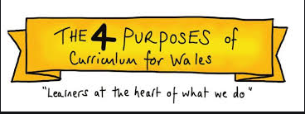
The purpose of the new curriculum is to support our children and young people to be:
- ambitious, capable learners, ready to learn throughout their lives
- enterprising, creative contributors, ready to play a full part in life and work
- ethical, informed citizens of Wales and the world
- healthy, confident individuals, ready to lead fulfilling lives as valued members of society.

The new curriculum is:
- a purpose-led curriculum – the four purposes are the heart of curriculum development at a national and local level
- organised as a continuum of learning from ages 3 to 16 – all children and young people will make progress along the same continuum
- organised around progression steps, articulated as achievement outcomes
- inclusive of the three cross-curricular responsibilities
- the basis for thinking of the 14–16 phase, qualifications and beyond.

Our new curriculum will not be:
- overly prescriptive or specific; it will not dictate time allocations for areas of learning and experience, subjects or disciplines driven by content coverage, defining detailed inputs for learners or groups of learners
- biased towards either knowledge or skills; it has been developed to allow schools to provide a balance of knowledge, skills and experiences

- based upon programmes of study; subjects and disciplines will work as parts of the areas of learning and experience to ensure that meaningful links are made.

Progression (of learning)
- Progression should be described along a continuum of learning in each area of learning and experience.
- It is formative and involves the learner actively in the process.
- Curriculum, assessment and pedagogy are seen as parts of an integrated whole.
- The model has been developed based upon research and evidence alongside the CAMAU project.
- Progression of learning is described through achievement outcomes at five steps on the continuum.
- Progression steps relate broadly to expectations at ages 5, 8, 11, 14 and 16.
- Progression steps should be reference points, providing a ‘road map’ for each individual learner’s progress in their learning, not universal expectations of their performance at fixed points.
- Authentic learning opportunities that connect aspects of the curriculum and make connections to ‘everyday life’.
- Achievement outcomes are not to be used directly for assessment. They should be used:
– for school-level and class- level curriculum design, development and planning
– to support practitioners’ understanding of moving learning forward.

Areas of learning and experience
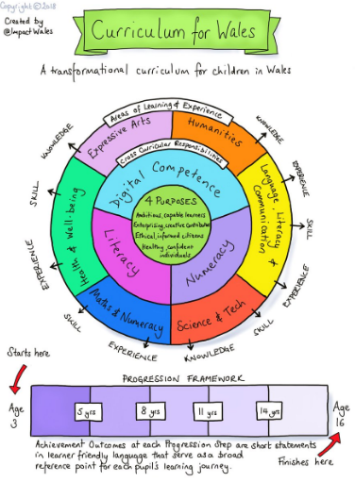
Each area of learning and experience is organised into a suite of what matters statements which prioritise the important concepts about which learners must have experiences, knowledge and skills
Achievement outcomes
- Described from the learner’s perspective, using terms like ‘I can … ’ or ‘I have … ’.
- Describe the broad knowledge, competency or experience a learner needs to gain.
- Should contribute clearly to the four purposes of the curriculum and have emphasis on achievement in a broad sense, rather than narrow measures of assessment.
- Allow learners to make progress along the same continuum, regardless of any additional learning needs they might have, though they may move between progression steps at a different pace.
- Should be used as the basis to build assessment approaches,
e.g. formative, summative, self, peer, portfolio.
- Should provide agency for professionals in developing curriculum and helping learners realise the achievement outcome

Achievement outcomes are not:
- narrow measures of attainment
- qualification specifications
- granular learning objectives
- shallow descriptions of content
- criteria for a single assessment piece.

What can you do now?
- Begin to explore the areas of learning and experience in detail – available online at hwb.gov.wales
- Follow the Curriculum for Wales blog at https://curriculumforwales.gov.wales
- Inform parents/carers about the ‘Education is changing’ website at https://beta.gov.wales/education-changing
- Follow #educationreformwales on Twitter.

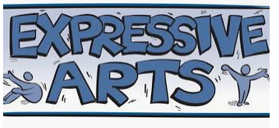
Vision and philosophy
- Allow the space for all learners to be creative.
- Make the offer fully inclusive.
- Link to positive health and well-being outcomes.
- Ensure that Expressive Arts skills are recognised
as transferable and that they have a direct link to careers and lifelong learning.
The rationale for change
- An arts-rich education is core to the whole-school experience of a learner.
- All learners need to have access to rich contexts in which they have time to explore, to respond and to create.
- Learners need access to all Expressive Arts disciplines.
How is it different?
- It encompasses dance, drama, film and digital media, music, and visual arts linked by a common creative process and transferable skills.
- Learning is linked through the creative process enabling a deeper understanding of individual disciplines to be developed.
- Progression is not linear.
- A focus on rich, authentic contexts for learning runs from ages 3 to 16.
- Learner voice is encouraged.
- Collaboration across the area of learning and experience and across other areas of learning and experience.
- Flexibility – variety of delivery models.

What Matters in Expressive Arts?
- Exploration through and of the Expressive Arts deepens our artistic knowledge and contributes to our understanding of identities, cultures and societies.
- Responding and reflecting, both as artist and audience,
is a fundamental part of learning about and through the Expressive Arts.
- Creative work combines knowledge and skills using the senses, inspiration and imagination.

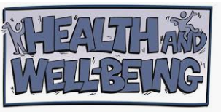
Vision and philosophy
- Designed to equip learners to lead healthy, fulfilling and productive lives.
- Enables successful learning and fulfilling relationships.
- Focuses on the physical, psychological, emotional and social aspects of our lives.
- A holistic approach to help schools address their priority areas.

The rationale for change
- Aligns with the Well-being of Future Generations (Wales) Act 2015.
- Education on mental, emotional and physical health needs to be more integrated – growing challenges.
- Current provision is inconsistent.
- Supporting and developing the health and well-being of all learners in Wales cannot be left to chance

How is it different?
- Holistic – Health and Well-being is an area of learning and experience but should be everyone’s responsibility.
- Experiences, knowledge and skills that lead to healthy and active lifestyles.
- Supports physical and mental health.
- Develops learners so they engage in lifelong physical activity.
- Must reflect local needs as well as national and global issues.

What Matters in Health and Well-being?
- Developing physical health and well-being has lifelong benefits.
- How we process and respond to our experiences affects our mental health and emotional well-being.
- Our decision-making impacts on the quality of our lives and the lives of others.
- How we engage with different social influences shapes who we are and our health and well-being.
- Healthy relationships are fundamental to our sense of belonging and well-being.

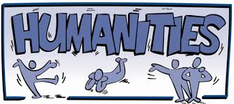
Vision and philosophy
- Encompasses history, geography, religious education, business studies and social studies.
- Holistic, integrated and interdisciplinary approach.
- Rigour and specialisation at Progression step 5 prepares learners for further studies.
- Develops a sense of heritage and place through their cynefin, Wales and as part of the wider world.
- Encompasses past, present and future, including the role of learners as citizens.

The rationale for change
- Autonomy, flexibility and creativity leads to authentic learning.
- Interdisciplinary approach supports development of knowledge and skills.
- Connecting experiences, knowledge and skills brings rich opportunities.
- Incorporates business and social studies.
- Religious education in the curriculum allows for parity

How is it different?
- Holistic and interdisciplinary.
- Disciplines more visible from Progression step 4.
- Greater importance on authentic experiences.
- Focus on global citizenship and participating in social action.
- Earlier engagement with business studies and social studies.
- Balance between local, Welsh/British and global studies.
- Religious education included and statutory for learners aged 3 to 16.
What Matters in Humanities?
These what matters statements are linked and are not intended to be taken in isolation.
- Developing an enquiring mind enables learners to explore and investigate the world, past, present and future, for themselves.
- Events and human experiences are complex and perceived, interpreted and represented in different ways.
- Our natural world is diverse and dynamic, influenced by physical processes and human actions.
- Human societies are complex and diverse, and are shaped by human actions and beliefs.
- Informed, self-aware citizens engage with the challenges and opportunities that face humanity, and are able to take considered, ethical and sustainable action.
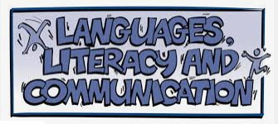
Vision and philosophy
- A celebration of languages and cultures, embracing a bilingual Wales in an international context.
- Bringing together Welsh, English and international languages and literature for all.
- Develop ambitious, capable and confident language learners who communicate effectively using both Welsh and English as well as international languages across a variety of media.
- Stimulated learners developing knowledge, skills, positive attitudes and motivation through meaningful contexts.
The rationale for change
- The citizens of modern Wales speak various languages reflecting diverse cultures; we want to celebrate and build on this.

- Exploring identities and cultures through languages can connect learners with people, places and communities in bilingual Wales and the multilingual world.
- Reverse the decline of modern foreign languages through positive, motivating experiences at a young age.
- Language skill sets promote understanding and development in all languages.
- Remove artificial distinction between Welsh and Welsh second language so all learners are able to use Welsh as per the four purposes of the curriculum.
- Differentiated achievement outcomes reflect the different pace and depth of learning, allowing learners and teachers to recognise progression pathways.
How is it different?
- Focus on the importance of learning about languages, and the way they relate and reflect our cultures and identities.
- By the end of primary school, learners will experience different languages and make progress in Welsh, English and at least one international language.
- When learners leave school, they will be able to use Welsh, English and their other languages in a meaningful way.
- Oracy, reading and writing have equal prominence.
- Literature for all learners: opportunities to explore and create a range of literature in Welsh, English and international languages.

What Matters in Languages, Literacy and Communication?
- Learning about identity and culture through languages prepares learners to be citizens of Wales and the world.
- Learners who listen and read effectively are prepared to learn throughout their lives.
- Learners who speak and write effectively are prepared to play a full part in life and work.
- Literature fires imaginations and inspires creativity

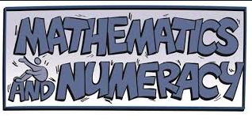
Vision and philosophy
- Mathematics is a critical part of life and for the country’s economy.
- Mathematics and numeracy experiences must be engaging, exciting and accessible, as well as challenging.
- To develop mathematical proficiencies, positive dispositions and the four purposes of the curriculum.
The rationale for change
- Research about mathematics performance: – Estyn– international – PISA.
- Too much reliance on procedural fluency (technique/tricks).
- Not enough conceptual understanding

How is it different?
- Organised around five mathematical proficiencies.
- Gives learners opportunities to use manipulatives and represent concepts in a variety of ways.
- Use verbs such as ‘explore’ and ‘derive’ to ensure balance between ‘breadth’ and ‘depth’.

Mathematical proficiencies
These inter-dependent proficiencies used in developing the descriptions of learning are central to progression at each stage of mathematics learning. Numeracy involves applying and connecting these proficiencies in a range of real-life contexts. The five mathematical proficiencies are:
- conceptual understanding
- fluency
- communication with symbols
- logical reasoning
- strategic competence.
A change in emphasis from ‘What’ to ‘What and How’ will influence pedagogy and result in teaching for conceptual understanding

What Matters in Mathematics and Numeracy?
- Learners will discover that the number system is used to represent and compare relationships between numbers and quantities.
- Learners will come to appreciate how algebra uses symbol systems to express the structures of relationships between numbers, quantities and relations.
- Learners will come to understand that geometry focuses on relationships involving properties of shape, space, and position, and that measurement focuses on quantifying phenomena in the physical world.
- Learners will see that statistics represent data, probability models chance, and that both support informed inferences and decisions

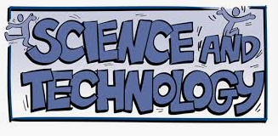
Vision and philosophy
- Science and technology are intrinsically linked, and includes design and technology, engineering, computer science, biology, chemistry and physics.
- Science and Technology demands a coherent framework for learning across traditional domains, reflecting real-world needs.
- The underlying concepts of science and computational thinking enable technological advancement.
- Science and Technology supports progression in and across subject specialisms, and prepares learners to use science and technology in their every day lives.
The rationale for change
- Boundaries of science and technology are continuously changing.
- Economic imperative – huge opportunities for learners.
- Need for learners to meet twenty-first century challenges and opportunities irrespective of career choice.
- Current learner preparation insufficient to meet needs.
- Need knowledge and skills – contextualised through experiences.
- Need creators of and through technology, not just competent users – hence conceptual understanding of computation.
How is it different?
- Computation is a new element for ages 3 to 16.
- Guided learner-led approaches and ‘thematic’ learning.
- Better balance between knowledge acquisition and skills development through real-world learning experiences.
- Likely to require a multidisciplinary approach.
- More seamless transitions – with greater clarity over prior learning and next steps.
- Outdoor learning to enhance the learning experience.
- Emphasis on the impacts of science and technology on learners’ lives and the environment.

What Matters in Science and Technology?
- Being curious and searching for answers helps further our understanding of the natural world and helps society progress.
- Design thinking and engineering are technical and creative endeavours intended to meet society’s needs and wants.
- The world around us is full of living things which depend on each other for survival.
- Understanding the atomic nature of matter and how it shapes the world.
- Forces and energy determine the structure and dynamics of the Universe.
- Computation applies algorithms to data in order to solve real-world problems.

