

Tonnau Primary Community School

Prospectus 2017-2018

Tonnau Primary Community School is housed in two separate buildings connected by a link path. The older building has the pupils from Nursery to Year 2, whilst the newer building has two semi-open plan teaching areas for the Years 3, 4, 5 and 6 pupils. This building also has the main school hall, used by all pupils for assemblies, P.E., drama and indoor games as well as for mid-day sandwiches or school lunch –which is cooked on the premises. The hall in the older building has been adapted to provide a range of teaching and learning activities, and is also used for infant assemblies. The Nursery has its own enclosed outdoor playing area, with a range of play equipment.

We are always looking to develop the fabric of our buildings and work closely with LEA contractors whenever finances allow. We are fortunate to have a hard working PTA and close links with the Community Council who provide us with access to funding we would otherwise not have.

The school has extensive, open surroundings which provide ample opportunity for quality provision. The Community Council has also used our grounds to build a Multi Use Games Area; again extending the experiences available to our pupils.

As the main focus for community activities many pupils return to the school in the evenings for Rainbows and Brownies, whilst their parents, grandparents or great grandparents could be in school in the evenings as members of the Tonna Male Voice Choir.

The school has strong links within the community. We often support and participate in activities with Tonna Hospital, St. Anne’s Church as well as Noddfa Newydd Chapel.
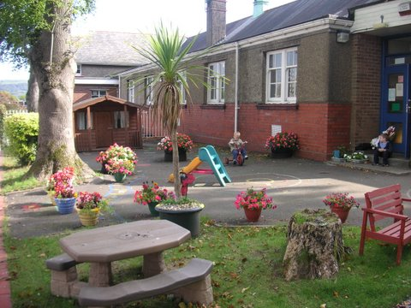


TONNAU PRIMARY COMMUNITY SCHOOL
GOVERNING BODY 589

Composition: September 2017
Clerk to the Governing Body – Mr. Peter White, 32 Heol Caredig, Tonna, Neath

Mrs. J. Francis (Chair) | L.E.A
Cllr. W Walters (Vice Chair) | Community
Vacant | L.E.A
Mrs. T. Irons | Co-opted
Mr T. Walters | Co-opted
Vacant | Co-opted
Cllr. S. Radford | Minor Authority
Vacant (election taking place now) | Parent
Mrs. R. Brown | Parent
Mr. M. Jones  Mrs. S. Owen | Parent  Parent
Mrs N Richards | Teacher Representative
Mrs. D. Evans | Non-Teaching Staff Representative
Mr L Jones | Headteacher
Mr. J. Gould | L.E.A Link


Neath Port Talbot County Borough Council
Cyngor Bwrdeistref Sirol Castell-nedd Port Talbot

Tonnau Primary Community School
YSGOL GYNRADD GYMUNEDOL TONNAU
Headteacher: Mr L Jones
Deputy Headteacher: Mrs N Richards

Tel: [01639] 637062 School Road, Fax: [01639] 638302 Tonna,
NEATH
SA11 3EJ
SA11 3EJ

Chair of Governors: Mrs. J. Francis

Staff

Mrs. R. Elias Teacher
Mrs. O. Weir Teacher
Mr. J. Hopkins Teacher
Mrs N Richards Deputy Headteacher
Mrs E. Griffiths Teacher
Mrs. J. Harris Teacher
Miss K. Clement Teacher
Mrs. N. Slee NNEB
Mrs. J. Jones Secretary
Mrs. B. Gwynne Secretary
Mrs. C. Cockwell HLTA / Lunchtime Supervisor
Mrs. D. Evans Learning Support Assistant / Lunchtime Supervisor
Mrs. R. Kethro HLTA / Lunchtime Supervisor
Mrs. E. Dutton Learning Support Assistant / Lunchtime Supervisor
Mrs. J. McKibben Learning Support Assistant / Lunchtime Supervisor
Mrs. L. Llewellyn Learning Support Assistant
Mrs. P. Afroz Learning Support Assistant/ Lunchtime Supervisor
Mrs. E. Evans Learning support, 1:1
Mr. F. Thomas Caretaker/ Cleaner
Lunchtime Supervisors. Mrs. H. Loaring, Mrs. R. Trehare, Mrs. P. Donaghue, Mrs. P.Crawley
Mrs. D. Al-Barwani Cook
Mrs. H. Harry Assistant Cook

SCHOOL AIMS, ETHOS AND VALUES

The school’s main aim is building self-motivated lifelong learners.

We are aware of the importance of providing a stimulating learning environment and the use of high quality displays, including pupils’ work, helps to create the correct ambience. The ethos of the school is very important and we strive to ensure that all pupils are happy, courteous and well mannered. Good relationships exist between each other and with all school staff.

The continuous development of our school is built around the strength of the team, with each member of the school community as a valued contributor.

Our vision for Tonnau Primary School can be summarised in the following statement:

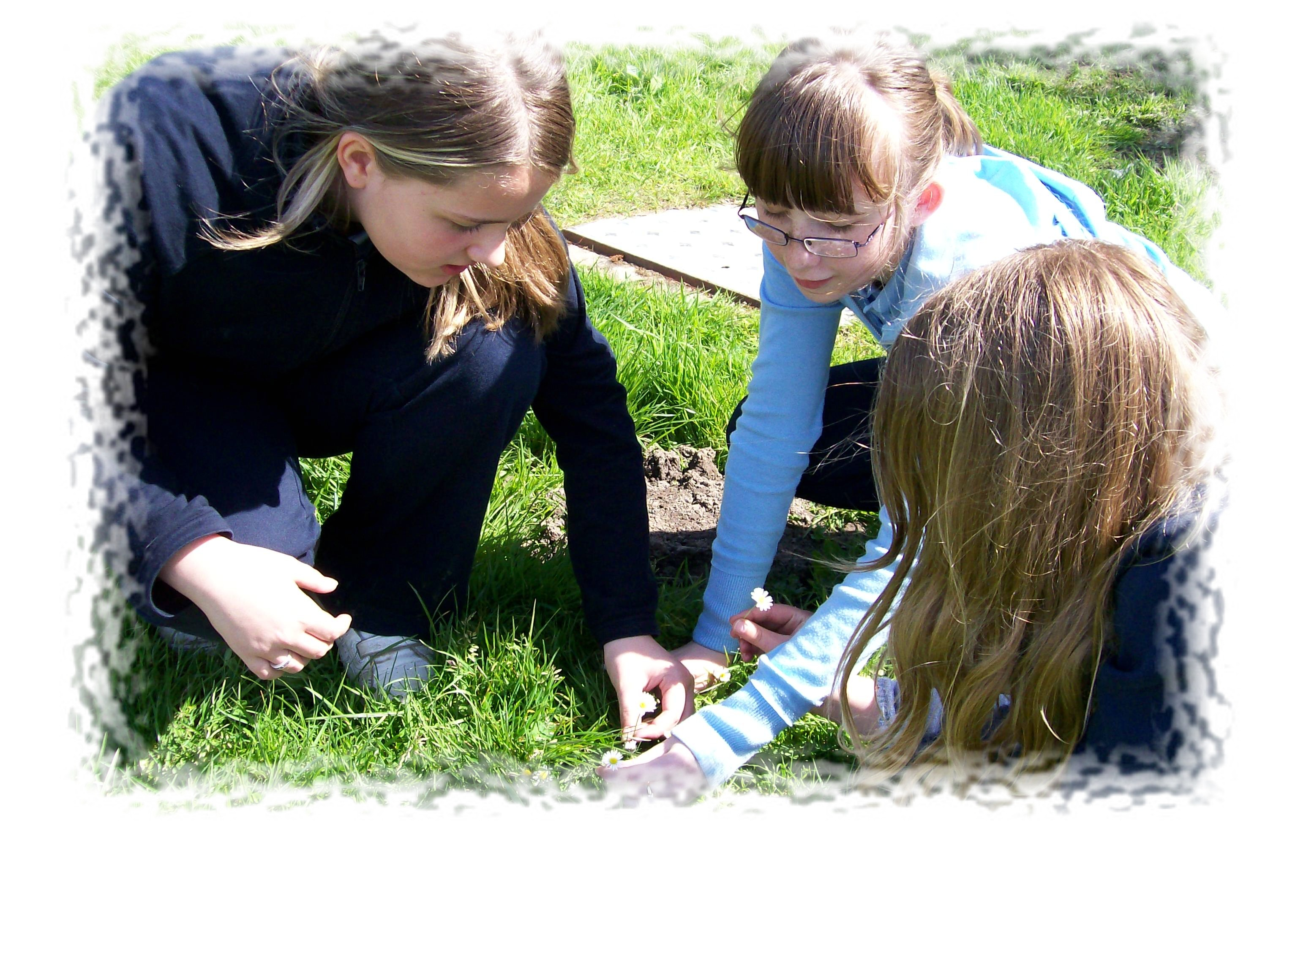
“We want our children to develop a positive attitude to learning by providing an experienced based approach whereby pupils acquire the knowledge and skills required to reach their full potential, in an ever-changing technological society. We expect self-discipline and self-reliance so that our children can work independently as well as in co-operation with others. We aim to create a happy, stimulating and challenging environment where our children can grow in caring surroundings, learning respect and tolerance for other people and their property”.

Our commitment to the vision statement means that we hope:

- To develop the whole child – academically, physically, spiritually and morally, by providing a happy, secure environment in which our children can learn important life skills.
- To involve our pupils as part of the learning process rather than being a product of the process.
- To help our pupils to become more confident, articulate and able to communicate and empathise with others.
- To empower our pupils by becoming literate, numerate and technologically able to function effectively in the twenty-first century
- To actively seek to raise all standards and be part of an on going self-evaluation process.
- To give pupils a strong sense of their own cultural identity whilst being aware of, and respectful towards, other diverse communities, locally and world wide.
- To develop good citizens who grow up to lead safe and interesting lives and make a positive contribution to society
- To cultivate a climate of success for all children, celebrating their achievements, in all aspects of their lives.

SCHOOL ORGANISATION
Classes are organised for 2018-2019 in the following groups:

Nursery
Reception/Year 1
Year 1/Year 2
Year 2/Year 3
Year 3/Year 4
Year 4/Year 5
Year 6

GENERAL SCHOOL CURRICULUM

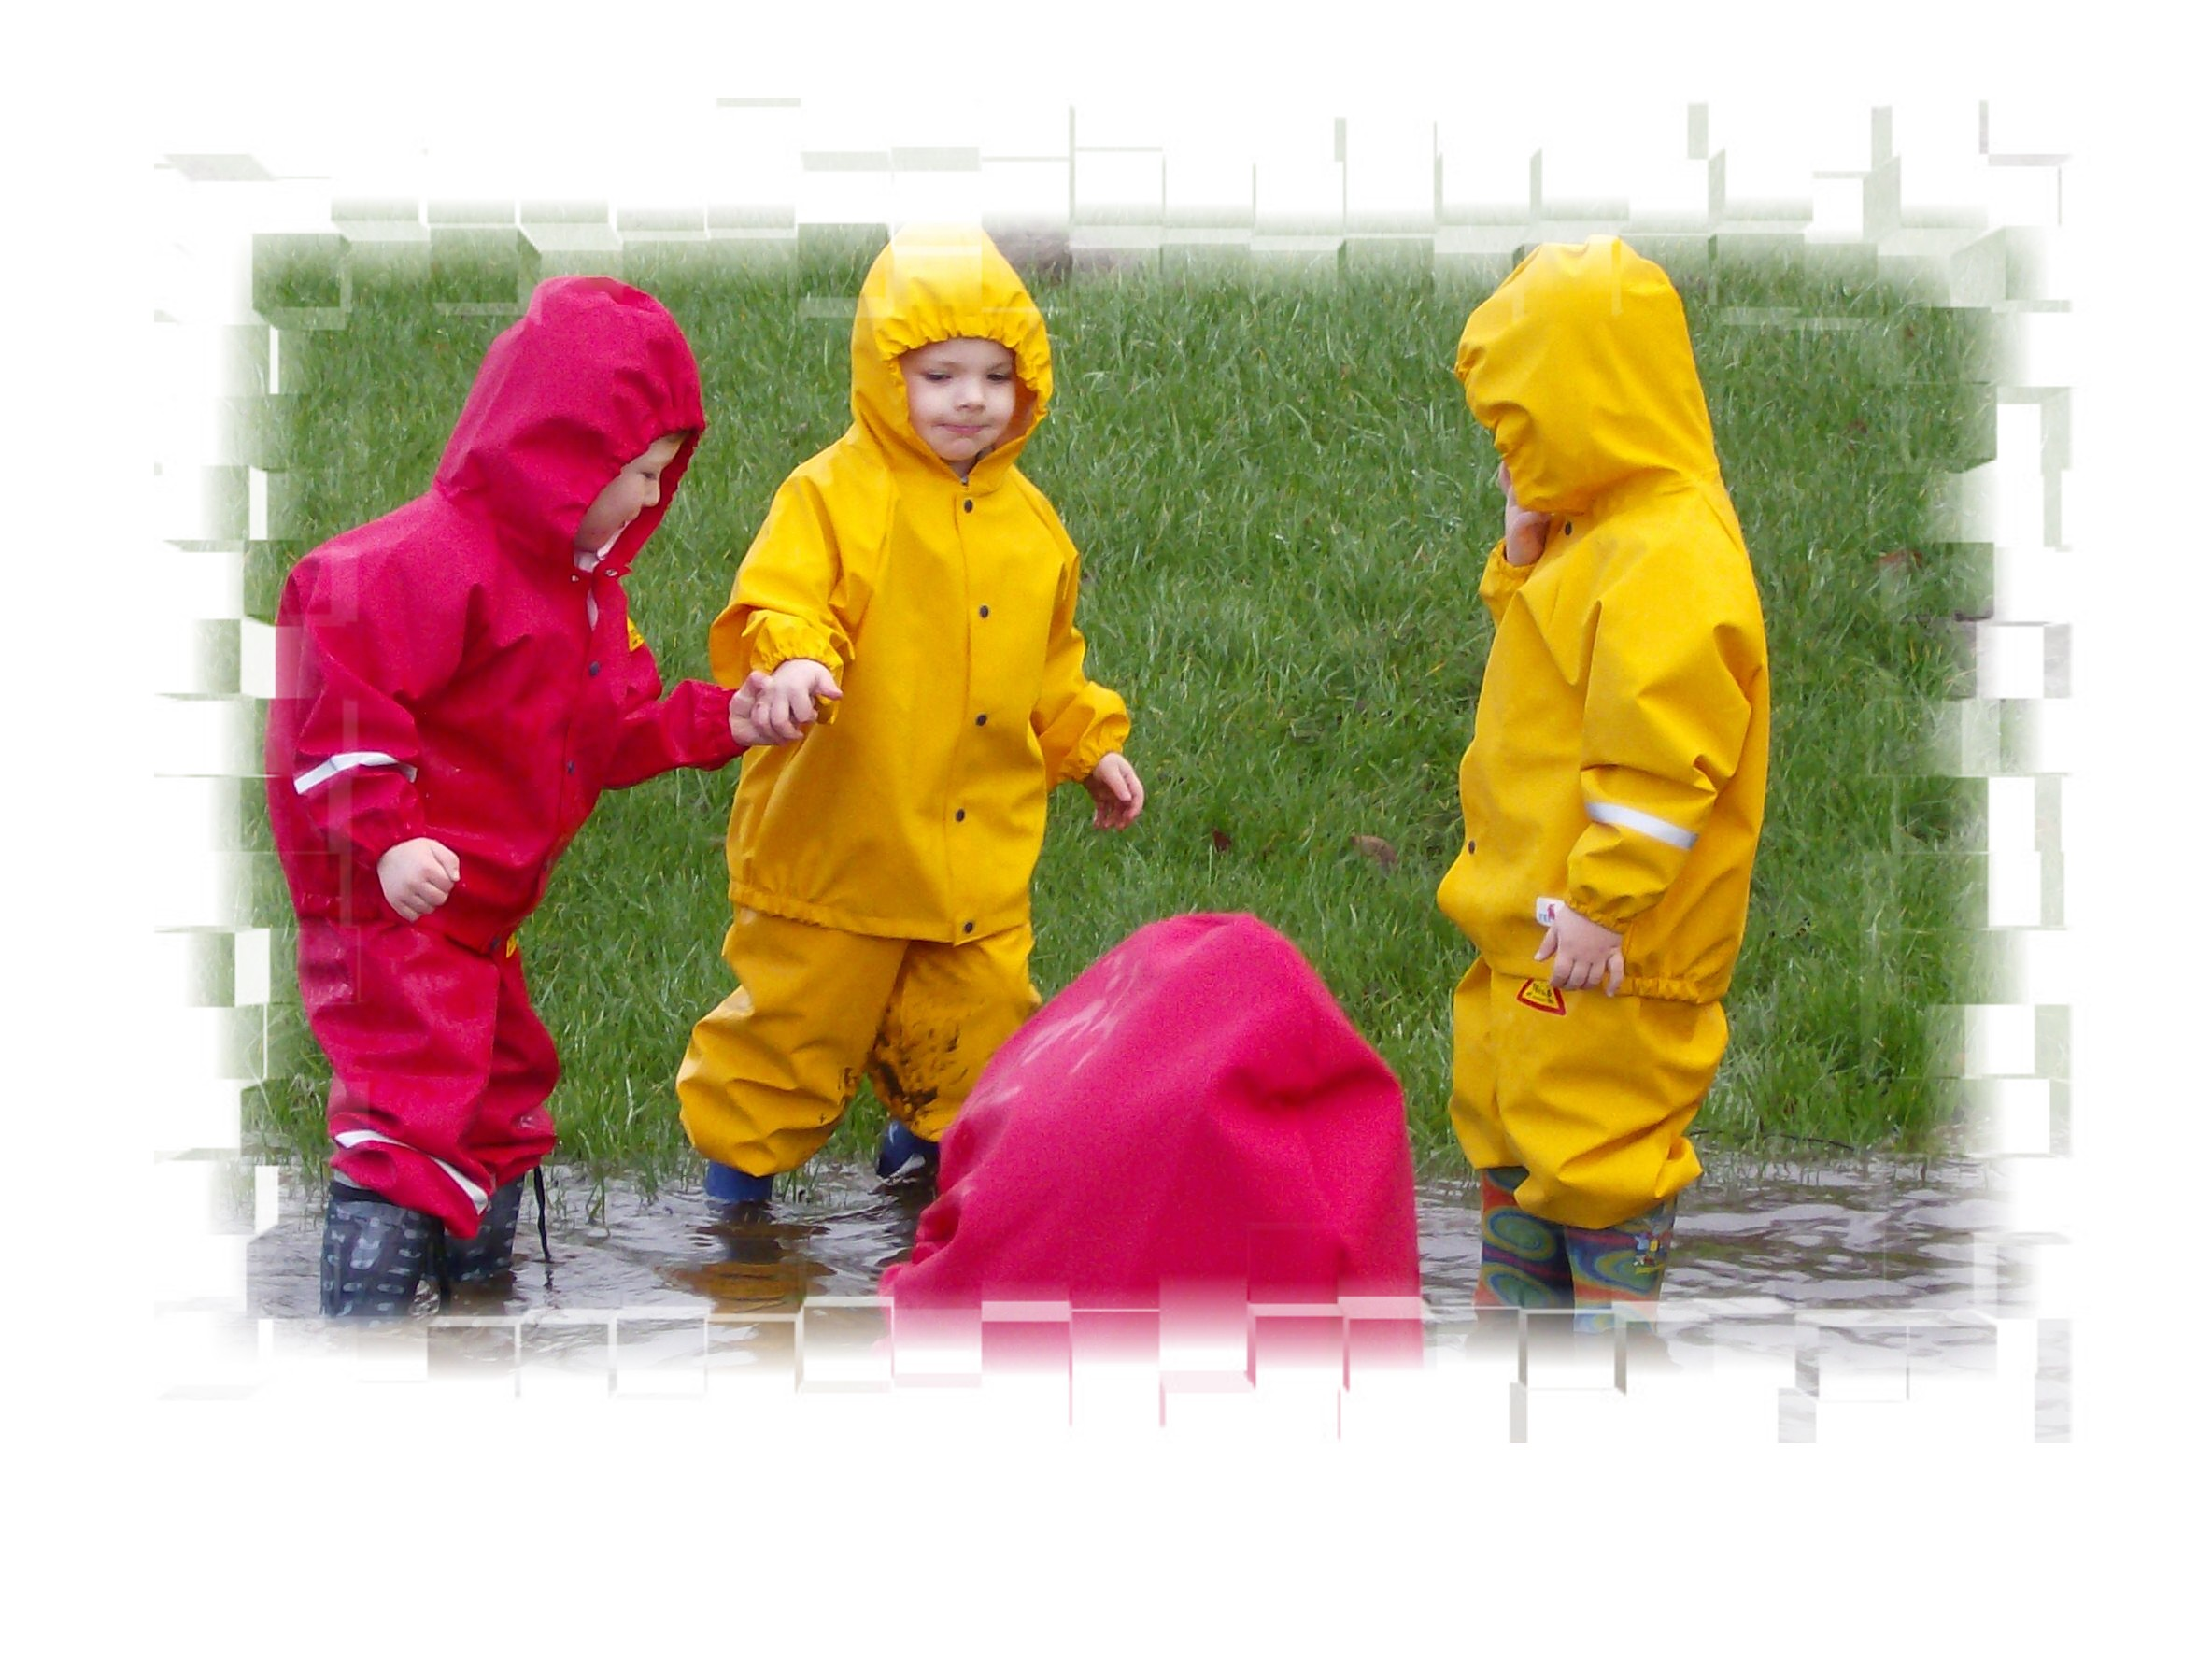
The school operates a broad curriculum. Our Nursery, Reception and Year 1 and Year 2 classes implement The Foundation Phase, following LEA advice and best practice. All other children follow the National Curriculum (copies of which maybe obtained from HMSO Books) in accordance with school and LEA policies. The Literacy and Numeracy Framework also influences our classroom work. Schemes of work are available for inspection by arrangement.

Pupils are taught to read through a variety of strategies, including our use of the Read, Write Inc. scheme. We encourage our children to use their reading as a pathway to greater knowledge and to develop a joy of reading for pleasure. Pupils are shown how to write, to spell, to use correct grammar and sentence structure. We support children to express themselves articulately, clearly, logically and with the confidence to express their opinions to others.

A variety of resources and techniques will be employed in developing the children’s confidence and competence in mathematics, science and technology. Geography and history are taught in accordance with the programmes of study in the National Curriculum, supplemented by environmental studies to make children more aware of their place in the world. The study of the culture of Wales with its particular history will be in addition to the teaching of Welsh as a second language to all classes. Religious Education follows local and national policies, as does Personal Social & Health Education and Citizenship. From an early age children work with Art and Craft, and Design Technology, whilst Music is taught in a variety of contexts including classroom practical work and group work ranging from action songs in the Nursery to whole school musical productions for parents and the community.

Physical Education is taught throughout the school and pupils are encouraged to participate and enjoy. PE lessons are held indoors or outdoors depending on weather conditions. Swimming is provided by the local pool and we make use of this provision as often as we can. It is the responsibility of parents to notify the school if for any reason their child should not take part, or may need specific medical conditions taken into account. All children will be expected to change for their P.E. and Games lessons. It is expected that all children’s clothes and footwear will be marked with the child’s name and, for obvious reasons, that the younger children will only wear shoes with fastenings that they are able to use themselves.
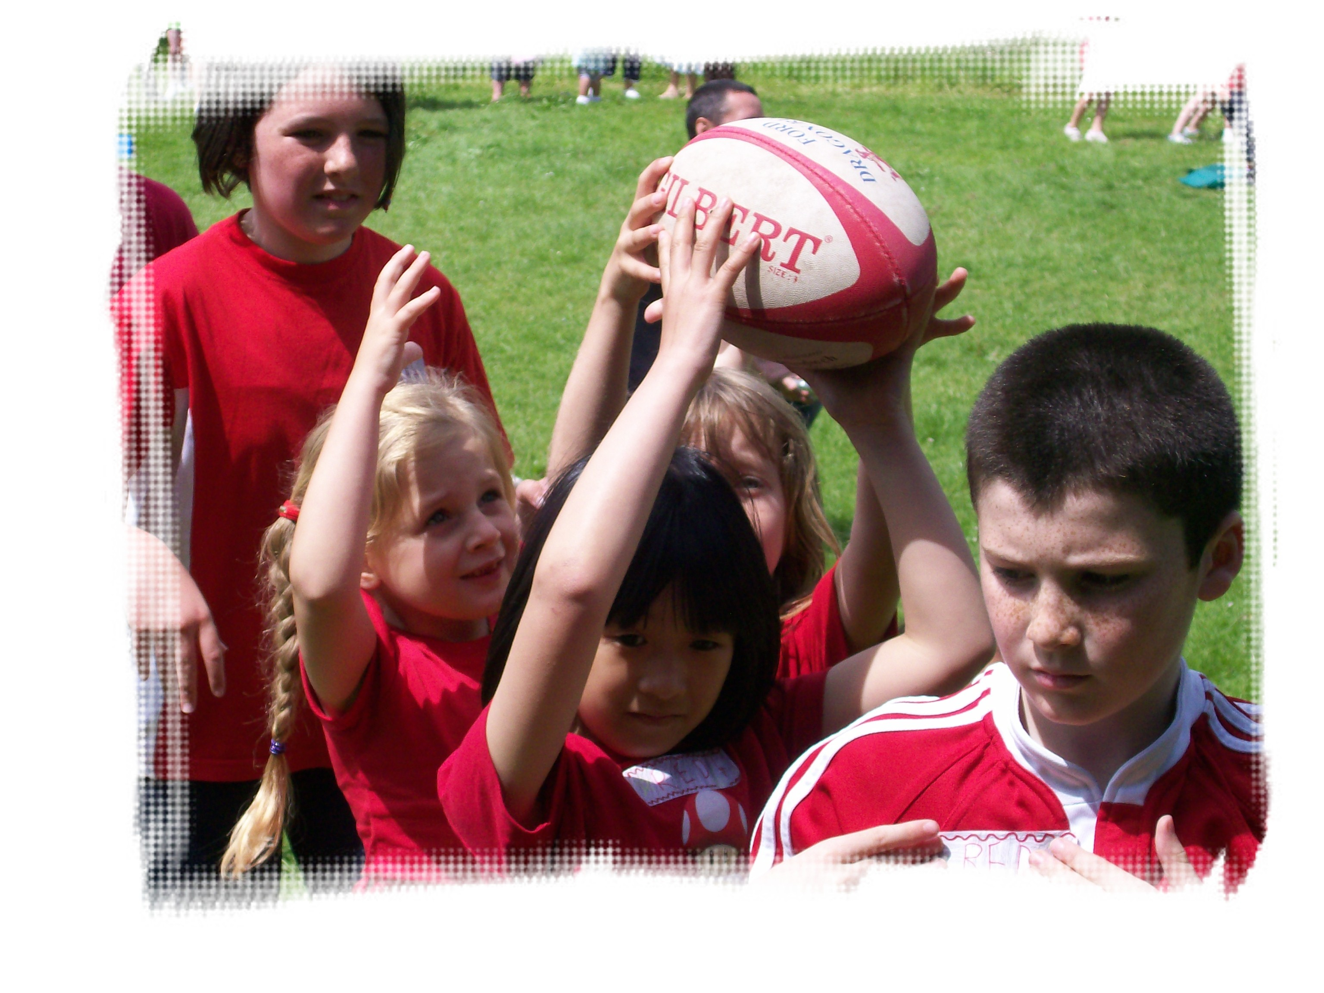
The school has a wide range of technical construction apparatus, enabling pupils to design, solve problems and talk about their ideas. Each classroom from Nursery to Year 6 has at least one computer system with multimedia facilities and broadband Internet access. Each classroom has its own Interactive Whiteboard. All classes have access to a set of i-pads and portable laptops. The school has a very wide range of software available to underpin the whole curriculum as well as continuous access to educational websites on the Internet.

Pupils are assessed regularly throughout the year as they work through the curriculum. Parents are informed of their child’s progress through the National Curriculum during Parents’ Evenings and in an annual school report.

SCHOOL DISCIPLINE

Children are encouraged to develop self-discipline. The calm, supportive atmosphere within our school is one of our main strengths and means that in 99% of cases a discussion resolves any issues we may have. However more serious punishment is usually through the loss of privilege. Parents would be informed where a child fails to respond to the school’s own measures and would be invited to work with the school for a positive resolution.

Personal Property
We do all we can to safeguard children’s possessions although we cannot take responsibility. Children bring equipment on to the premises at their own risk.
Jewellery: Children are not allowed to bring valuables or jewellery to school; watches are permitted conditionally and only at the child’s own risk. In line with other schools, earrings are not permitted except for stud or “sleeper” types. For health and safety reasons no jewellery can be worn during PE.
Money: The children will need to bring money to school regularly e.g. dinner money, trip money etc. Please ensure it is in an envelope clearly marked with the child’s name and class. No other money should be brought to school.
Clothing and equipment: Please mark all items clearly. Unclaimed belongings are kept in a ‘lost property’ collection. High heel shoes are unacceptable footwear for school, and clothing and hairstyles must be suitable for a classroom environment. Chewing gum is not allowed on the premises, nor are children to bring aerosol deodorants or Tippex fluids.
Mobile telephones: No mobile ‘phones should be brought to school. If a child needs to contact parents/family provision will be made to use the office telephone.

ATTENDANCE
Attendance at school is compulsory. Parents are asked to notify the school as soon as possible with the reason for an absence. Absences due to illness, medical appointments or other unavoidable reasons will be authorised on receipt of a letter explaining the situation. Any pupils with an attendance below an acceptable value are investigated by our Education Welfare Officer and a home visit maybe undertaken. Attendance in 2017-2018 was 94.6%.

EXTRA-CURRICULAR ACTIVITIES AND PARENTAL LIAISON

Parents and other members of the community are encouraged to take an active role in the life of the school, and do. At present parents and ex-parents help regularly in a variety of ways, including the preparation of materials, helping with cookery and taking groups for art/craft work. If you have any skills to offer and would like to help us here in school, please let us know.
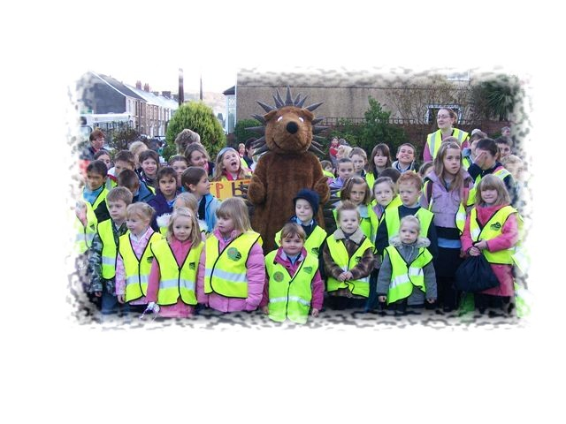

As voluntary duties, extra curricular activities offered will vary according to the availability of staff and the sporting and festival season. At present activities provided include school rugby/soccer, short tennis, athletics, netball and choir.

Although formal visits to discuss the children’s progress are arranged during the year parents are encouraged to contact the headteacher at any time if they have a query about their child.

PASTORAL CARE ARRANGEMENTS

Each class teacher has responsibility under the headteacher for the pastoral care of the children in the respective classes. At break time teachers and support staff are on duty. During lunch break supervisors are employed to look after the children. It is the responsibility of parents/carers to keep up to date the school’s list of contact names, addresses and telephone numbers to which reference can be made in case of accident or illness or other emergency. Minor accidents will be dealt with in school. Parents/carers will be contacted if your child is more seriously hurt or ill to collect him/her from school. In a medical emergency your child, accompanied by an adult, will be taken to hospital by ambulance. If your child has a potentially serious medical condition you will need to draw up a healthcare plan with the Headteacher.

During their time in the school the pupils are seen by the Health Authority’s staff for dental, hearing and vision inspections. Where it is considered appropriate contact can be made with the Schools Psychological Service and parents would be involved. Where children are presented to school with infections or contagious diseases they will be excluded according to the written procedures for the length of time indicated in the relevant document – copies available on request from the school. Children who are sick or have diarrhoea at home must not be presented to school until they have been free of such symptoms for 48 hours.

Head lice is a national problem for which schools are often the easiest target and the first to be blamed for the cross infestation. Often a recurrence a week after treatment is not a child catching head lice again in school but the hatching of eggs that survived the previous treatment, and hence repeat treatments a week apart are essential to avoid this happening. Where parents become aware that their child has become infected the local surgery or pharmacy will give specific advice but the school should in any case be informed in confidence.

The school must be informed if your child is diagnosed with asthma.

SCHOOL UNIFORM

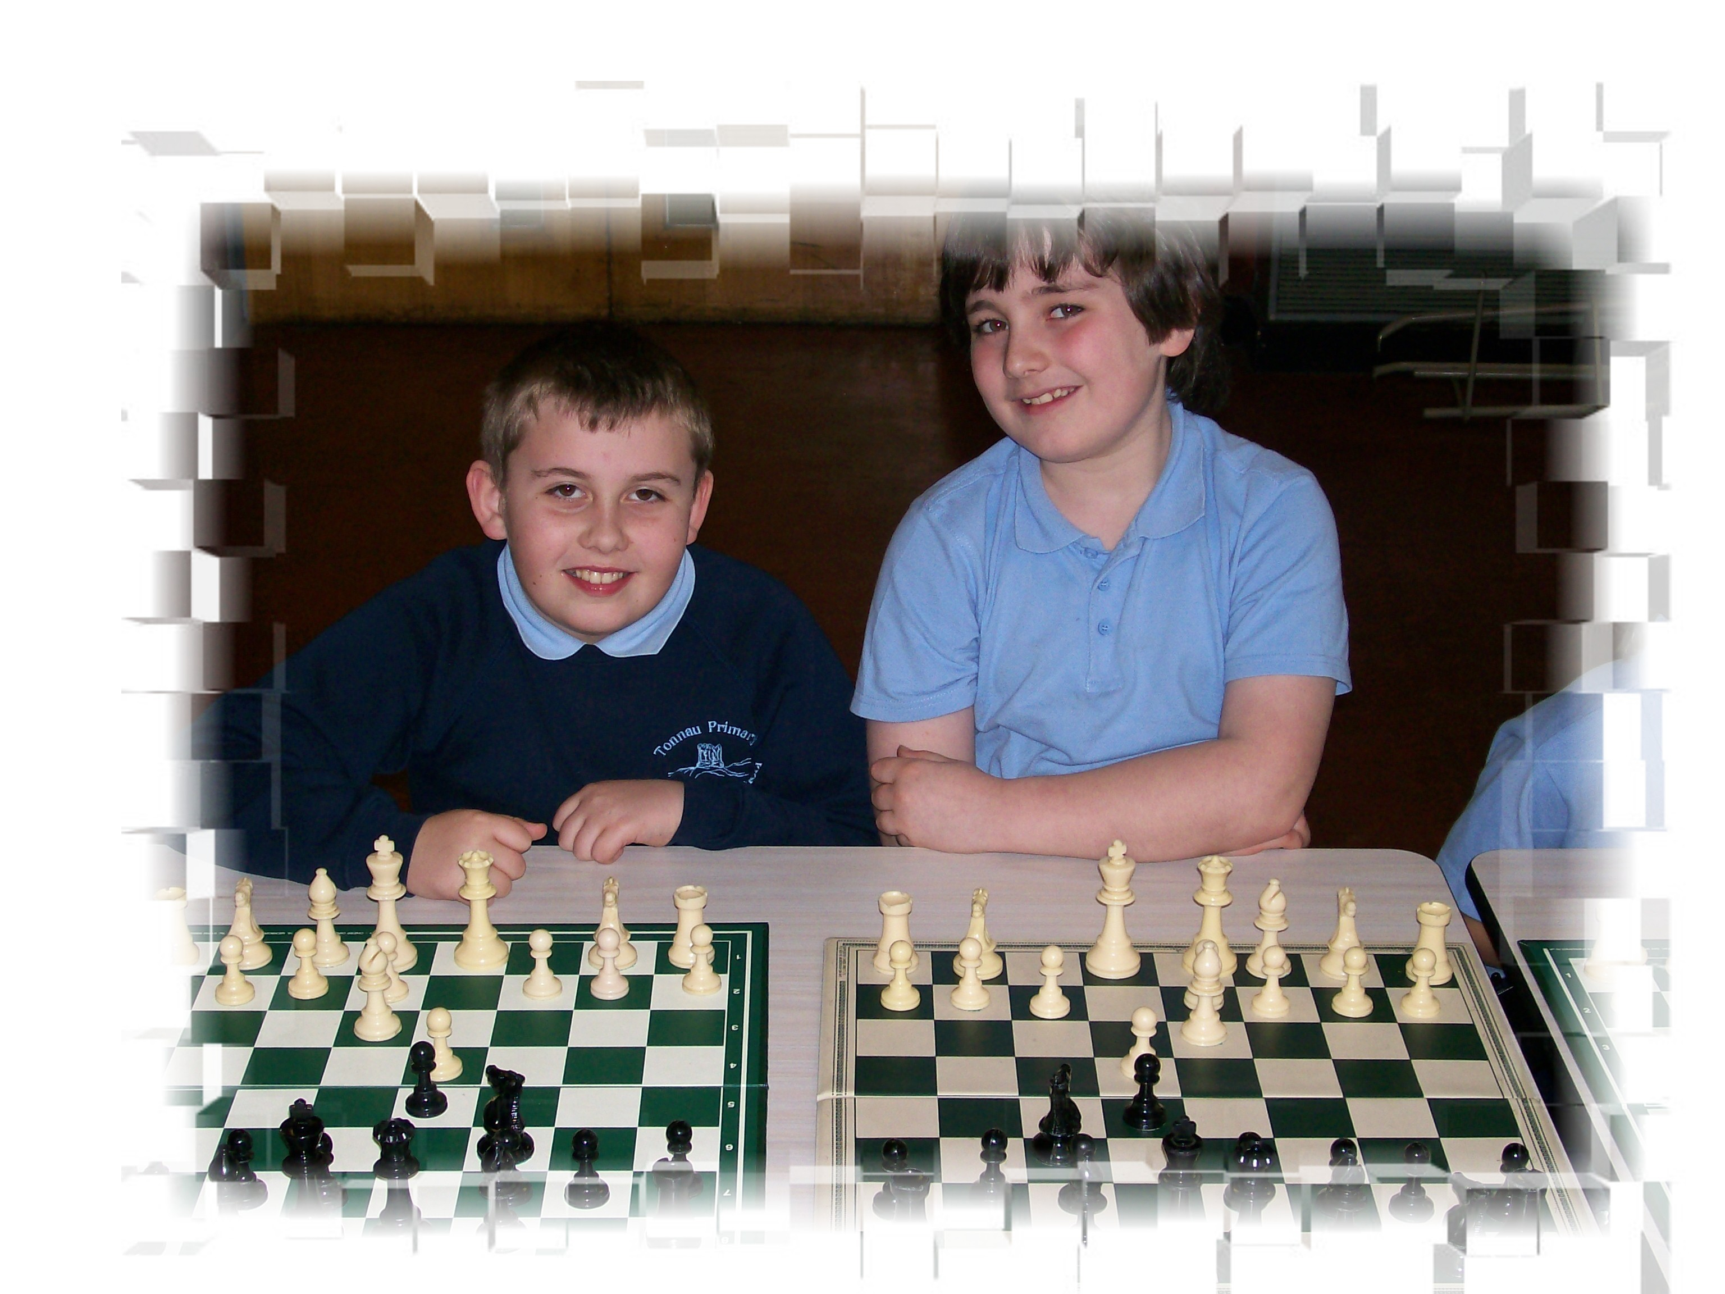
Although school uniform is not compulsory all pupils are encouraged to wear a navy jumper, hoodie or cardigan, a sky blue polo shirt or blouse and navy trousers or skirt. An alternative casual outfit is also encouraged, comprising a navy blue sweatshirt and jogging bottoms, a sky blue polo shirt or T shirt, each top garment having the school badge embossed on it and is available through the school. Other garments for the uniform are available from a variety of local stores. School logo book bags are also available at reasonable cost via the school office.
The school cannot be held responsible for lost articles of clothing that do not have the child’s name clearly marked. Coats must have tabs for hanging easily on coat hooks. Children must be able to take off and put on their own shoes, and must be appropriately chosen for the child’s ability. Nail varnish and make-up are not appropriate for school.
Since storage of a large number of oversized bags can be a problem, parents are asked to help by checking that the size of the bag the child brings to school is only as large as is actually necessary for that day.

Lost property will be held for up to half term and following an advertised display, may then be disposed of.

SCHOOL TRAVEL PLAN

The school is closely involved with the Road Safety Department in developing and updating a School Travel Plan aimed at increasing pupil safety when travelling to and from school. A committee comprising representatives of the pupils - the Junior Road Safety Officers – meet regularly to review progress and agree new targets. There is a varied approach to improving safety by reducing traffic congestion at the entrance to the school at peak times and encouraging pupils (and parents) to walk at least part of their journey. Older pupils may cycle once they have participated in cycling proficiency training. A copy of the travel plan is available from the school upon request.

DISABLED ACCESS

The junior building is adapted for disabled access with a ramp, wide doors and disabled toilet facility. The infant building has recently installed ramped wheelchair access. Pupils with special educational needs (physical) but not in a wheelchair can be catered for by special arrangements with additional adult support. We have several policies supporting equality and are available from the school.

CHARGING POLICY

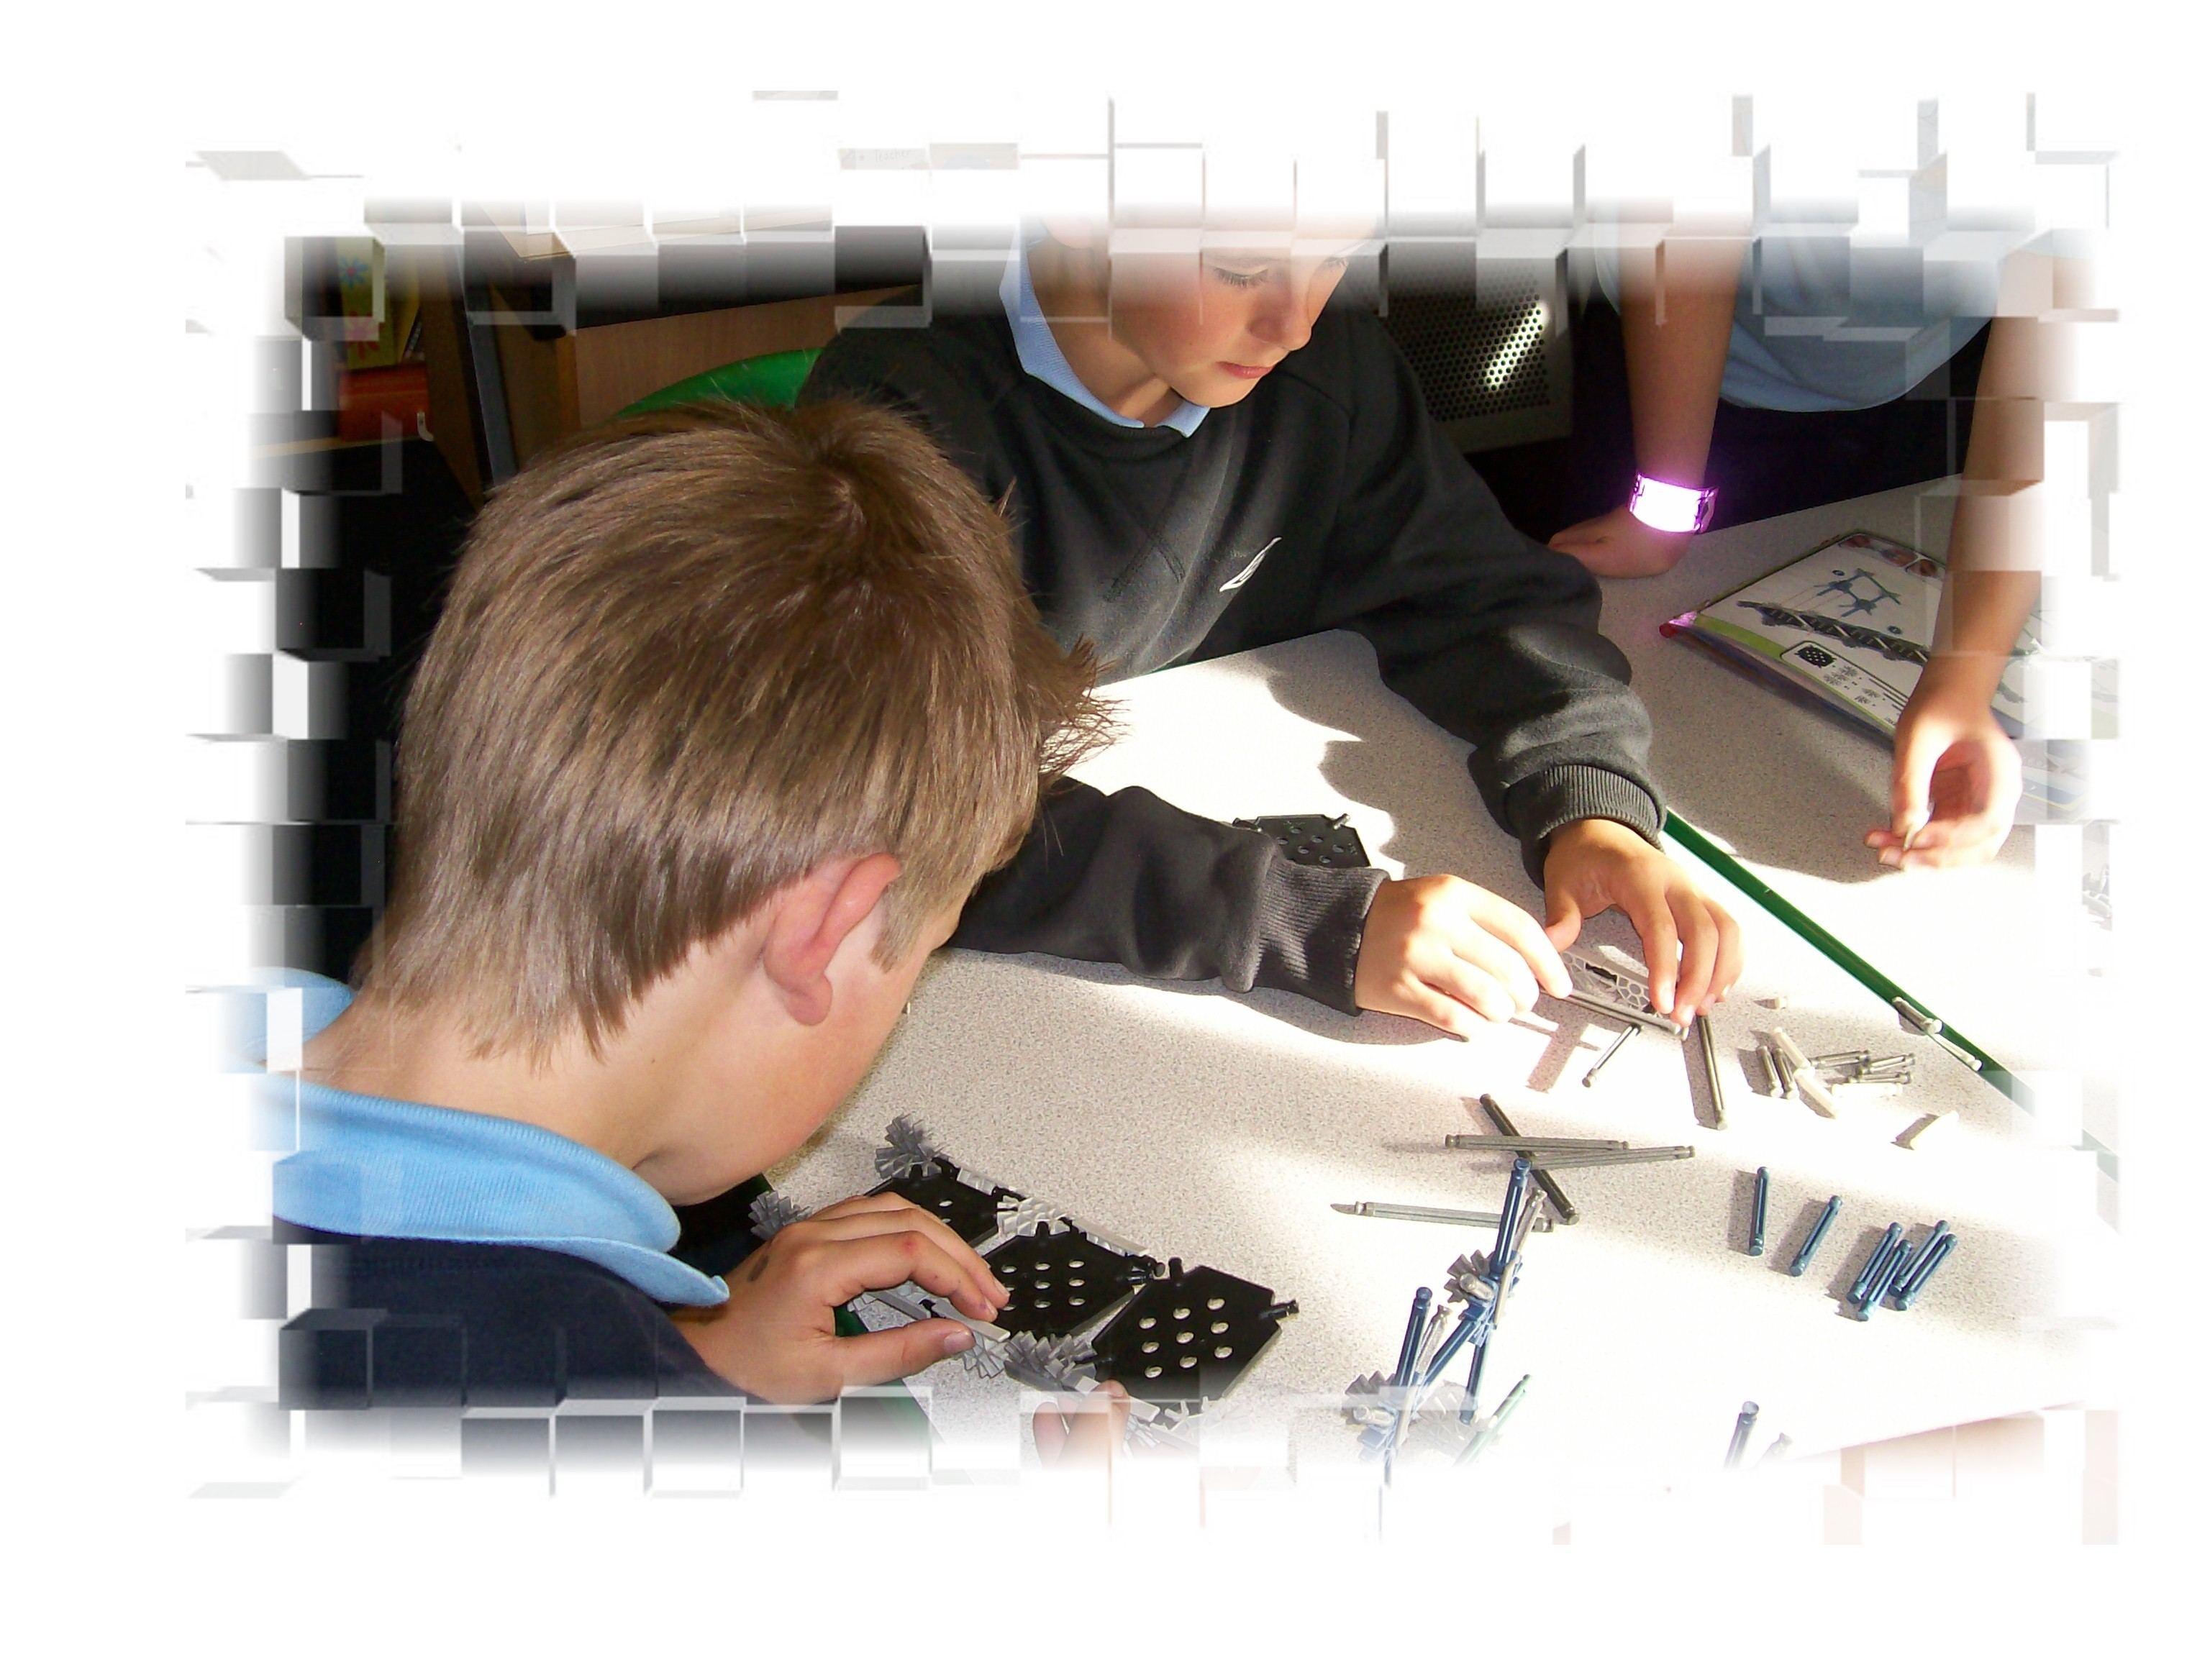
The Governing Body has agreed that where visits/activities are planned, parents may be asked for a voluntary contribution to cover the cost and help our funds go further. No children have ever been excluded on the basis of whether or not such a payment has been made, nor will they be, but in the event of the school deciding that the whole activity is not financially viable it may be cancelled and all donations refunded. Where an activity such as a field studies residential trip takes place more than 50% outside school hours (e.g. a weekend or holiday time) this will not form part of the charges and remissions policy and only those paying (or having payment made on their behalf by application – details from the school) will be allowed to participate. Please speak to the Headteacher if you have any concerns over cost. Your concerns will be treated in confidence. Swimming is at present met from the school’s own budget.

PROVISION FOR SPORT

We have a range of apparatus and small equipment to meet all aspects of the P.E. scheme of work. The yard is level and suitable for a range of activities. Our school field is large, safe and provides space for a wide range of sporting experiences. Swimming is currently arranged in two blocks at Dyfed Road Leisure Centre.

The school’s sporting aim is to develop in our children a lifelong habit of sports participation and enjoyment. Our pupils have the opportunity to experience gymnastics, rugby, netball, rounders, football, cricket and swimming. Extra curricular activities have included short tennis coaching, cross country, netball, rugby, cricket and athletics training. Through participation in athletics tournaments, short tennis competitions, and rugby, netball, football and cricket matches we wish to instil in the pupils a sense of achievement in participation as much as a pride in individual or team success. The school is committed to its involvement with Dragon Sports.

USE OF THE WELSH LANGUAGE

The medium of instruction is English. Welsh is taught as a second language as part of the National Curriculum, with emphasis on conversation. Welsh culture will be part of the pupils’ experience and the children will learn Welsh songs, verses and hymns in addition to learning about the history and folklore of Wales.
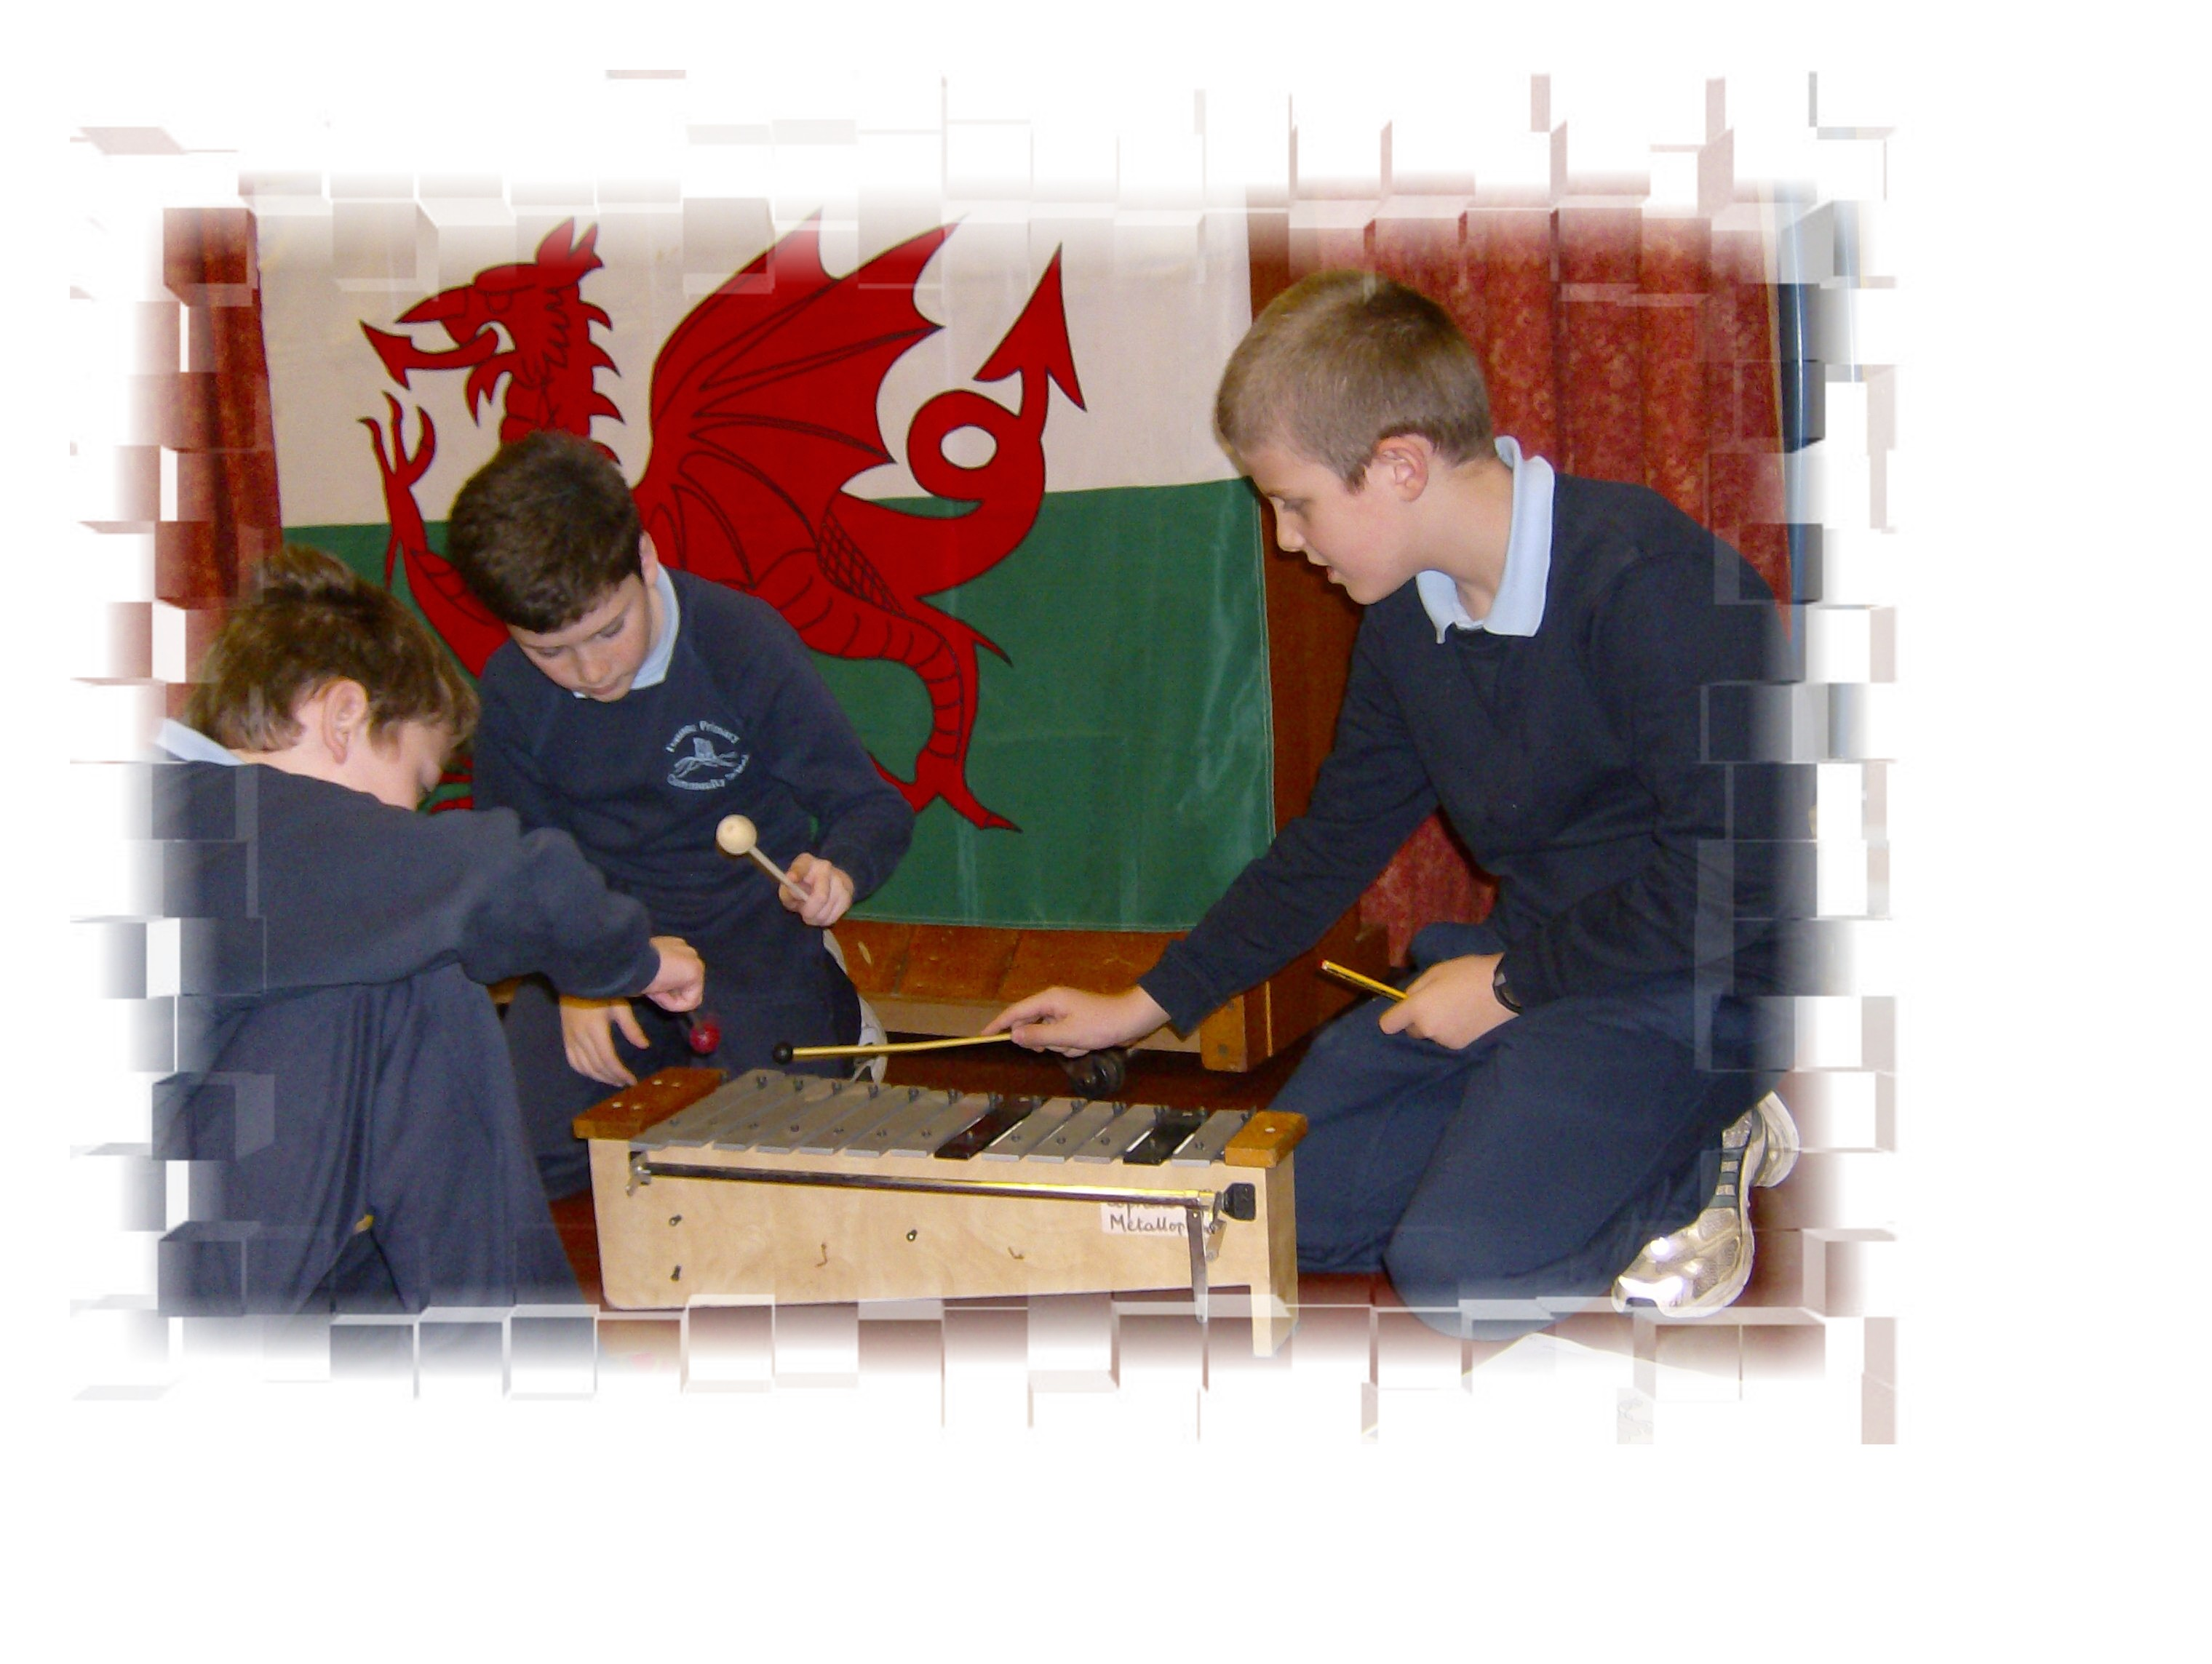

RELIGIOUS EDUCATION AND COLLECTIVE WORSHIP

Religious Education forms part of the curriculum and is taught in accordance with the LEA policies. A collective act of worship takes place each day either as a school or department in addition to class lessons on R.E. Parents who wish to withdraw their children from such daily worship or religious instruction are asked to notify the school in writing of their wishes.

ARRANGEMENTS FOR SPECIAL EDUCATION NEEDS

The school maintains a register of pupils identified as in need of additional or specific attention. Children with ALN (Additional Learning Needs) are helped in three ways. Firstly the class teacher will give the child suitable work and help. Secondly the school’s ALNCO will advise the class teacher and we will provide additional support within the classroom. Thirdly we will call upon the Local Education Authorities specialist teachers and do our best to follow their advice. Parents are informed at all stages of this process.

HEALTH AND SAFETY POLICY

The school has a Health and Safety Policy, which is available for inspection upon request.

SEX EDUCATION

In accordance with the Education Act 1994 Governors have determined that specific lessons on sex education will not form part of the school’s curriculum. We do work very closely with the school nurse to ensure appropriate sessions are held by her within our schools. All information is shared with families before any work is carried out in class.

SCHOOL HOURS

Morning session begins at 8.50 a.m. and ends at 12.00 p.m.
Afternoon session begins at 1.00 p.m. and ends at 3.20 p.m.
Morning Nursery begins at 9.00 a.m. and finishes at 11.30 a.m.

Pupils must not be on the premises before 8.40 a.m. and the register will be taken at the beginning of each session providing a permanent record of lateness. Whilst occasional lateness can be unavoidable the Education Welfare Officer may become involved where the computer printouts show a pattern of lateness occurring.

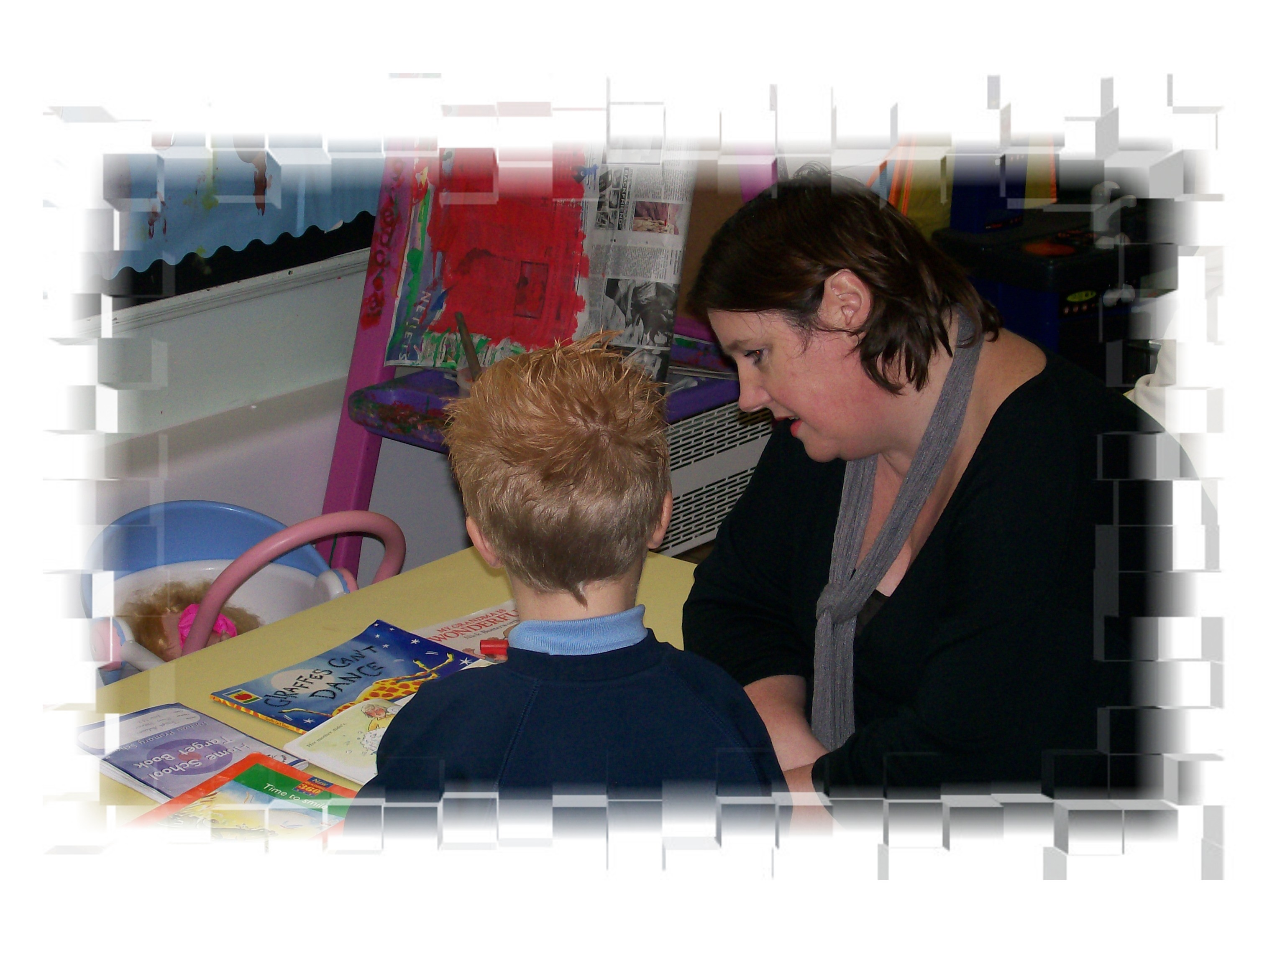
TEACHING HOURS

The hours spent on teaching during the normal school week, including Religious Education but excluding registration, daily acts of worship and breaks (including lunch) = 23.5 at Key Stage 2 and 22.5 at Key Stage 1.

EQUAL OPPORTUNITIES POLICY

The school has an Equal Opportunities Policy, which is available for inspection upon request.

HOMEWORK POLICY

We would encourage all children to read at home. Pupils can also expect to be given a reasonable amount of homework by the class teacher when he/she feels it’s appropriate. We endeavour to make homework a positive experience for your child by encouraging and praising success.

SCHOOL MEALS

Mid-day meals are prepared and cooked and served on the premises; all children dine in the school hall, and children bringing a packed lunch eat in the same hall at about the same time. Charges are currently £2.30 per meal, and must be paid for weekly first thing on Monday mornings only. The school cannot handle school dinner money at any other time. Cheques must be made out to “NPTCBC” and the school is no longer allowed to accept cheques that do not have the cheque guarantee number written on the back. Where dinners have been paid for on the Monday and the child is subsequently absent credits will be given. School meals must be paid for in advance. The school cannot allow families to build up a debt as this will be recovered from the school’s budget. Application forms for free school meals are available from the school.
Children who stay in for school meals or a packed lunch are not allowed out of the school premises during the mid-day break. Pupils who normally stay in at lunchtime will only be allowed to leave the premises if collected by a parent/carer or by prior written arrangement with the school.

ADMISSION POLICY

The school follows the Admission Policy of the LEA, details of which are available for inspection upon request.

AFFILIATION WITH PARTICULAR RELGIOUS DENOMINATIONS

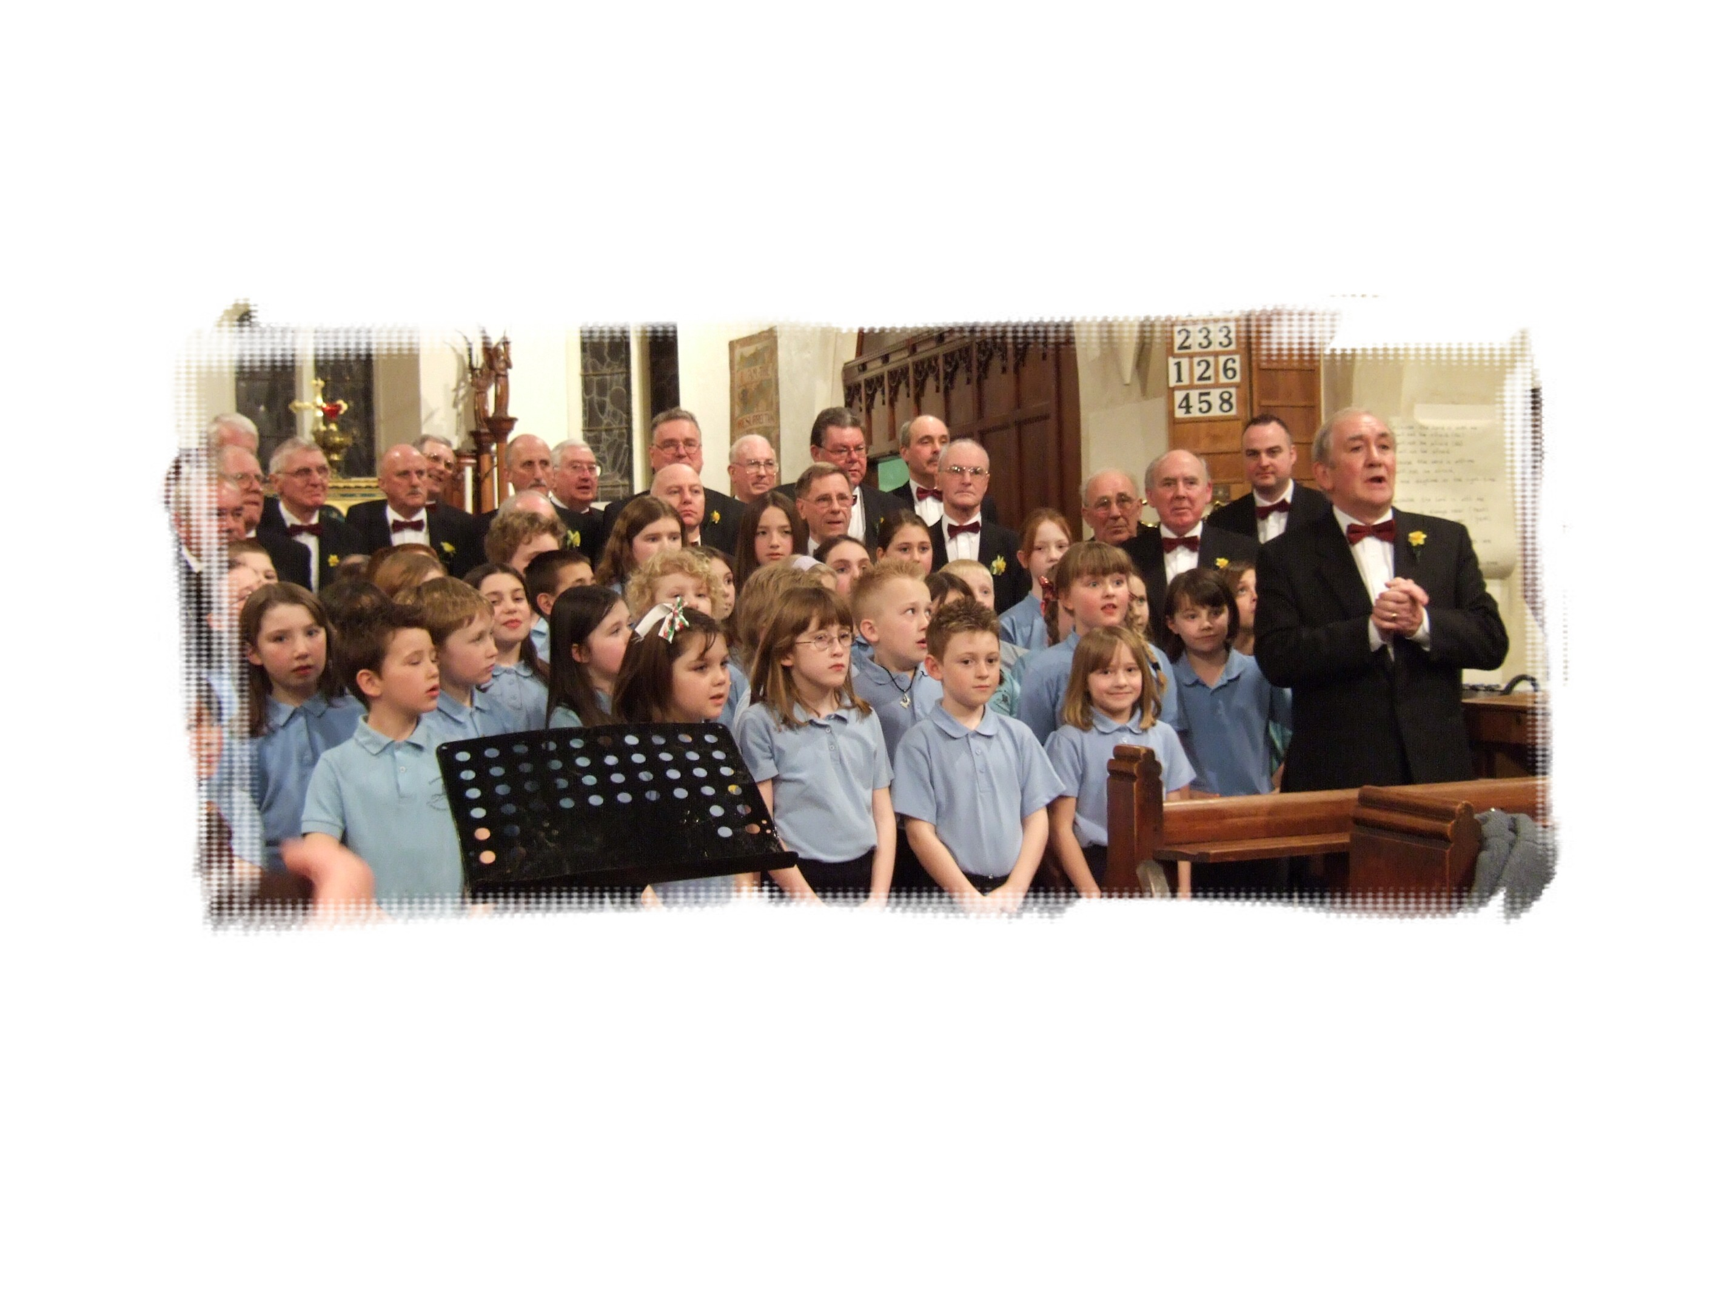
The school does not have affiliation with any particular religion or religious denomination, but the ministers from local churches and chapels may be invited to participate in school assemblies. We also hold events such as Carol Services at the local church or chapel, as well as visiting places of worship within the locality and further a field – such as a synagogue or mosque – as part of the R.E. curriculum.

INSPECTION OF DOCUMENTS

Documents relating to the school’s curriculum are available for inspection by arrangement, and where appropriate may be copied at the school, during school hours only, on the payment of the prevailing charges.

INFORMATION ABOUT HOW TO MAKE A COMPLAINT

Should any parent need to complain about any matter relating to our school we would encourage you to arrange an appointment with the Headteacher. Any complaint will be dealt with sensitively and as openly and honestly as possible.

Croeso I Ysgol Tonnau!
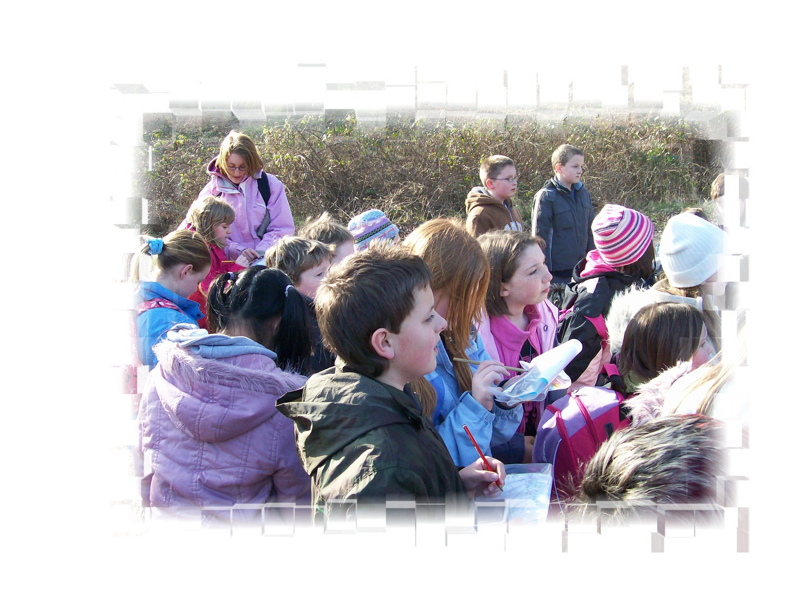
Children, parents and staff must all work together to make sure Tonnau Primary Community School remains a safe and happy place to work and learn.

Teacher Assessments 2018
% of pupils reaching expected levels of achievement

Year 2 | ENGLISH % | MATHEMATICS % | PSD | FSI %
School | 79 | 84 | 95 | 79
NPT | 70 | 75 | 87 | 82

Year 6 | ENGLISH % | MATHEMATICS % | SCIENCE % | CSI %
School | 94 | 94 | 100 | 89
NPT | 90 | 88 | 88 | 86

