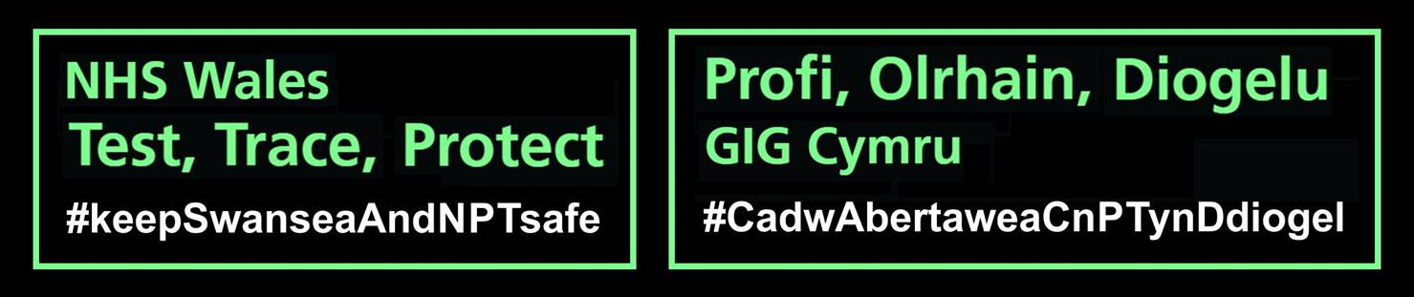

**Test, Trace and Protect (TTP) Overview**

**Information for Staff/Parents/Guardians.**

**The following information will set out what to expect in the event of a phone call from a member of the TTP team.**

You may be contacted by us if you/a minor in your family are:

* **A case (i.e. you have tested positive for coronavirus)**

**OR**

* **A contact -**is defined as a person who has had contact with the case in the period 48 hours prior to, and 10 days after the confirmed case’s symptom onset **or** specimen collection date (where case has no symptoms). These are the different types of contacts:

**Household contact**: Those that are living or spending significant time in the same household e.g. those that live and sleep in the same home. Other scenarios would include accommodation settings that share a kitchen/bathroom. Further inclusions are people who have cleaned a household/carer where a case lives without personal protective equipment etc.

**Non- household contact:**

**Direct contact**: Face to face contact with a case for any length of time, including being coughed on or talked to. This includes exposure within 1 metre for 1 minute or longer.

**Proximity contact**: Extended close contact (within 1 to 2 metres for more than 15 minutes) with a case or travelled in a small vehicle with a case.

**Aeroplane contacts of cases returning from exempted countries):** Passengers sitting within two seats in every direction (i.e. the 2 seats either side, and then then 2 rows in front and behind of these seat) and cabin crew serving the area where the case was seated.

**International travellers:** All international travellers are considered contacts, except from those returning from countries on an exemption list. This applied even if they are not known to have had household or non-household contact with a case.

**The Phone Call**

* Calls will mainly come from this number: 02921 961133. On occasions it may be necessary for our staff to use an alternative number.
* If you miss a call from the service, you will be called again. It is important that you answer calls from the NHS Wales Test, Trace, Protect Service promptly. You will not receive a voicemail, but if you ring the number back you will hear a message confirming that you were called by the NHS Wales Test, Trace, Protect service. Calls from this number are outbound only, so you will not be able to speak to a contact tracer and will need to wait for a call back later or possibly the following day.

**Information that will be gathered over the phone**

* We will need to know where they live and who they live with i.e. household contacts.
* We will need to know where a case has been in their infectious period and who they will have had contact with.
* This will include school contacts and social contacts. The relevant school will also be contacted. The nature of the contact will be explored, and it will be important to identify if the contact was a household, direct or proximity contact.
* Symptoms and the onset of symptoms or date of positive test if asymptomatic (no symptoms). We will need to know if the person has been to the shops, to school, to work, pubs/restaurants, parties, café’s and canteens etc. This information will enable us to identify clusters.
* We will need to know what classes at school they have attended.
* How the case goes to school e.g. bus/taxi/car/walks with friends.
* Any other relevant questions relating to where they have been/who they have seen during specific dates when infectious.

**What you WON’T be asked**

* Contact tracers will not ask for any financial information, bank details, passwords or any other data other than information detailed above as part of the contact tracing process.
* If there are any doubts, then you should not provide the information.
* People should be vigilant for any signs of cyber security, spoofing, phishing or fraud.

For more information see [**staying alert to scams**](https://gov.wales/contact-tracing-stay-alert-scams)**.**

**Further Information.....**

For further, constantly updated information, refer to:

<https://gov.wales/coronavirus>

Contained in the document above is more specific guidance in different situations.

**Stay at home if you or anyone in your extended household has symptoms:**

**• a high temperature**

**• a new, continuous cough**

**• loss of smell or taste (anosmia)**

**Where any/all these symptoms are apparent – get tested...**

For information on how to obtain a test, see:

<https://sbuhb.nhs.wales/coronavirus-covid-19/coronavirus-covid-19/test-trace-protect/>

For further information on employers' responsibilities to help with coronavirus testing and contact tracing please go to the following link.

[https://gov.wales/employers-coronavirus-test-trace-protect-guidance](https://gov.wales/employers-coronavirus-test-trace-protect-guidance%C2%A0)

**Keep Wales Safe**

• always observe social distancing

• wash your hands regularly

• if you meet another household, outside your extended household, stay outdoors

• work from home if you can