***St Therese’s Catholic Primary School***

**Ysgol Gatholig San Therese**

**Be Joyful, Learn & Keep the Faith**

***Voluntary Aided School***

***of the Diocese of Menevia***

**Southdown Road**

**Port Talbot**

**SA12 7HL**

*Tel: 01639 882797*

*Fax: 01639 882797*

*E-Mail:* [*sttheresesprimary@npted.org*](mailto:sttheresesprimary@npted.org)

*Website: www.npted.org/sttheresesprimary*



***Headteacher: Mr C J Welsh BA(Hons) PGCE NPQH***

***Chairman of Governors: Mrs C O Neil***

School Prospectus

2017-18

**HEADTEACHER’S MESSAGE**

Croeso, Welcome!

2016-2017 was yet another very busy and productive year for everyone at St. Therese’s Catholic Primary School. It is a real privilege to be the Headteacher at St Therese’s and to lead such a talented, dedicated and committed staff, the teachers, their assistants, the cooks and supervisory staff, the cleaners, caretaker and office staff.

It is also important to recognise the small army of people who make St Therese’s the successful school it is - the Governors, the Friends of St Therese’s and the many parents who help in school with reading and sporting events. This truly is a community school and I hope that we continue to work together to help the children grow spiritually and academically.

Our children continue to be a credit to themselves and their families and we are proud of all their achievements. The only thing I expect, and indeed demand, is that every child always tries their best and reaches the highest level they possibly can so that when they leave us to go to the Comprehensive School they are equipped to be as successful as their God given talents allow.

On the sports field we enjoyed continued success, competing in a wide variety of local and county events including rugby, netball, football, cross country, and athletics.

Our School Council and Eco Committee continued their excellent work to enhance the facilities both internally and externally. These democratically elected councils meet at least once every half term and are constantly planning to improve the school.

St. Therese’s Catholic Primary School continues to be very safe, happy and productive. Everyone works very hard and tries their best. I am extremely grateful to everyone who helps us to provide the most exciting and broad education for the children - academically, physically and spiritually. I believe our greatest strength is that we are truly a Christ-Centred Community School where every child is important to us.

We have two basic aims at our school

* ***To bring our pupils closer to Christ at every opportunity, in line with our Mission Statement***

and

* ***To develop our pupils in a way that enables them to learn at the highest level possible and in so doing, reach the highest academic standards.***

I hope you enjoy reading about life at St Therese’s Catholic Primary School and that you decide to send your children to us. If you have any queries after reading this prospectus, please do not hesitate to contact me at the school.

With your help and support I am sure that with the outstanding team I have around me we will continue to make St Therese’s a happy, spiritual and exciting place to learn.

Chris Welsh

**Headteacher**

**CONTENTS**

Staffing

Mission Statement

Admission Policy

Curriculum Statement

Prayer and Worship

Charities

Statement on Sport

Educational Visits and Visitors

Use of the Welsh Language

Additional Learning Needs

School Organisation

Collection of Children

School Uniform

School Lunch Provision

Health & Safety

Home School Links

Secondary Links

Pastoral Care and Discipline

Home School Agreement

School Term and Holiday Dates 2017– 2018

Attendance Data

The National Curriculum Assessment Results

The National Comparative N.C. Assessment Results

Complaints Procedure

**STAFFING**

**Teaching Staff**

***Class Teacher Year Pupil Numbers***

Mrs A Stephens N2 23

Miss F Sartori/Miss L Davies R 24

Mrs C Wilson-Sollars 1 29

Mrs L Cross 2 31

Mrs D Perry 3 31

Miss E Carlsen 4 30

Mr M Rees 5 30

Mrs A Stanier 6 28

**TOTAL 214.5 FTE**

**Support Staff Title/Area of Support**

Miss E Morgan TA

Miss E Larkman TA

Miss B Jeffries TA

Miss C Bailey TA

Mrs L Gittins TA

Mrs T Langridge TA

Mrs E Valetta TA

Mrs A Jones TA

Miss M Ryan TA

Miss D Cook TA

Mrs R Leyshon TA Curriculum Support/Senior Support Assistant

Mrs P Curran TA Curriculum Support

Ms P Slattery Admin Officer

Mr M Davies Caretaker

Mrs K Brooks Support Assistant

Mrs R McDyer Support Assistant

Miss C Taylor Support Assistant

Mrs L Lawrence Support Assistant

Miss C Bamsey Support Assistant

**Peripatetics**

Mr C Thomas Music

Mrs A Streefland Welsh

**LEA**

Mr S Jones Challenge Advisor

Ailyth Jackson School Counsellor

***Headteacher*** Mr C Welsh - manager with overall responsibility for Curriculum and Management structures within the school. .

**MISSION STATEMENT**

St Therese’s Catholic Primary School is a Catholic School of the Diocese of Menevia. Our mission is to care, protect and present a model of Christian living for our children that is clear to all.

Specifically, we aim to:

- stand out as a happy caring community, noted for the strength of its beliefs, its ethos and the treatment of the people within it;

- provide an education that develops the God-given gifts of the whole person irrespective of faith, age, gender, ability or ethnicity;

- celebrate, through prayer and worship, all that God has given us;

- develop the relationship between the school, home, parish and the local community;

- be a witness of Christ’s values to the wider world

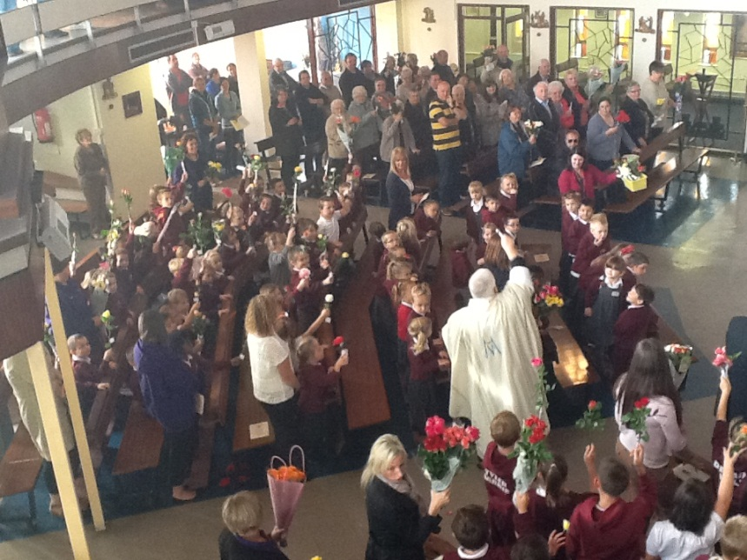

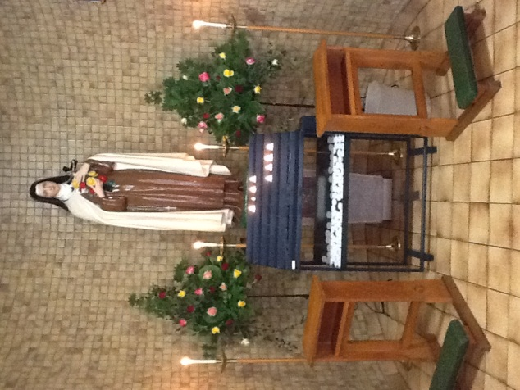

**ADMISSIONS POLICY**

**Admissions Policy and Oversubscription Criteria**

Indicated Admission Number: **30**

St Therese’s Catholic Primary School will act in accordance with all relevant provisions of the statutory codes of practice (the Welsh Assembly Government School Admissions Code and the School Admission Appeals Code of Practice) as they apply at any given time to maintained schools and with the law on admissions as it applies to maintained schools.

Reference in the codes to “admission authorities” shall be deemed to be references to the Voluntary Aided Governing Body of St Therese’s Catholic Primary School. References to “the Local Authority” or “LA” shall be deemed to be references to Neath Port Talbot. In particular, St Therese’s Catholic Primary School will take the advice of the Diocese of Menevia and will participate in the co-ordinated admission arrangements operated by Neath Port Talbot.

In line with Neath Port Talbot schools’ admission policies, application for admission to St Therese’s Catholic Primary School will be made in line with parental preference.

**Admissions Criteria**

Where the number of applications exceeds the number of places available, the Governing Body will apply the following over-subscription criteria in priority order:

1. Baptised Catholic ‘Looked After’ children, in the care of a local authority, within the parishes served by the school.

2. Looked After Children who are in the care of a local authority (children in care) or provided with accommodation by them (e.g. children with foster parents)

3. Baptised Catholic children within the parishes served by the school.

4. Other Baptised Catholic children.

5. Baptised Catholic children who have a brother or a sister at the school at the time of likely admission.

6. Any other children who have a brother or sister in the school at the time of admission.

7. Children of other Christian Denominations whose parents seek Catholic schooling.

8. Children of other faiths whose parents seek Catholic education for their child.

9. Any other children whose parents seek Catholic education for their child.

10. Children for whom the LEA has specifically asked for a place at the school.

**Tie breaker for all categories**

In the event of a tie breaker being required in any of the categories above, the governors will admit those applicants who live nearest the school. In the case of a child whose parents have joint/shared responsibility the parent who has the greater responsibility during the school week and whose residence is nearer the school will be the determining factor. Proof of residency will be required in the form of one of the following:

* Current council tax notification letter for the address on the application
* Current child tax credit note
* Current child benefit notification letter
* Current income support notification
* Current pension award notification
* Current housing benefit notification

The governors will use the shortest walking route calculated using Ordnance Survey customised route data from the front door of the school to the front door of the house or flat of the applicant. Where necessary, the governors will request assistance from the local authority to determine the shortest route.

**Waiting List**

A waiting list of unsuccessful applications will be maintained. If a place becomes available, the governors will consider those on the waiting list on the basis of the published oversubscription criteria, not on the date the application was received. If the governors place an application on the waiting list it will not affect the parent’s right of appeal. The waiting list will be maintained until 31st August in the school year that the application was made. After that date, the parent must inform the school that the application should be taken forward to the next academic year.

**NOTES**

Note 1.

Children with a Statement of Special Educational Needs who name the school must be admitted. This will reduce the number of places available to applicants.

Note 2.   
In all categories, for a child to be considered as a Catholic, evidence of Catholic Baptism or Reception into the Church will be required. Those who face difficulties in producing written evidence of Catholic Baptism/Reception should contact their Parish Priest.

Parents making an application for a Catholic child should also complete a supplementary information form (SIF). Failure to complete the SIF/provide evidence of Catholic Baptism/Reception may affect the criterion the child’s name is placed in.

Note 3.

For Catholic and non-Catholic children the definition of a brother or sister is:

1. A brother or sister sharing the same parents;
2. Half-brother or half-sister, where two children share one common parent;
3. Step-brother or step-sister, where two children are related by a parent’s marriage;
4. Step-brother or step-sister;
5. Adopted or fostered children

The children must be living permanently in the same household

Note 4.

Distances are calculated on the basis of a straight-line measurement between the applicant’s home address and a point decided by the school, usually the front gate. The local authority uses a computerised system, which measures all distances in metres. Ordnance Survey supply the co-ordinates that are used to plot an applicant’s home address within this system.

In a very small number of cases it may not be able to decide between the applicants of those pupils who are qualifiers for a place, when applying the published admission criteria.

For example, this may occur when children in the same year group live at the same address, or where there are twins, or if the distance between the home and school is exactly the same, for example, blocks of flats. If there is no other way of separating the application according to the admissions criteria and to admit both or all of the children would cause the legal limit to be exceeded, the local authority will use a computerised system to randomly select the child to be offered the final place.

The home address of a pupil is considered to be the permanent residence of a child. The address must be the child’s only or main residence for the majority of the school week. Documentary evidence may be required*.*

Where care is split equally between mother and father, parents must name which address is to be used for the purpose of allocating a school place and proof may be requested.

Note 5

a) Admissions to the Nursery classes does not necessarily secure admissions to the Primary School.

b) The Governing Body reserve the right to admit children with proven and exceptional medical and social needs where admission to the Nursery class may best satisfy those exceptional needs, providing that such an application is submitted with appropriate evidence or report from the doctor or social worker. If the school is named in a statement of special educational needs the Governing Body has a duty to admit the child to the school. All Christian applicants will be required to produce baptismal certificates.

c) The decision with regard to the allocation of a morning or afternoon place rests with the Headteacher.

**CURRICULUM STATEMENT**

Religious Education is at the heart of the life of school. In following the Catholic Bishops of England and Wales’ National Project for Catechesis and Evangelisation for Primary Schools, ‘*Come and See’*, the school fully complies with the requirements of the Catholic Church regarding Religious Education.

The school also complies fully with the requirements of the Welsh Assembly in delivering the National Curriculum.

These subjects are:

English

Mathematics

Science

Information Communication Technology

Welsh as a second language

History

Geography

Art

Music

Design & Technology

Physical Education

Personal Social and Moral Education

**International Primary Curriculum (IPC)**

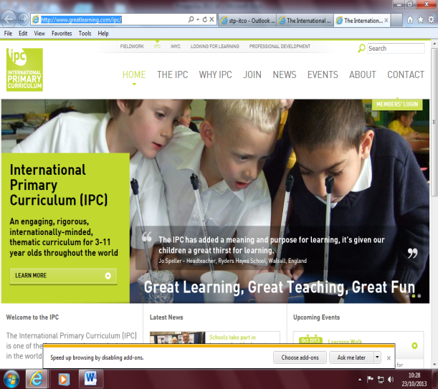The school has recently adopted the IPC which is a skills-based curriculum where foundation subjects are covered through themes. Further information about this curriculum can be obtained from the school or by visiting the IPC website: [www.internationalprimarycurriculum.com](http://www.internationalprimarycurriculum.com)

Documentation relating to the School’s Curriculum may be obtained from the school and are also available on the school website.

Following governors/parents consultation, **sex education** is provided in Year 5/6 via the local health service.

**PRAYER AND WORSHIP**

Prayer and worship are an integral part of the life of St Therese’s Catholic Primary School.

Assemblies have high priority within the life of the school and the assembly schedule is as follows:

Monday – whole school

Tuesday – class worship

Wednesday – class worship

Thursday – whole school

Friday – whole school celebration assembly

Mass is also celebrated in the church or at the school on special occasions.

Children in Year 3 make their First Holy Communion

Opportunities for the celebration of the Sacrament of Reconciliation are provided during Advent and Lent.

Throughout the year a range of services are provided to celebrate the major feasts and seasons of the Church’s Calendar.

Teachers take every opportunity to pray with the children at appropriate times of the day.

**CHARITIES**

As a Catholic school, one of our primary aims is to help the children appreciate the importance of caring for others.

A number of awareness raising and fund-raising activities take place throughout the year.

Recent charity work has included:

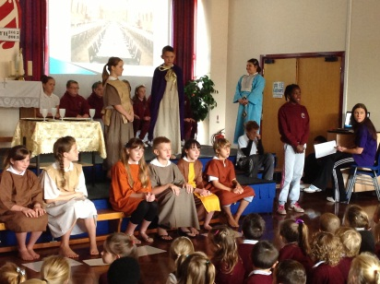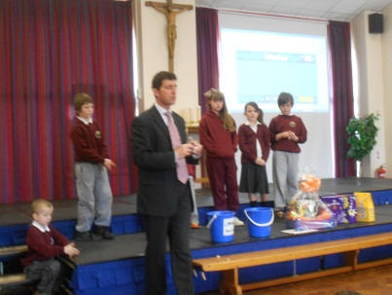Mission Club

CAFOD

British Legion Poppy Appeal

Water Aid

Marie Curie Cancer Care

RNLI

NSPCC

**STATEMENT ON SPORT**

Physical Education plays a vital role in St Therese’s Catholic Primary School. In our search for excellence and in the development of the individual, it provides a unique opportunity to develop a wide range of skills and further develop the whole person.

Sport is a strength of our school. Children are not only provided with a rich and diverse range of physical activities in line with the National Curriculum, but also given additional opportunities to take part in a whole range of activities to further develop individual talent and personal interest.

These include rugby, football, netball, athletics, cross country, cycling, dance and gymnastics. Quality coaching enabling children to become better at learning, refining skills and achieving their true potential is also provided by outside agencies such as Aberavon Rugby Club, Ospreys, Port Talbot Football Club and Dragon Sports

High standards in teaching and learning and excellent support from extra-curricular coaching has impacted on sporting achievement.

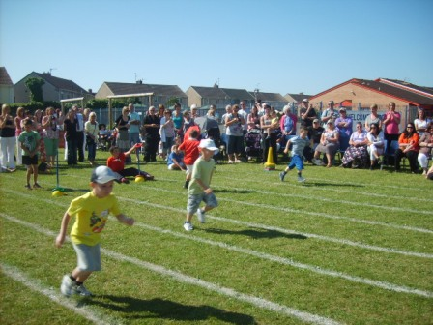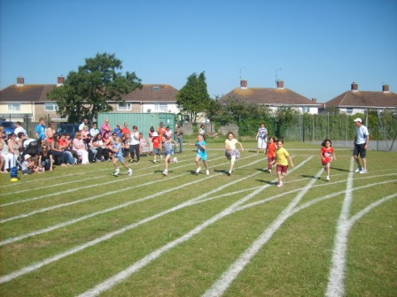

**VISITS/EDUCATIONALVISITS AND VISITORS**

We welcome all visits by parents and prospective parents to the school. An ‘Open Door’ policy exists within the school and visits can also be arranged via the school secretary.

At St Therese’s a wide range of educational visits and activities take place both inside and outside the school.

These include:

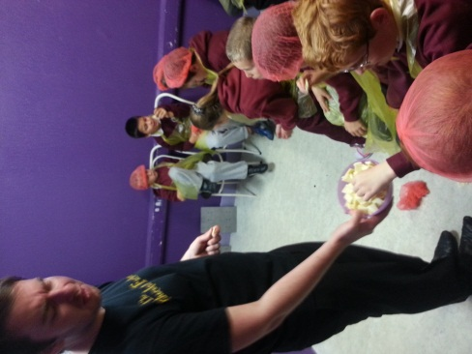

Circus workshop

Theatre workshop

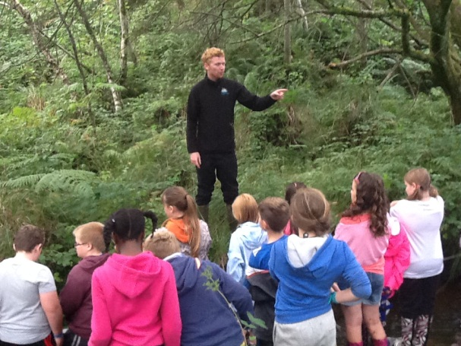 Visits to museums

Margam Park Residential Visit

Visits from Community Police Officer

Visit to Chocolate Factory

Theatre visit

Workshops with Tata Steel

Visits from Nurse and Dentist

Science Visits

History workshops

Geography field trips

The school asks the parents for a voluntary contribution to cover the costs of any out of school activity which is arranged.

**USE OF THE WELSH LANGUAGE**

A prominent place is given to the teaching of Welsh as a second language through a structured scheme of work. Incidental Welsh is used throughout the school day. St David’s Day is celebrated with a school Eisteddfod.

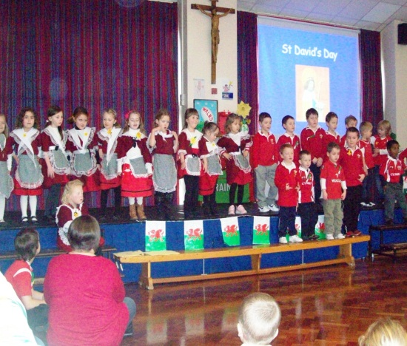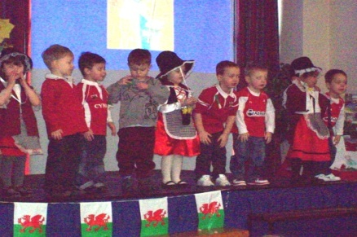

**ADDITIONAL LEARNING NEEDS**

This school enjoys a very good relationship with the Education Psychology service.

In April 2002, the Special Educational Needs Code of Practice for Wales came into effect. Stages 1 – 5 of the previous Code have been replaced as follows:

SCHOOL ACTION – Class teachers identify a child’s special educational needs and set targets to be achieved. The child may receive additional help from the support teacher or teaching assistants. Most children fall into this category.

SCHOOL ACTION PLUS – A small number of children may have difficulties which cannot be met without more expert help. The ALN Co-ordinator and relevant teacher will liaise with the Educational Psychologist and/or Support personnel to seek advice.

FORMAL ASSESSMENT – A very small number of children have needs which are not being fully met at either of the above stages. At this point, written educational advice is requested of all those involved with the child. The Educational Psychologist attached to the school will carry out a Formal Assessment in which the child him/herself and the parents play a central role.

STATEMENT – As a result of the Formal Assessment, LEA the Educational Psychologist may decide to issue a Statement of ALN, which outlines in detail the way forward for the child and grants him/her legal entitlements. Alternatively a ‘note in lieu’ may be issued.

The Statement is reviewed annually at school at a meeting attended by the parents and all professionals with whom the child has worked.

As always, all pupils identified as having special educational needs are fully integrated within the school.

**Disabled Pupils**

As a Catholic School, committed to Christ’s ministry and recognising the uniqueness and value of each individual, we welcome children with disabilities who meet the school’s admissions criteria. Every effort is made to provide the necessary resources to help any disabled pupil access the curriculum as fully as possible. The school co-operates with other professionals in seeking each child’s full entitlement e.g. speech therapist, visual impairment personnel, hearing impairment personnel etc.

**LOOKED AFTER CHILDREN**

Looked After Children (LAC) have a high priority within the aims and mission statement of the school, as can be seen from our Admissions Policy. The member of staff responsible for LAC children is Mr C J Welsh, Headteacher.

**SCHOOL ORGANISATION**

The school hours are as follows:

**Morning Session** 9.00 am - 12.00

**Lunch** 12.00 - 1.00

**Afternoon Session** 1.00 - 3.30

Absences from school must be explained by letter or telephone.

**The school should be informed on the first day of absence.**

Pupils are allocated to mixed ability teaching groups. The class teachers are responsible for most of the curriculum provision for their class, though some subjects may be taught by subject specialists.

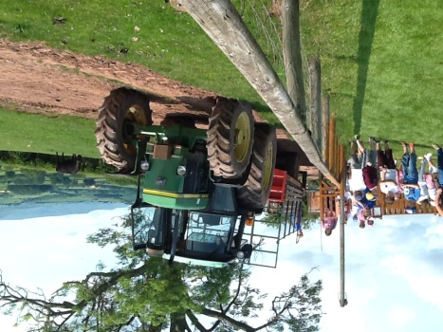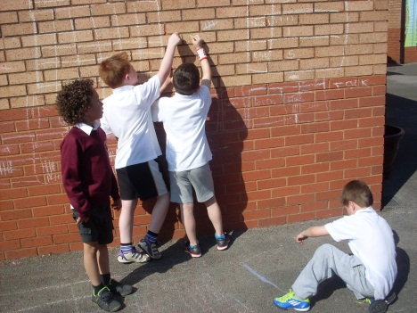

**COLLECTION OF CHILDREN**

All Infant children must be accompanied to school by an adult and collected at the end of the school day by an adult. **No Infant child** will be allowed to leave school at home time without a designated responsible person. Parents must inform the school if there is a change in the person whom they have approved to collect their child.

**SCHOOL UNIFORM**

BOYS Burgundy school sweatshirt

White school polo shirt

White shirt / tie

Available from:

Image Shops,

Aberafan Shopping Centre

Burgundy or grey tracksuit bottoms

Grey trousers

Shorts (burgundy or white

GIRLS Burgundy school sweatshirt

White school polo shirt

White shirt / tie

Burgundy or grey tracksuit bottoms

Grey skirt/trousers

Shorts (burgundy or white)

PE/GAMES KIT –KS2

We have recently introduced a new PE/Games kit for KS2 pupils. This kit is available from Macron Stores Neath and should be worn for all PE/Games lessons and when pupils represent the school in off-site sporting activities.

**PLEASE LABEL ALL CLOTHING WITH YOUR CHILD'S NAME!**

**SCHOOL LUNCH PROVISION**

Freshly prepared and cooked meals are provided at a cost of £11.50 per week - £2.30 per day. Money for these should be paid on Monday mornings. To ensure that the children are getting a balanced diet we do not allow snacks to be brought into school. **Sweets and gum are strongly discouraged**.

Parents claiming certain Social Security benefits may be entitled to free school meals. Please contact the school for further information. If possible, please pay dinner money by cash or cheque (made payable to NPTCBC), on a Monday morning. Envelopes will be provided for dinner money. Please ensure your child’s name and class is written on the envelope.

**HEALTH & SAFETY**

Teaching staff carry out supervisory duties before and after the morning and afternoon sessions and during break times. At lunch-times five supervisory assistants under the direction of the Headteacher and Deputy Headteacher carry out supervisory duties.

Visitors to the school are required to come to the office to register their arrival on the premises before approaching staff and pupils.

A full Health & Safety Audit is carried out termly by the Headteacher and an appointed Governor.

Procedures for emergency drill in case of fire are known to all staff.

Fire drill is practised regularly.

PE equipment is only used with teacher supervision.

Pupils are not allowed to wear jewellery in school because of health & safety requirements.

If pupils are ill during school hours, parents are notified immediately. Minor accidents are treated at the school. If more serious accidents occur, parents are notified and the child may be taken to hospital.

In general, medicine is not administered in school. However exceptions can be made when necessary.

If your child needs medication administered in school written permission and instructions must be given to the Headteacher. All medicines must be labelled clearly with the child’s name.

Please contact the Headteacher for further advice regarding asthma pumps.

**Security**

Since the installation of the security shuttering, the main school has not suffered any vandalism or breaches of security.

The main entrance door of the school has a self-closing mechanism and a tannoy system. Visitors to the school are required to come to the office to register their arrival on the premises before approaching staff and pupils. External doors are fitted with a fob opening mechanism.

The Health & Safety policy has been reviewed by the Governing Body and appropriate responsibilities allocated.

Members of staff hold a Paediatric Basic Life Support Certificate.

**HOME AND SCHOOL LINKS**

In order to encourage stronger partnership between the home and school, the school has a written Home-School Agreement as required by Sections 110 and 111 of the School Standards and Framework Act 1998. A sample copy is included in this Prospectus.

We believe that the parents of our pupils are the primary educators of the children and that it is our task to assist them with their children's education. Formal Parents’ Evenings are arranged during the year and a written report on each child is produced at the end of the Summer Term. Parents are welcome to visit the school at any time by prior arrangement with the Headteacher.

**Homework Policy**

The purpose of homework is to give children the opportunity to practise, consolidate and extend their learning at school.

Our Mission Statement recognises that the parents are the primary educators of our children and that the school assists them in this ministry. Hence homework is also important because it:

- helps parents to understand more clearly what their children are learning in school;

- helps parents to encourage and congratulate their children on their progress;

- helps provide activities which encourage parents to work with their children;

- helps to improve the partnership between home and school.

**The Setting of Homework**

At the start of each term parents are notified of expectations regarding homework. They are told when homework in literacy and numeracy will be set and when it should be handed in.

**Reading**

Reading Guidelines are issued to parents every September which give guidance to parents on how to help their child improve reading skills.

**Friends of St Therese’s**

The Friends of St Therese's Catholic Primary School help to raise money for the school in a variety of ways including quiz nights, children’s discos and the annual Christmas and Summer fetes. New members are most welcome. A meeting is held once or twice a term for those parents who are interested in helping.

**SECONDARY SCHOOL LINKS**

We believe it is important to develop a sense of unity in Catholic education from age 3 to 18. Regular meetings are held with the Secondary School at all levels and every opportunity is taken to ensure that transition is as smooth as possible for our children.

**PASTORAL CARE AND DISCIPLINE**

Our approach to pastoral care and discipline is built upon our belief that every pupil is a child of God. Respect, co-operation, forgiveness and self-discipline are the hallmarks of such a policy.

Minor breaches of discipline are dealt with by the class teacher and the headteacher. When significant difficulties occur, parents will always be notified and consulted in order that the most appropriate action is taken.

**Reward System**

Praise for good behaviour, good work and positive attitudes is given frequently to reinforce high standards. Teachers may consider sending pupils to another teacher or to visit the headteacher in order to give further praise. This is supported formally by the School's Merit Award Scheme and Golden Time (Friday –KS2)

**SCHOOL TERM AND HOLIDAY DATES**

**Term Dates 2017-2018**

**SCHOOL TERM AND HOLIDAY DATES 2016/17**

|  |  |  |  |
| --- | --- | --- | --- |
|  | | **Mid Term holiday** | |
| **Term** | **Term begins** | **Begins** | **ends** | **Ends** |
| **Autumn**  **2017** | Monday  4 September | Monday  30 October | Friday  3 November | Friday  22 December |
| **Spring 2018** | Monday  8 January | Monday  19 February | Friday  23 February | Thursday  29 March |
| **Summer 2018** | Monday  16 April | Monday  28 May | Friday  1 June | Tuesday  24 July |

Staff Training Days for the current year: Monday, 4 September

Tuesday, 5 September

Friday, 27 October

Monday, 23 July

Tuesday, 24 July

**ATTENDANCE**

**Period: 01/09/2016 – 31/08/2017**

|  |  |  |  |  |  |  |  |  |  |
| --- | --- | --- | --- | --- | --- | --- | --- | --- | --- |
| **All Pupils/Yr holl ddisgyblion** |  | **2013/14** | | **2014/15** | | **2015/16** | | **2016/17** | |
|  | **%** | **Quartile** | **%** | **Quartile** | **%** | **Quartile** | **%** | **Quartile** |
| St Therese's RC Primary |  | 94.95% | 1 | 94.95% | 2 | 94.95% | 2 | 94.93% | 0 |
| NPT/CNPT |  | 94.61% | | 94.78% | | 94.55% | | 94.69% | |
| Family/Teulu |  | 94.30% | | 94.70% | | 93.70% | | 0.00% | |
| Wales / Cymru |  | 94.80% | | 94.94% | | 94.92% | |  | |

**END OF KEY STAGE TEACHER ASSESSMENT RESULTS**

The 2016/17 results for pupils at the end of Foundation Phase and KS2 are summarised below:

**Foundation (Outcomes)**

|  |  |  |  |  |  |
| --- | --- | --- | --- | --- | --- |
| **Foundation Phase - 5+** | **Subject** | **2013/14** | **2014/15** | **2015/16** | **2016/17** |
|  | **%** | **%** | **%** | **%** |
| St Therese's RC Primary | FPI | 84.62% | 83.87% | 75.86% | 73.33% |
| St Therese's RC Primary | LCE | 84.62% | 83.87% | 75.86% | 80.00% |
| St Therese's RC Primary | LCW | n/a | n/a | n/a | n/a |
| St Therese's RC Primary | MDT | 84.62% | 83.87% | 79.31% | 80.00% |
| St Therese's RC Primary | PSD | 96.15% | 96.77% | 89.66% | 90.00% |

**Key Stage 2 Levels**

|  |  |  |  |  |  |
| --- | --- | --- | --- | --- | --- |
| **Key Stage 2 - Level 4+** | **Subject** | **2013/14** | **2014/15** | **2015/16** | **2016/17** |
|  | **%** | **%** | **%** | **%** |
| St Therese's RC Primary | CSI | 82.76% | 88.00% | 90.00% | 82.76% |
| St Therese's RC Primary | English | 82.76% | 88.00% | 90.00% | 82.76% |
| St Therese's RC Primary | Welsh | n/a | n/a | n/a | n/a |
| St Therese's RC Primary | Maths | 89.66% | 92.00% | 90.00% | 86.21% |
| St Therese's RC Primary | Science | 86.21% | 92.00% | 90.00% | 86.21% |

**COMPLAINTS PROCEDURE**

If you are not satisfied with your child's education or have a complaint under Section 23 of the Act:

1. If you have a concern about the curriculum or religious education first try and resolve the matter by making an appointment to discuss your concern with the Headteacher.

2 If unresolved you may refer the matter to the Governing Body. The Chairman of Governors is: Mrs C O Neil

3 If you feel that your complaint has not been resolved you may wish to telephone the Awards Officer, Civic Centre, Port Talbot 01639 763580

4 If the problem is still unresolved you should inform the Director of Education in writing and again an attempt will be made to resolve the problem, if at all possible, before recourse to the official Complaints Procedures.

5 Details of the Authority’s Complaints Procedure are available at any school by appointment with the Headteacher, the Education Department or Public Library



**Be Joyful, Learn & Keep the Faith**

**ADMISSION APPLICATION**

**AND**

**HOME-SCHOOL-PUPIL-AGREEMENT**

**As a Parent/Guardian I will:**

* Support the school in its efforts to live, learn and grow as a Catholic Christian community
* Ensure that my child attends school regularly, on time, properly equipped and in school uniform
* Inform the school of any concerns or problems that might affect my child’s well-being, work or behaviour
* Support the school’s policies and guidelines, including those relating to behaviour
* Support my child in homework and other opportunities for home learning
* Attend Parents’ Evenings on designated dates and any discussions about my child’s progress
* Provide a note of explanation if my child is absent and consider carefully the effects of missing school before booking family holidays during term time

**As a School we will:**

* Encourage children to achieve their full potential in a secure and stimulating environment informed by Catholic Christian values
* Contact parents if there is a problem with attendance, punctuality or equipment
* Arrange Parents’ Evenings during which progress will be discussed and any problems that affect your child’s work, behaviour or well being
* Keep parents informed about school life through termly newsletters, regular letters and notices about special events
* Set, mark and monitor homework

**As a pupil I will:**

* As a member of a Christian Community show respect, care and concern to children, staff and visitors alike
* Attend school regularly, on time and in uniform
* Do all my classwork and homework to the best of my ability and hand it in on time
* Follow the school’s Code of Conduct and rules for good behaviour
* Take home newsletters, school letters and notices about special events

Name of Pupil……………………….…………………….(male/female)

Date……………………………

Signed…………………………………………….…………….(Parent)

Signed…………………………….………….(Pupil – Key Stage 2 only)

Signed………………………………………………….… (Headteacher)

**You have requested admission of your child into St Therese’s Catholic Primary School.**

**The procedure is as follows:**

1. Please fill in the form as completely as possible.
2. If your child was baptised at St Therese's and you are attending this Church, please make an appointment to see Fr Paul Brophy to confirm facts. His telephone number is 01639 884791.
3. The application will be considered by the Admissions Panel and signed by the Chair of Governors.

**Name of Child**....................................................................(male/female)

**Address**......................................................................................................

**Post Code**………………………………………………………………..

**Telephone Number**......................................................................................................

**Father’s Name**..........................................................................................................

**Mother’s Name**..........................................................................................................

**Child’s Date of Birth**...........................................................................................................

**Church of Child’s Baptism**......................................................................................................

**Date of Child’s Baptism**...............................................................................................

**Signature of Parish Priest where child was baptized** *(if applicable)*

…………………………………………………………………………....

**Church attended by Parents**...................................................................

**Signature of Parish Priest of Church attended**

…………………………………………………………………………....

**Signature of Chairman of Governors**.....................................................

**Medical Information**: ***please give any information which the school needs to be aware of:***

....................................................................................................................

**Declaration:** (*delete as appropriate)

*\*We/I agree to abide by the above rules of St Therese's Catholic Primary School. *We/I confirm that *we are/I am a:*

*practising*......................................................................... *(denomination*)

*Signed*..........................................................................................*(parent)*

*Date*………………………………………………………………..…...

*Child's Name*...........................................................................................

*Signed*………………………………………*(Pupil – Key Stage 2 only)*