Beech Class Pick & Mix Homework
Spring 1 2017

Enjoy Reading  - Practise my reading book. (1 point)  - Retell a story you have listened to.  (2 points)  - Think of some words that rhyme with cat. Write a list of them in your homework book. (5 points) | Enjoy Maths  - Say the number that is one more than a given number 1-10 (2 points)  - Write numbers 1-10 (3 points)  - How many ways can you make 5/6/7/8 – choose one number. List them eg 5 = 1+4, 3+2. Use counters to help you. (5 points)  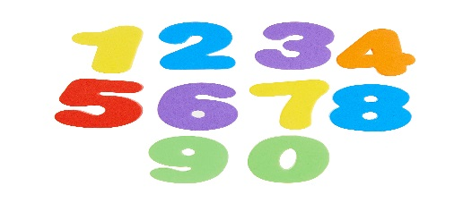 | Enjoy Writing  - Write a list of family members. (2 points)  - Sound out and spell 6 CVC words eg cat, dog, sun etc (3 points)  - Write a sentence about your reading book. (5 points)  Remember to form your letters correctly – look at the Read Write Inc letter formation sheet to help you and use capital letters and full stops.
Be Creative  Draw a picture of a “Superhero.” You can use pencils, felts or paint. Bring in your design to show the class. (3 points)  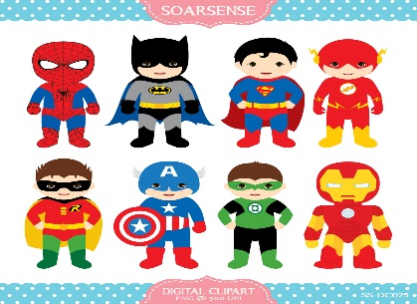 | Be Physical  - How many jumps can you do in a minute? (1 point)  - Practise throwing and catching a ball with a partner. (2 points) | Detective Skills  Go on a letter/word hunt indoors or outdoors. What letters can you recognise? (2 points)  What words can you read? (3 points)  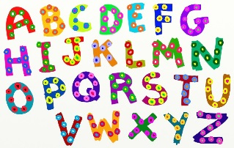
Eco-Challenge.
Make a label with a message about how we could look after our environment, to be attached to our eco tree Messages will be displayed outdoors so think about the materials you can use to make it. (4 points)

Dear Parents,
Here is the first half term's homework choices. Each activity is worth 1, 2, 3 or 5 points. The aim is to score 5 points every week completing the activities of your choice. Activities can be repeated with a different focus e.g. write different words/sentences, choose a different number to write some number bonds. Hopefully a variety of activities will be attempted. At the end of the 4 week half term a total of 20 points is to be achieved.
Please bring in your homework chart every Thursday to show me how you are progressing and to help with any difficulties or queries. Please sign and date the reading, counting and speaking activities once completed.

 | Parent Comments/signature | Total Points | Teacher Comments
Week 1
19.1.17
Week 2
26.1.17
Week 3
2.2.17
Week 4
9.2.17

