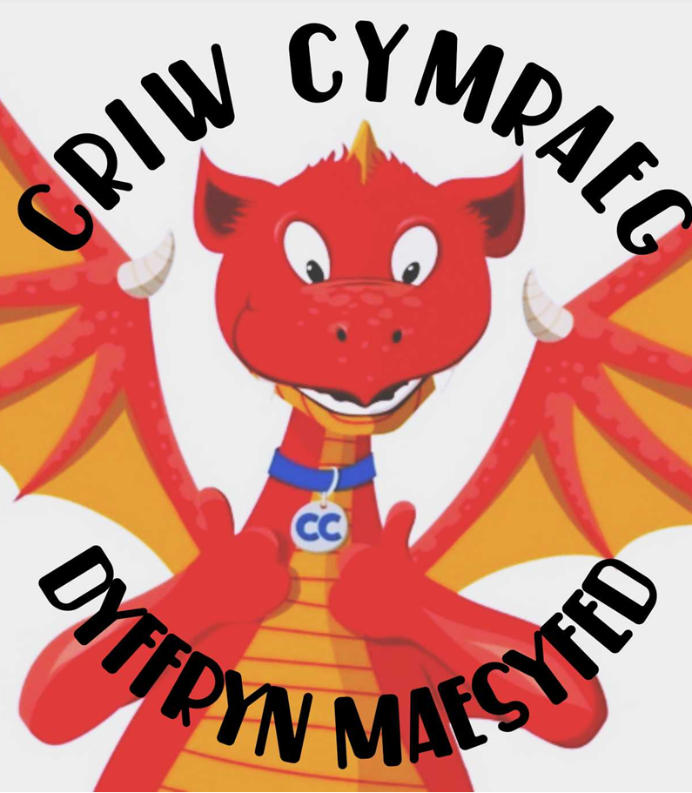
Croeso i'n Tudalen Criw Cymraeg!

Meet this year’s Criw Cymraeg

INSERT PHOTO

‘Shwmae!’

What we do:

Our main task is to try and promote a strong Welsh ethos in our school and help other children to enjoy learning Welsh!

We also:

Bob Dydd  Daily | Bob Wythnos  Weekly | Bob Pethefnos  Fortnightly | Yn Aml  Often
Encourage everyone to speak Welsh | Lead a Welsh assembly | Meet as Criw Cymraeg to discuss Welsh ideas and how to encourage Welsh across the school. | Help organise special Welsh Days e.g. Dydd Gwyl Dewi, Dydd Santes Dwynwen
Lead yard games in Welsh during Amser Chwarae | Announce who is ‘Dosbarth Cymraeg y Wythnos’ | Introduce ‘Patrwm y Pythefnos’ | Run Welsh competitions

What we do helps us to meet targets that work towards:

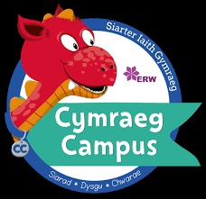
‘Excellent Welsh’
Awards

We would like to encourage everyone to have a go at speaking Welsh at home too!
At school we introduce a new Welsh pattern to learn each fortnight (Patrwm y Pythefnos) - here are the Autumn Term’s for you to practice at home:
Dyddiad | Patrwm
 | Foundation Phase | KS2
13 & 20 Medi | Sut wyt ti? | Dw i wedi gorrfen
27 Medi & 4 Hydref | Ga i ……? | Ga i …… os gwelwch yn dda?
11 & 18 Hydref | Pa liw? | Ble est ti ddoe?
1 & 8 Tachwedd | Dw i’n hoffi …. .  Dw i ddim yn hoff …. . | Roeddwn i’n hoffi ….  Doeddwn i ddim yn hoffi…
15 & 22 Tachwedd | Fy hoff …….ydy ……. .
29 Tachwedd & 6 Rhagfyr | Dw i’n byw yn …….. . | Dw i’n meddwl bod ….
13 & 20 Rhagfyr | Nadolig Llawen | Nadolig Llawen a Blwyddyn

Here are some links to Welsh Apps and Games that will also be useful to help practise Welsh:

PLEASE MOVE THE LINKS FROM THE CURRENT CRIW CYMRAEG PAGE

Diolch ac yn mwynhau siarad Cymraeg!

