Ysgol Llanychllwydog



Gwreiddiau'r Gorffennol-Canghennau'r Dyfodol

School Handbook
2019-2020

Ysgol Llanychllwydog

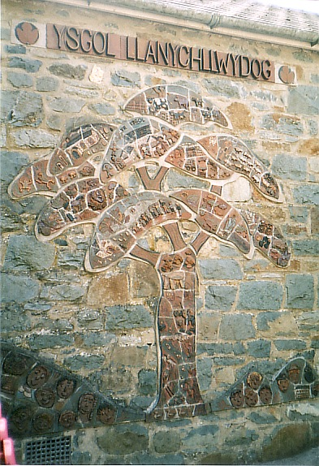

Acting Head:
Mrs Amanda Lawrence
Ysgol Llanychllwydog Phone no: 01348 881 307
Pontfaen
Fishguard
Pembrokeshire
SA65 9SE
admin.Llanychllwydog@pembrokeshire.gov.uk

Ysgol Llanychllwydog

Use of I-Pads to stimulate the children.
Interactive White Boards in each class room.

The school takes pride in transferring yesterday’s values using the technology of the twenty-first century.
Our motto at Ysgol Llanychllwydog is:
Yesterday’s roots – Tomorrow’s shoots

Various ICT resources.
School website:
www.head.llanychllwydog.wixsite.com

Ysgol Llanychllwydog

Dear Parent,
It is my pleasure to present to you the school handbook.
You will find information about the school within its pages.
Children can start part-time education at this school the term after their third birthday. If you wish, you can bring your child to see the school, and to meet the staff, before the start date, and your child can spend a short time in the company of other children.
Of course, the details within this handbook may change, and the change may have an effect on the arrangements during the school year.
Please get in touch with me should you wish to visit the school.
Yours faithfully
A.Lawrence (Acting Head teacher)
S. Grim (Chair of Governors)

Gwreiddiau'r Gorffennol-Canghennau'r Dyfodol

Ysgol Llanychllwydog

Welcome to Ysgol Llanychllwydog
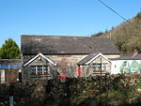

Ysgol Llanychllwydog is a small, traditionally Welsh primary school, with a rural catchment area that takes in pupils from the local agricultural community.

The school was built during the 1880s and has served the community well throughout the ages. All this contributes to the strength of the homely, family atmosphere that exists in Ysgol Llanychllwydog.

Ysgol Llanychllwydog is a Welsh Medium school as described by Pembrokeshire County Councils’ Language Policy; the Welsh language is the day to day operational language of the school and the whole school atmosphere is essentially Welsh. The area is still traditionally Welsh.

Term Session Times:
Full time -9.00am - 3.15pm
Part time – 1.00pm – 3.15pm

There is free transport for those pupils who are eligible. There is a travel code of conduct which must be followed whilst pupils travel on the bus.
Children are accepted as part-time pupils at the beginning of the term following their third birthday. They are transferred to full time education the term after their fourth birthday.

Ysgol Llanychllwydog

This School is committed to:

Developing pupils to reach their full potential, and encouraging Lifelong Learning.
Providing a happy rural atmosphere that is caring and safe for children.
Creating a supportive, encouraging and helpful environment in order to promote and facilitate opportunities for every child.
Providing active, thoughtful and creative learning.

Aims
Our aim is to create a comfortable and supportive establishment, where every child has the opportunity to develop to his or her full potential, educationally, emotionally and socially.

This School Provides:
Enthusiastic and conscientious staff.
Equal opportunities and inclusion for all pupils.
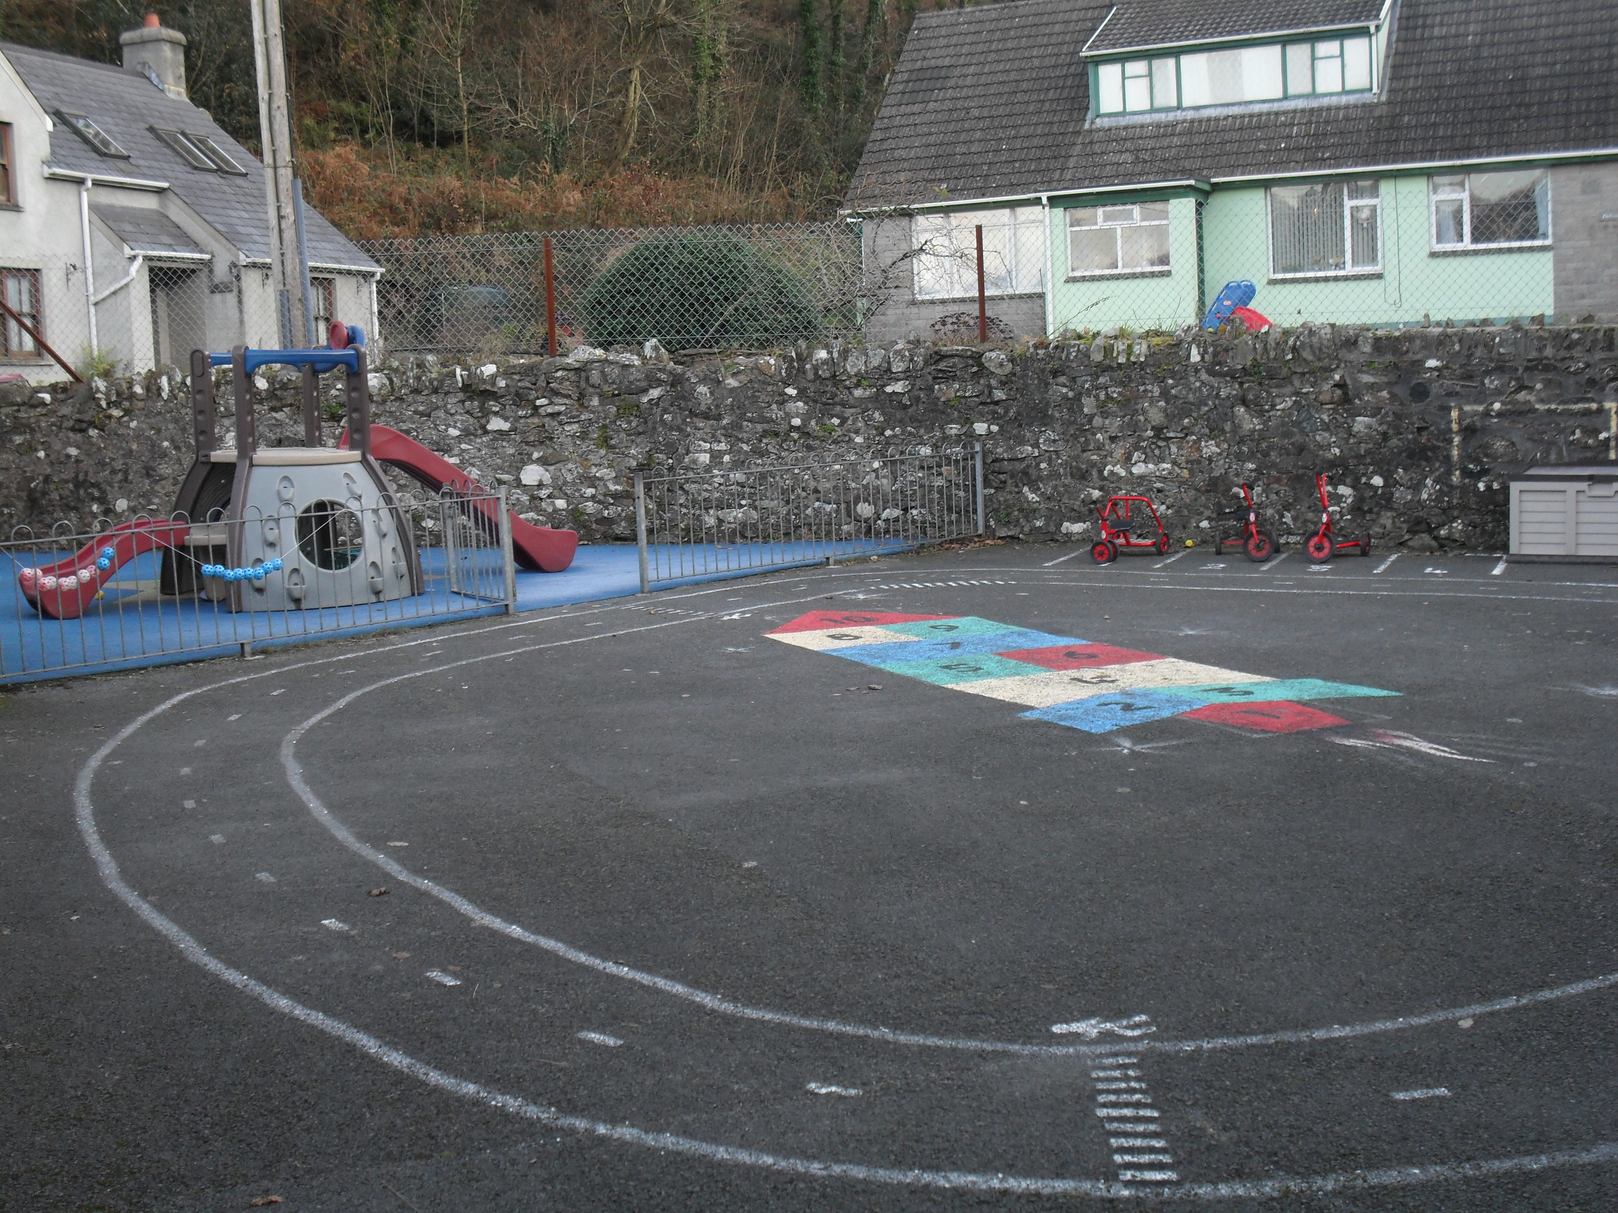
A close and homely atmosphere.
Opportunities that stimulate and promote learning.
A Welsh atmosphere.

Ysgol Llanychllwydog

School Staff
Mrs Amanda Lawrence Acting Head teacher
Mrs Ruth Evans Foundation Phase Teacher
(4 days a week)
Mrs Mererid Francis Key Stage 2 Teacher (4 days a week
Mrs Hedydd Hughes 0.2 Teacher
Mrs Sharon Griffiths 0.2 Teacher (ALN and KS2 Science)
Mrs Sharalyn Jenkins Music Teacher
Miss Rhian Homer Class Support
Mrs Delyth Thomas Administrator
Mrs Marie Sapsford Cook in charge/ lunch-time supervisor
Mrs Linda Davies School Caretaker

Ysgol Llanychllwydog

Members of the Governing Body
Chairman: Mrs Sara Grim
Meysydd
Maenclochog
Pembrokeshire

Clerk: Mrs Kate Evan-Hughes
Director of Education
Department of Education and Services
County Hall
Haverfordwest
Pembrokeshire
SA61 1TP

NAME STATUS
Mr Haydn Williams Community Representative
Mrs. Amanda Lawrence Acting Head teacher
Mrs Mererid Francis Staff Representative
Cllr Bob Kilmister Local Authority Representative
Mrs Joy Phillips Local Education Authority Representative
Mrs. Marian Phillips Community Representative
Mr Dyfan Evans Parent Representative
Mrs Sara Grim Parent Representative
Mrs Glesni Evans Parent Representative
Mrs Gemma James Community Representative

There is an application form for school governor on the County website.

Ysgol Llanychllwydog

General Information

The morning session begins at 9am, and the afternoon session begins at 1pm. School closes at 3.15pm. The children are collected by the main entrance gate. We kindly request that you refrain from parking outside the main entrance to the school.
In order to teach good habits, all pupils are expected to arrive at school on time. Registration time is between 9 and 9.10 am. A record is kept of all pupils who arrive late at school. We also kindly ask you to collect your children promptly at the end of the day so that we can continue with our afterschool activities, meetings, training, afterschool clubs, practises, and so on.
Please phone the school before nine o’clock if your child is going to be absent. If we are not informed before nine o’clock in the morning, your child will be marked as absent without permission.
If any concerns arise regarding the above, the school will take the appropriate steps.
We strongly advise you to label your child’s clothes clearly, so as to avoid losing them. Please could part time pupils bring extra clothing in their bags, (i.e. a pair of trousers, a pair of socks and underwear).
Children are not permitted to bring sweets of any description to school.
Children are not permitted to bring toys to school. We provide enough resources for their needs.
With regards to safety during playtime, physical education lessons and generally in the classroom, no jewellery is permitted, and children are advised to tie up their hair.
It is the duty of parents to check their child’s hair regularly for head lice, and to treat them appropriately if needed.
If your child is ill with flu like symptoms or with a sickness bug, please keep your child at home for at least 48 hours.
The importance of drinking water is given a high profile. Please provide your child with a clean plastic water bottle every day. Water bottles can be purchased from the school. Glass bottles and cans are not permitted.
There are five training and transition days during the academic year, as stipulated by the Welsh Assembly Government.

Making an application for a place at School
Applications for your child to start school should be made in good time. If your child is to start in January, April or September, an application should be made by 31 January the previous year. Forms are available on the county website as well as the school website.

Ysgol Llanychllwydog

Extra Curricular Activities
There are various activities organised for the pupils – trips, workshops and performances at the school, instrumental lessons, sporting competitions, afterschool clubs etc.
School Clubs
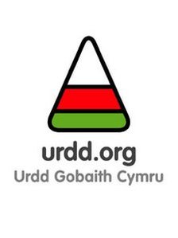  Urdd Club  Monday  (every week)  Autumn, Spring and Summer Terms  3.15-4.15pm |   Various Pupil Led Clubs (football,netball,Lego,craft)  Lunch time  12.20-1.00pm |   Sports Club  Wednesday  (every week)  Autumn, Spring and Summer terms  3.15-4.15pm
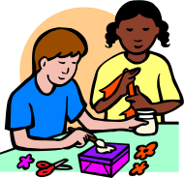
Craft and Cookery Club

(every other week)

Spring Term
3.15-4.30pm
The clubs are run by the staff with the support of parents.

Ysgol Llanychllwydog
Trips
Educational trips are organised to reinforce lessons taught at school. These can vary from visiting museums, local businesses, shows and plays, activity centres, etc. There will be a charge for some of the activities.
Instrumental Lessons
Violin, guitar and brass lessons are available and pupils are expected to practise regularly to achieve progress. Also, as a part of the Music Curriculum, all pupils are expected to learn one instrument. They will do this during music lessons.
Charging policy
We ask that you kindly make a contribution towards the costs of some activities at the school.
Toast and Milk
Pupils are given the opportunity to purchase toast from the school council for 50p a week. The money is used to buy resources decided upon by the pupils. Free milk is provided for all pupils in the Foundation Phase.
Medication
If staff are required to administer medicine or lotion at any time, a letter must be sent in to the school. This also includes asthma pumps. Please inform the school of any allergies or of any medication required.

Ysgol Llanychllwydog
Holidays
Parents must ask the school’s permission before taking a child on holiday during term time. Holiday forms are available from school. The school will closely monitor the child’s attendance and decide whether such an absence can be authorised. There are more details in the school’s attendance policy.
School Dinners
School dinners are not prepared on site, they are transported from a nearby school and are of a high standard. Dinner money is payed through the Pembrokeshire County Council website. If it is considered that a child is eligible, parents are asked to contact the head teacher or the Education Department, to obtain a free school meals application form. The school cannot allow credit for school dinners. Should you wish, a pupil may bring a packed-lunch. Please inform us if your child has any food allergies.
School Administration System
All information concerning pupils is kept on a computer, as required by the County policy. This information is confidential, and your child’s rights are protected by the Data Protection Act.

Ysgol Llanychllwydog
Equal Opportunities
The school promotes equal opportunities for all. The school has a Strategic Plan for equality that notes specific targets for promoting equal opportunities for all. You may see this plan by making a request to the Head teacher. The building and the site are in a good condition and are suitable for addressing the needs of children with additional needs, which gives everybody an equal opportunity. We promote respect within the school, and we highlight the importance of treating every individual equally. Any adjustments to the methods of introducing the curriculum are made according to the need. The school has policies on inclusion, accessibility and additional educational needs.
Health and Safety arrangements
The Head teacher conducts risk assessments of the building and the site in order to ensure that they are in a good condition. When damage is noted, arrangements are made for appropriate repairs. Risk assessments are also conducted each time we take the pupils on educational trips.
Fire drills are held each term. The school fire alarm system and fire extinguishers are inspected regularly, and a fire officer conducts a risk assessment. Staff have been trained to use fire extinguishers. The school is in a good condition and is safely surrounded by a fence.

Ysgol Llanychllwydog

General Aims and Objectives of our School
- The main aim of Ysgol Llanychllwydog is to ensure that every individual is happy and reaches his or her full potential, intellectually, socially and physically. Our school motto is ‘Yesterday’s roots – Tomorrow’s shoots.’
- To help pupils to develop thinking skills to enable them to research, work independently, question and solve different problems logically.
- To teach children to work together and to show tolerance towards others, whatever their background, colour or religion.
- To nurture a pupil’s interest in Literacy, Numeracy and Science, thus developing skills for a wider understanding.
- To promote our culture, thus creating an appreciation of language, our history, our local area and our innovators, and giving the pupils an understanding of moral values.
- To develop the child’s awareness of the need for personal cleanliness, courtesy, self respect and to respect others.
To encourage all children to take part in various activities in the school, as well as extracurricular activities, in order to develop individual talents.
- To work closely with the parents and the community for the well being of the child.

Ysgol Llanychllwydog
The Curriculum – What is Taught?
We provide the National Curriculum, the Foundaiton Phase Curriculum, Religious Education and Collective Worship, and Personal and Social Education for all pupils.
The National Curriculum subjects and the Foundation Phase curriculum are taught under themes. The themes are followed for half a term or a term at a time, there is a four year cycle. We plan with the children at the beginning of each new theme so that they guide the teaching.
Year 1
Class | Autumn Term | Spring Term | Summer Term
Foundation Phase | Mud, Mess and Mixtures | Electric Rainbow | Community Investigators
Foundation Phase | Orchestra | Growing Things | Pop Up
Key Stage 2 | Potions | Senses | Summer Camp
Key Stage 2 | Gallery | Allotment | Sports Clothes Designer
Year 2
Class | Autumn Term | Spring Term | Summer Term
Foundation Phase | Supermarket | Pitter Patter | Small Things
Foundation Phase | Dinosaurs | Dandelions and Dens | Bounce
Key Stage 2 | World Wide Gourmet | The Big Submersion | Under The Skin
Key Stage 2 | Blitz | Monster Maker | Champion

Year 3
Class | Autumn Term | Spring Term | Summer Term
Foundation Phase | Happiness | Dragons and Castles | The Beach
Foundation Phase | Remember! Remember! | Carnival | Orchestra
Key Stage 2 | Blood, Bones and Gory Bits | Off With Your Head | Wonderful World
Key Stage 2 | Children of the Revolution | Rollercoaster | Gallery
Year 4
Class | Autumn Term | Spring Term | Summer Term
Foundation Phase | Family Album | When I am Asleep | The Big Wide World
Foundation Phase | Superheroes | Small Zoo | Look Land
Key Stage 2 | Druids Dream | Life in the 60’s | Travel Agent
Key Stage 2 | Heroes and Villains | Wild Woods | Turn and Flow

Ysgol Llanychllwydog

The School’s Organisation
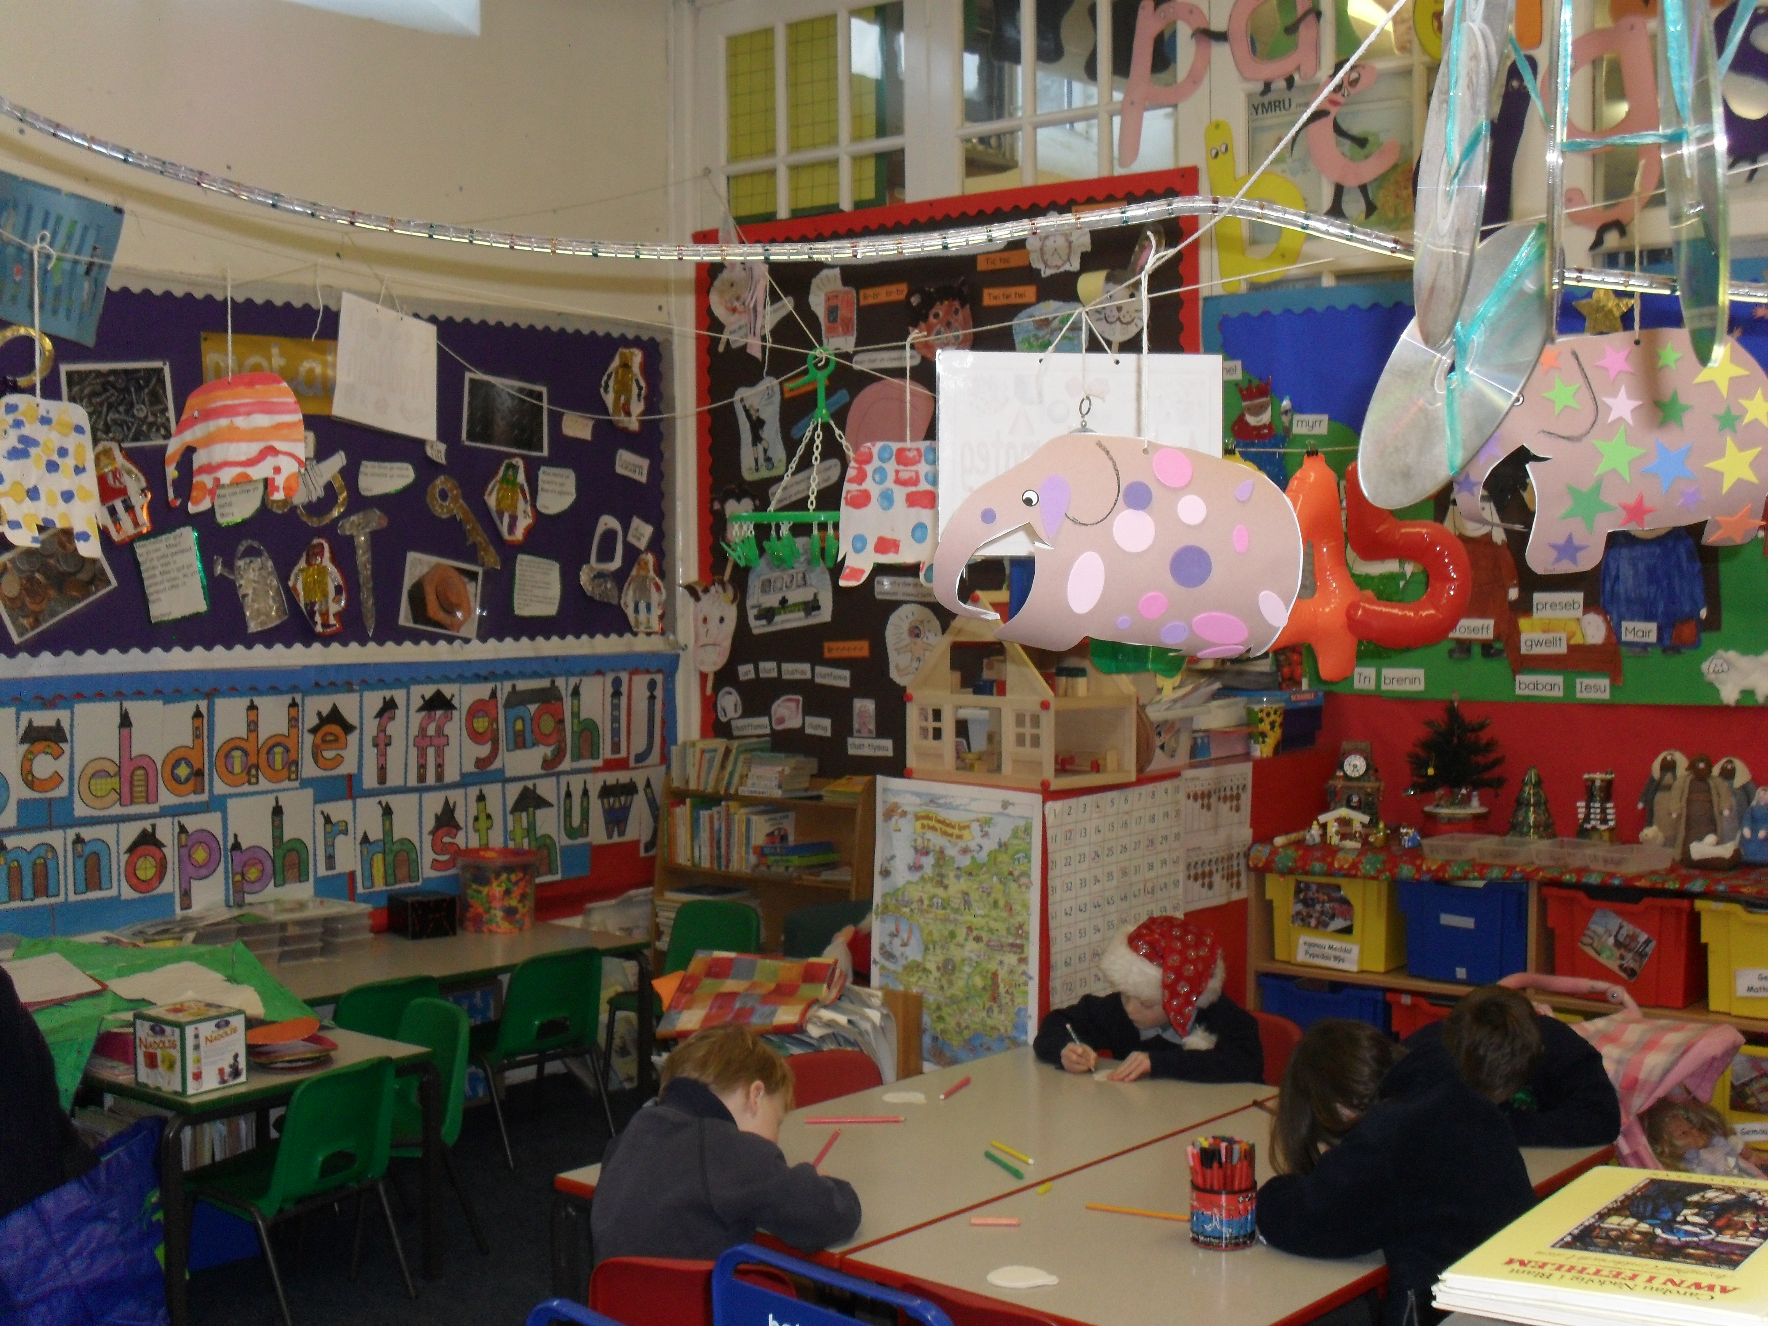
There are two classrooms within the school, one for children in the Foundation Phase (Dosbarth Mês) and the other for Key Stage 2 (Dosbarth Derwen). There is an entrance lobby for both classrooms where there are hooks for the children's coats and bags. The lobby is used as an extension to the classrooms. The classes are organised according to the age of the children and are of mixed ability, as far as numbers permit. The children have their lunch in their classroom.
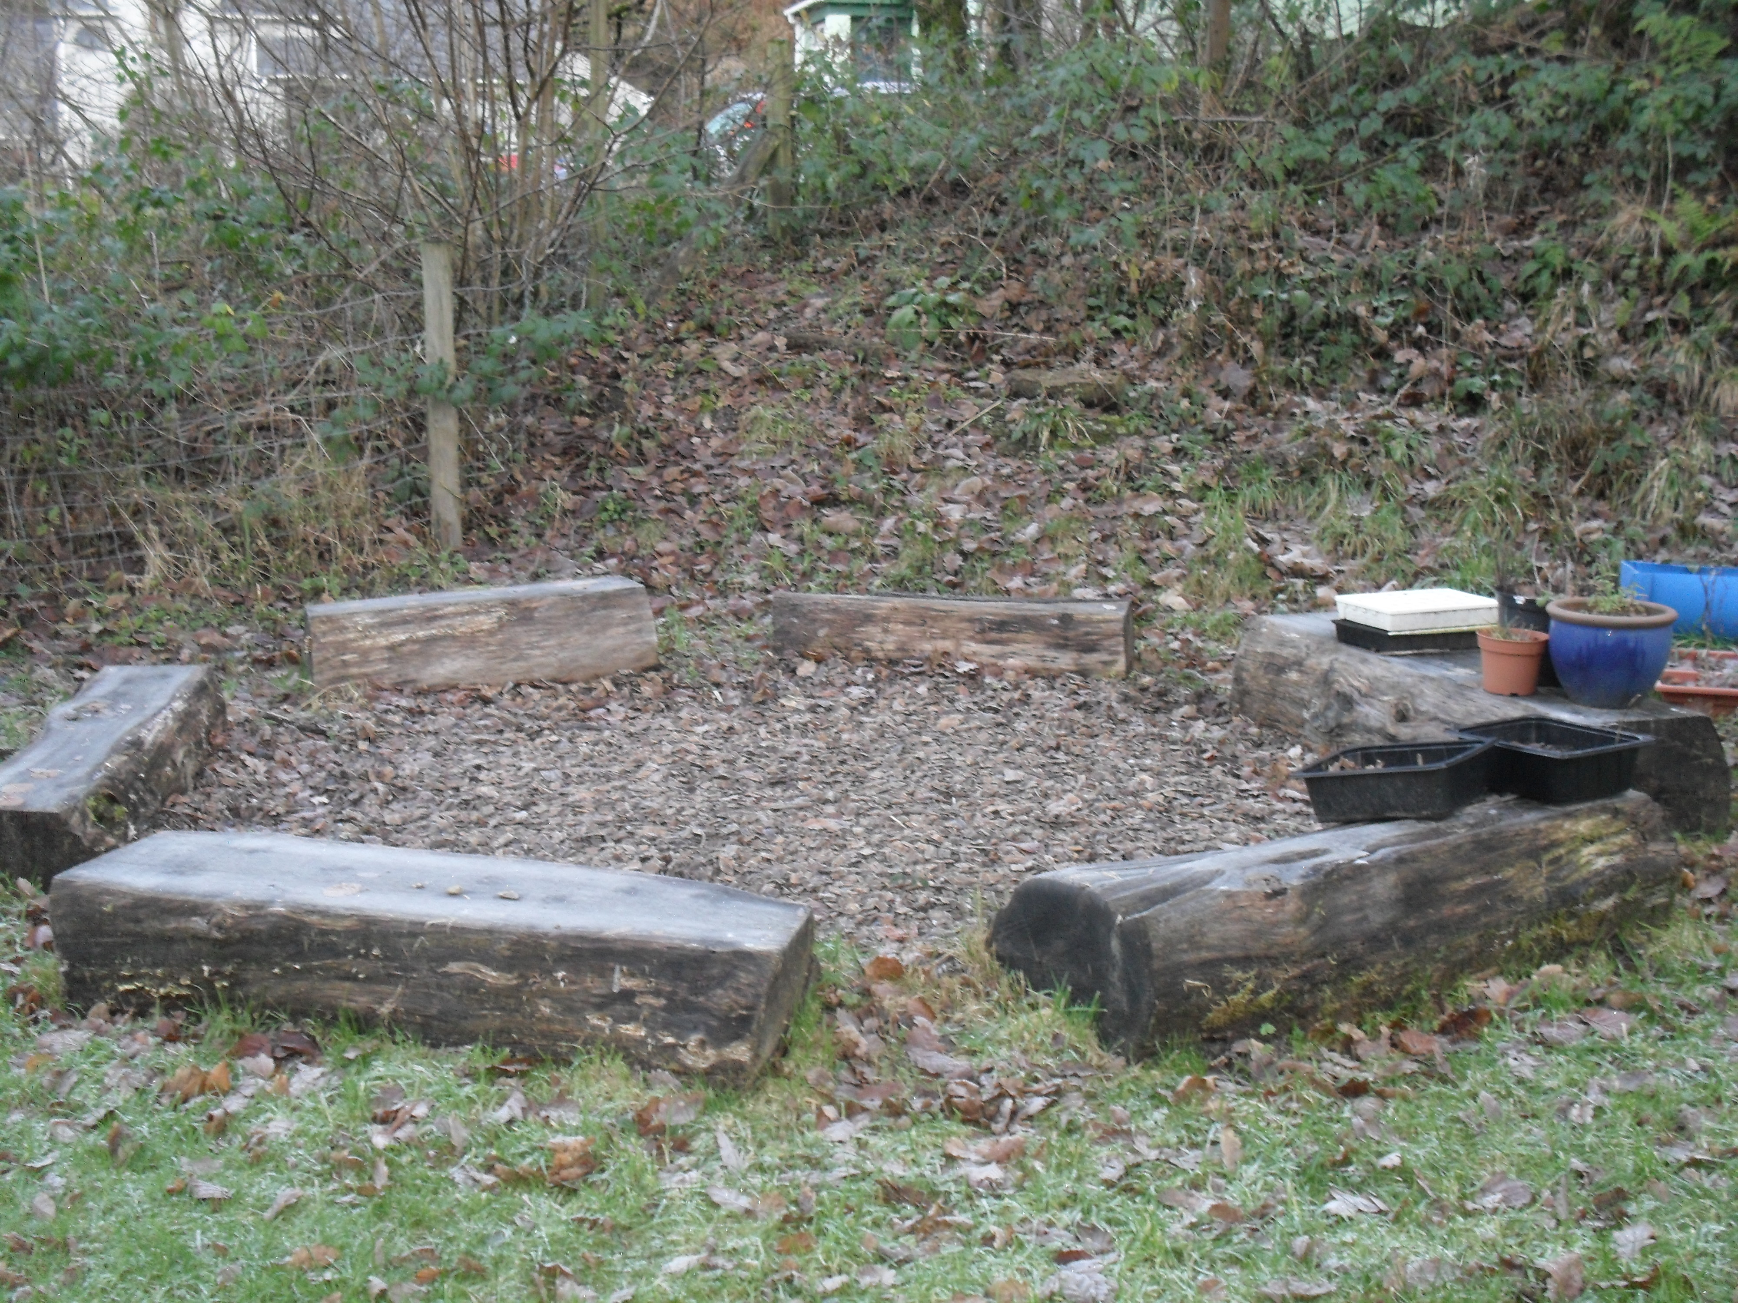
There is a yard surrounding the school. In one corner there is a soft surface and toys for the youngest children.
The office is behind the school building. There is one new disabled toilet within the school building. There is also an outdoor classroom where pupils can develop their research skills. The school offers Forest School twice a term at present.

Ysgol Llanychllwydog
The Foundation Phase
At Ysgol Llanychllwydog the Foundation Phase enriches the learning experiences that enable children to be creative, to use their imagination and to have fun whilst learning. The children have more opportunities to explore the world around them and understand how things work by taking part in practical activities that are fun and relevant to the level of their development.
There are six Areas of Learning in the Foundation Phase, where structured play activities can be woven into the learning experiences in a manner that inspires the children. The Foundation Phase Curriculum has been planned on the basis of these 6 areas:
Six Areas of Learning
Language, Literacy and Communication Skills
Physical Development
Knowledge and Understanding of the World

Personal and social development, welfare and cultural variety
Creative Development

Mathematical Development

Ysgol Llanychllwydog
Key Stage 2
Our aim in Key Stage 2 is to nurture within every pupil the feeling of personal and cultural identity that is tolerant and is respectful of others. We encourage all pupils to be full members of our school community, accessing the wider curriculum and the whole school’s activities in a variety of learning and teaching styles.
The following subjects are included in the Key Stage 2 Curriculum:
Hanes
Information and Communication Technology

Mathematics
Welsh

National Curriculum Subjects
English
Science

Music
History

Design and Technology
Art and Design

Physical Education
Geography

Ysgol Llanychllwydog
Teaching and Learning
Our aim is to create pupils who learn effectively, and who are:
- Motivated
- Responsible for their own learning
- Able to use new technology
- Able to learn new skills and adapt them effectively throughout their lives.
A number of strategies are used to implement and develop the teaching and the learning within the school.
Learning and Teaching
Learning Collaborative
Interactive Learning
Focus on Thinking Skills
Assessing for Learning

Ysgol Llanychllwydog

The Welsh Curriculum
One of the main strenghts of the school is its Welsh atmosphere. Promoting the Welsh Curriculum is of high importance to us.
Pupils across the school develop a sense of the unique cultural identity of Wales across all areas of learning in an integrated manner. The children develop a sense of belonging and learn to appreciate the heritage, literature and the arts in Wales as well as the Welsh language.

P.S.E.
Personal and Social Education is a statutory part of the curriculum. It reflects commitment to put emphasis on teaching wider skills that children need to become active citizen, and to embrace the challenges and opportunities of life. In the Foundation Phase, Personal and Social Education is developed across all areas of learning as the children take a hands on approach to learning though experience.

Assessment for Learning
The school focuses on pupil achievement and how to progress:
- Where is the pupil on the learning continuum?
- What are our aims?
- How do we get there?
Teachers plan assessments in order to assess for learning so as to gain detailed information of each pupil’s strengths and the areas that need more support.

Ysgol Llanychllwydog

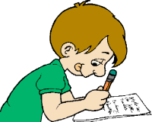
Homework

Homework Arrangements for KS2
Every child is given a homework book. It is important to respect the book by looking after it and keeping everything neat and tidy. We expect every child to do his/her best and make an effort to complete every piece of homework that is set. Every child is expected to return homework on time. These are the arrangements for homework:
Set | Return
Monday/Tuesday | Friday
Friday | Monday
Homework activities vary from learning tables and learning items for the Eisteddfod to written work/ recording etc.
Every child is expected to do some reading every night. At times, pupils are given the task of creating a project on a specific topic. This enables a child to develop his/her research and recording skills.

Remember: Homework is the child’s work but please show an active interest and give your support.

Homework Arrangements in the Foundation Phase
No specific homework tasks are set in the Foundation Phase, but at times they are given the task of looking for something specific, e.g. a picture/word/object etc.
However, we would appreciate it if you would expand their learning experiences by:
- Listening to them reading and reading stories to them regularly.
- When out on a trip or when visiting a special place, talk to your child
about the different things that they see.
- Singing and listening to nursery rhymes.
- Watching Welsh children’s programmes, Cyw, on S4C.

Ysgol Llanychllwydog
Concerns/Complaints policy
If parents are concerned about any aspect in association with the school, including the curriculum, they should contact the class teacher or the head teacher in the first instance, to try and solve any issues. If you still have concerns, then please contact the Chair of the Governing Body.
Additional Learning Difficulties
We conduct an annual assessment of the pupil’s additional learning needs, should your child be assessed as having additional needs, his/her name will be placed on the schools’ register for Additional Learning Needs. We will ask parental permission before placing any child on the register. In accordance with County Policy, which in itself responds to the current Code of Practice. Within the stages of the Code of Practice, the child’s progress is monitored, while helping the individual to overcome the difficulties by implementing an individual educational plan. Should the problems persist, arrangements will be made for appropriate provision in co-operation with the authority’s external support agencies, e.g educational psychology service or speech and language. A child’s additional educational needs can be emotional, educational, physical or behavioural. It is considered that an exceptionally gifted child also has Additional Educational Needs, and his/her needs are considered in accordance to the Local Education Authority. We keep a close contact with parents/guardians throughout the process.
Mrs Sharon Griffiths is the Additional Educational Needs Co-ordinator for the school. Children on the register are taught in class and may have weekly sessions in small groups or individually.
Pastoral Care
The pupils are supervised by the staff 15 minutes before the school begins officially and 15 minutes after the school closes. In the instance of extracurricular activities, the supervision will extend throughout that time. In order to teach good habits, children are expected to arrive promptly at school. Supervision is organised throughout the day but, despite this, accidents will happen. Injuries are given every care possible and First Aid is administered promptly. Parents are informed immediately about the accident, and if the accident needs medical treatment, arrangements are made to take the child either to the local Surgery, or to Withybush Hospital, Haverfordwest. If a child is ill during school hours, our policy is to contact the parents and advise them to come and collect their child and take him/her home. This also happens should we notice that a child has a contagious condition. It is important to keep the child home until the contagious infection has cleared completely. The school nurse visits the school regularly, parents are informed of these visits beforehand.
Parents need to inform the school in a letter:
a) when they need to take the child out of school before the usual closing time.
b) explaining the child’s absence on the first day of returning to the school. If a letter is not forthcoming within a reasonable amount of time, the child is marked as being absent without permission.
c) explaining why medicine has been sent to school with the child, and to give permission for a member of staff to administer the medicine to the child.
d) providing a justifiable explanation as to why the child cannot participate in swimming or physical education lessons.
d) to ask permission to release the child from school if they wish to go on holiday during term time.
When organising trips for the children e.g. educational visits, we ask parental permission in the first instance. Information is given beforehand concerning the dates for school holidays, closure days for In Service Training, as well as all extracurricular activities that are arranged.
Parents are asked to fill in a number of forms at the beginning of the school year. We would appreciate their prompt return.
If there are any changes in individual circumstances within the year, please inform the school.
One consent form is sent out for the academic year, requesting your permission as a parent or guardian to take your child’s photograph. By signing this form you give permission to have your child’s photograph taken for use at the school, e.g. newspapers and the school handbook, to be recorded on the camcorder during various activities within the school, to be filmed for television programmes and possibly the school website, unless otherwise informed by parents/guardians. We will not be able to inform you in advance about all individual arrangements.

Inclusion

Mrs Mererid Francis is the appointed person for looked after children (LAC) and she is responsible for their welfare. Confidentiality is ensured at all times.
As a school we try to ensure that all children requiring inclusion have the appropriate educational provision of a high standard and have access to a wide, balanced and relevant curriculum.

Language Policy – Category 1 Welsh Medium Primary School
Our aim is to educate children to speak Welsh and English when they leave the school so they are full members of the bilingual community that they are a part of. Welsh is the main language of education in the Foundation Phase. If the child’s mother tongue is English, Welsh is introduced in a sensitive manner. English is introduced as a subject in the third year. Mathematics and Science at Key Stage 2 are taught mainly through the medium of Welsh.

Ysgol Llanychllwydog

Protecting and Safeguarding Children
The school has a Child Protection Policy and Mrs Mererid Francis and Mrs Ruth Evans are the appointed members of staff. Protecting children from harm is the responsibility of all staff members at the school. We follow the All Wales Child Protection Procedures which have been adopted by the Local Child Protection Board. The intention of these procedures is to prevent child abuse and to inform the relevant authorities of instances of abuse.
We provide an environment where children and young people feel safe and secure, where they feel appreciated and respected, where they are confident and know how to approach adults if they are in difficulties, believing that they will be listened to in a responsive manner.
A DBS check and two references are required before any individual is allowed to work with our children. For more information, please contact the Head teacher.
The appointed governors for Child Protection are:
Cllr Bob Kilmister

Ysgol Llanychllwydog

Discipline and School Rules
It is the school’s role to prepare children to grow up to be responsible, caring and respectable citizens within society. All pupils are therefore expected to behave in a courteous manner as members of the school community.
We believe that all children should:
• behave courteously towards fellow pupils and adults.
• treat the school building, furniture and equipment and all other public places with respect.
• give of their best at all times.
The school will deal with all cases of misbehaviour fairly and on an individual basis. Good behaviour is emphasised in all aspects of school activity. In instances of serious misbehaviour, a personal meeting is arranged with the child’s parents. If the child’s behaviour is of a very serious nature the governors have the right to exclude him/her for a period of time. The school has policies on behaviour and bullying in place.

Anti-bullying
We expect everybody to be well behaved and emphasis is put on positive behaviour and ethos, respecting others and treating them in a manner we would like to be treated ourselves, showing maturity in the way we treat others.

Ysgol Llanychllwydog

The school considers bullying as a cause for concern. Instances of bullying will not be tolerated.
Bullying is an intentional and conscious desire to harm, threaten or frighten someone time after time.
The school discusses bullying as a part of Personal and Social Education with the pupils, as well as during circle time and religious services.
If you suspect that your child is being bullied then you should contact the school immediately.


Urdd Gobaith Cymru
The Urdd is the Welsh League of Youth – a Welsh language cultural movement throughout Wales.
The majority of children at the school join the Urdd every year. We would like to remind parents that there is more to the Urdd than competing in singing and recitation in the Eisteddfodau. There are art and craft competitions, Quiz competitions, games and sports and, of course, the camps at Llangrannog and the Millennium Centre at Cardiff. There is an annual membership fee.
We hold an Eisteddfod at the school every year where each child is given the opportunity to perform on stage and compete in art and craft competitions. A chair is presented to the pupil who has the higherst combined score for both the onstage and offstage competitions. The have the opportunity to compete in the Local Eisteddfod for Fishguard District, and the winners from the local eisteddfod go on to the Pembrokeshire County Eisteddfod and possibly the National Eisteddfod. There are two school houses, namely Brynach and Dewi, and the teams compete enthusiastically in the school Eisteddfod and the school Sports day.


Transition arrangments
At the end of KS2, pupils can choose at which school to continue their education. Most pupils transfer to either:
Ysgol Bro Gwaun School, Fishguard, or
Ysgol y Preseli, Crymych.
The children are given the opportunity to visit both schools at various events throughout the year.

There will be an opportunity for them to visit the schools of their choice.

Ysgol Llanychllwydog


Physical Education
Physical Education is the aspect of the curriculum that deals with physical skills, knowledge and understanding of games, swimming, dance, athletics and outdoor activities. All pupils are taught swimming throughout the year at Fishguard Leisure Centre. Physical education sessions are also held at Fishguard Leisure Centre.
During the year competitions in athletics, netball, football, hockey and cross country are organised. The school holds a Sports day every year during the Summer Term. A shield is presented to the best boy and the best girl in each key stage. The overall winner is also presented with a trophy. Every child is encouraged to participate in each event. In order to promote personal health education, children are expected to bring suitable clothes to take part in physical education lessons. Pupils are not allowed to wear any form of jewellery during Physical Education lessons and games.

Ysgol Llanychllwydog

Sex Education
There are no formal lessons in Sex Education as such, but it is a part of Personal and Social Education. Every effort is made to answer the children’s questions in an honest and sensible manner. The statutory elements required by the science curriculum that relate to reproduction and growth are addressed. The children are made aware of the fact that their bodies will change as they grow older.
An annual visit by the Health Authority’s Nurse is organised for Year 6 pupils, in order to discuss and introduce information about changes in the body, this talk will prepare them for their adolescence.
If it is your wish as a parent for your child not to take part in this discussion, please inform us before hand.

Religious Education and Worship

The Religious Education that is taught is based on the Authority’s recognised syllabus.
Children have the opportunity to worship together in the daily services as a school or as a class. Arrangements can be made for children whose parents do not wish them to attend religious services. Please make an application in writing to the Head teacher.

Ysgol Llanychllwydog

The Voice of the Pupils
The voice of the pupils is important to us. Pupils are given the opportunity to voice their opinions and to promote their ideas regularly using various means – Circle Times, Assessment for learning and the Class/School Council. The school has been recently awarded with the national kite award for pupil participation.

School Council
The School Council includes a group of children who have been chosen to represent the opinion of other pupils regarding improving the school.
Every year in Class 2 each school year will elect a pupil to represent them on the School Council and one representative from Class 1.
The School Council has made several decisions in the past, e.g. raising money for various charities, taking part in interviews, raising health and safety issues, creating a system for encouraging the use of the Welsh language in school and a behaviour system. The school council gives the children a sense of enabling the voice of other pupils to be heard, the school can respond to this opinion, and their needs can play an active role in making the school a better place.
Healthy Schools
The school takes pride in taking part in the Healthy Schools Programme. We have already won three leaves for our work in promoting good health. The programme plays an important part in the everyday life of the school. Children are encouraged to drink enough water throughout the day as well as having a healthy diet. Keeping healthy is regularly discussed as a part of the school work as well as educational values, and we will continue to develop the healthy element with the school and society.
The Outdoor School
As a school, we pride ourselves in the fact that the school is situated in an especially beautiful spot. We use the outdoor area often, we have an outdoor classroom in the woods, where we develop our research work. We also use Pembrokeshire National Park for outdoor work. The school offers forest school activities twice a term.

Ysgol Llanychllwydog

Arrangements for Assessing and Keeping Records
The school’s main aim is to promote the educational development of the children, and to discover how well the pupils work on their tasks. Therefore, assessment is an essential part of the teachers’ work. While planning the teaching for the term particular attention is paid to the opportunities for assessing. The teaching and the assessing are planned side by side.
Children are grouped according to their abilities/age for teaching purposes, and they are assessed for their oral skills, and their mathematical and science skills, by listening to their discussions in group situations. The individual levels of pupils are assessed by watching what they do, talking with them and asking questions, and by recording significant comments they make. Written work is assessed by reading and studying the finished work and by paying attention to correctness and the creative content. Reading is assessed by listening to children reading and group reading tests.
All the information collected is kept together in the pupils’ attainment records. The assessment is therefore linked to the National Curriculum attainment targets and includes examples that prove that statements have been achieved. Parents receive reports at the end of the two key stages, namely year 2 and year 6, noting the levels achieved in the different curricular subjects through teacher assessment and the County Assessment results.
Standardised assessments in reading, spelling, mathematics and non-verbal reasoning are held annually.
They also include records of the child’s attitude towards learning, the school and society – i.e. the hidden curriculum. Information is collected as the child starts school, and the profile is built on this basis.
Teachers are available to discuss your child’s work at any reasonable time at the end of the school day. Arrangements for such meetings must be made before hand. Meetings to discuss your child’s progress and to report back to parents are arranged during the year. Individual pupil reports are distributed at the end of the summer term.
The Partnership between the Home and School
We have an open door policy, parents are encouraged to come in to school to discuss any issues they may have. Arrangements are made for parents to discuss the progress of their child during the year.
Targets are set for every child during the Autumn Term, and we offer advice and support to parents to help their children to achieve these targets.
Reports on their children’s progress are given to parents at the end of the Summer Term, and they are welcome to discuss their child’s progress with the staff.
Parents are encouraged to come into school to help in any way possible. If you have any skills, talents or expertise to offer we would appreciate your help.
There is a contract between the home and the school. The contract means that the pupil and his/her home and the school have agreed to provide the best educational opportunities possible for the child. This is given to you as your child starts at school.
By signing this contract, our intention is that it will form an effective link between the home and the school, a link that will lead to a better understanding of our responsibilities, and that your child will benefit from the promises that we have made together.
Ideas and suggestions for parents to follow to prepare a child under 5 for school

Before a child starts at school it is important to prepare him/her for the first step of their educational career. It is an advantage for a child to attend a local nursery before starting in the primary school.
The following is a list of basic suggestions that could be of some help to parents:

a) Ensure that the child can use the toilet properly, get dressed and put their shoes on, can organise their belongings, can follow simple instructions, wash their hands, recognise their name, use a knife and fork.
b) Include your child in conversations such as organising visits, shopping and going on holidays.
c) Chose appropriate radio and television programmes, and discuss them.
d) Read to your child every day if possible. While you are shopping or in the library, draw your child’s attention to books that are appropriate to their age.
e) Encourage your child to draw pictures and to paint in order to give them an opportunity to nurture self-confidence.
f) Help your child to realise the importance of numbers in everyday life.
g) There is no need for formality, simply draw your child’s attention to the numerous opportunities to count objects that surround them every day.
h) Teach nursery rhymes and songs to your child, and play with them.

Ysgol Llanychllwydog

Pupil Attendance 2018-2019
Attendance | Absent with Permission | Absent without Permission
95.1% | 94.9% | 0%

Ysgol Llanychllwydog

School Uniform
All pupils wear our school uniform a selection of uniform is available through the School Trends website or sweatshirts and T-shirts can be bought from TeesRUs Haverfordwest.
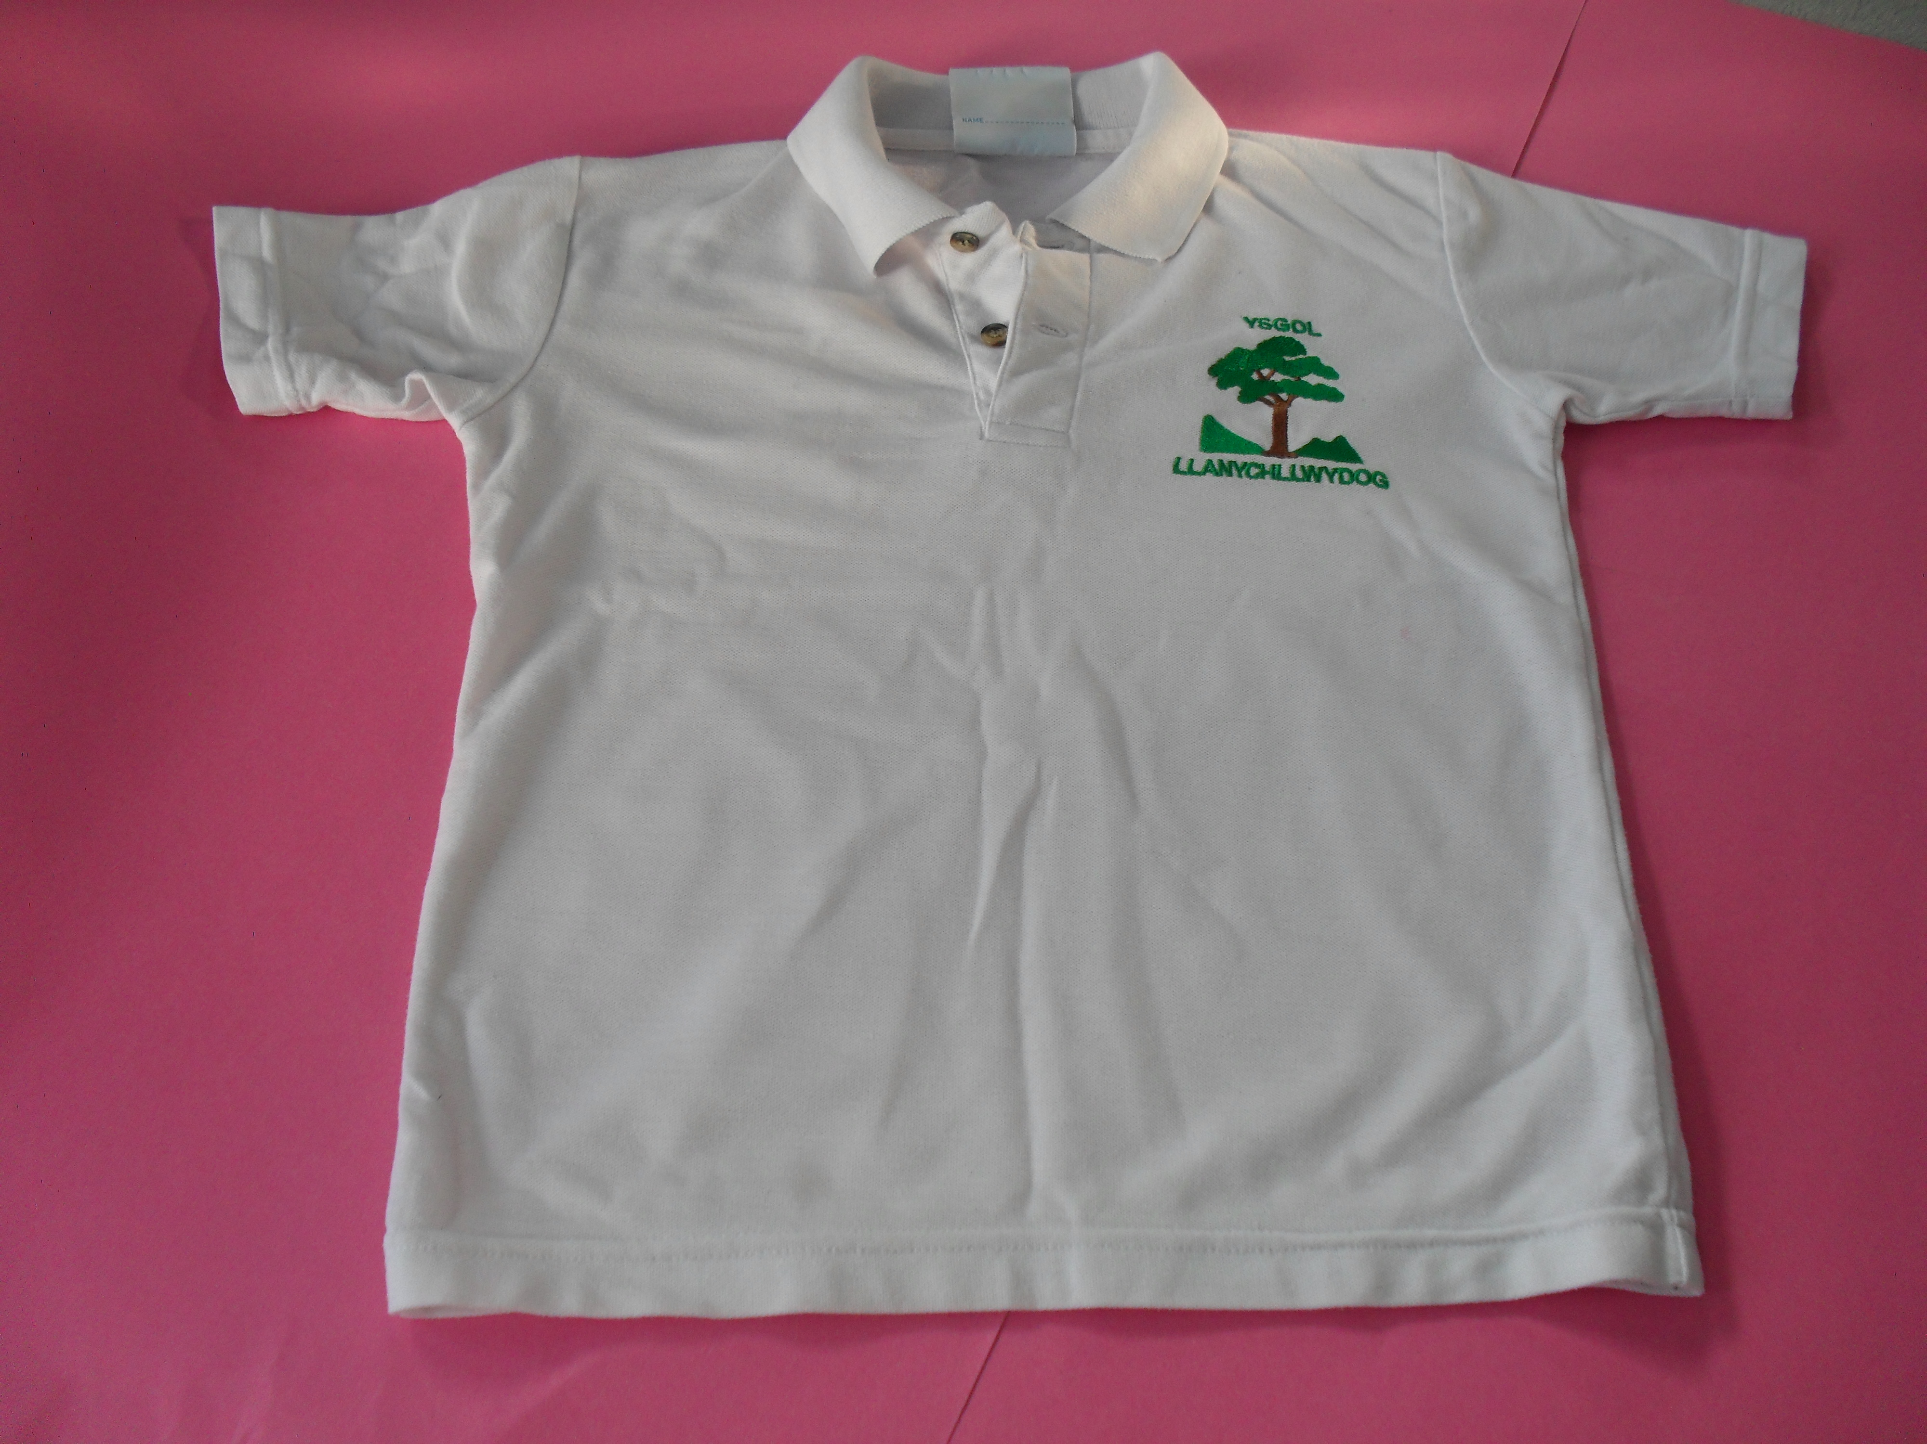
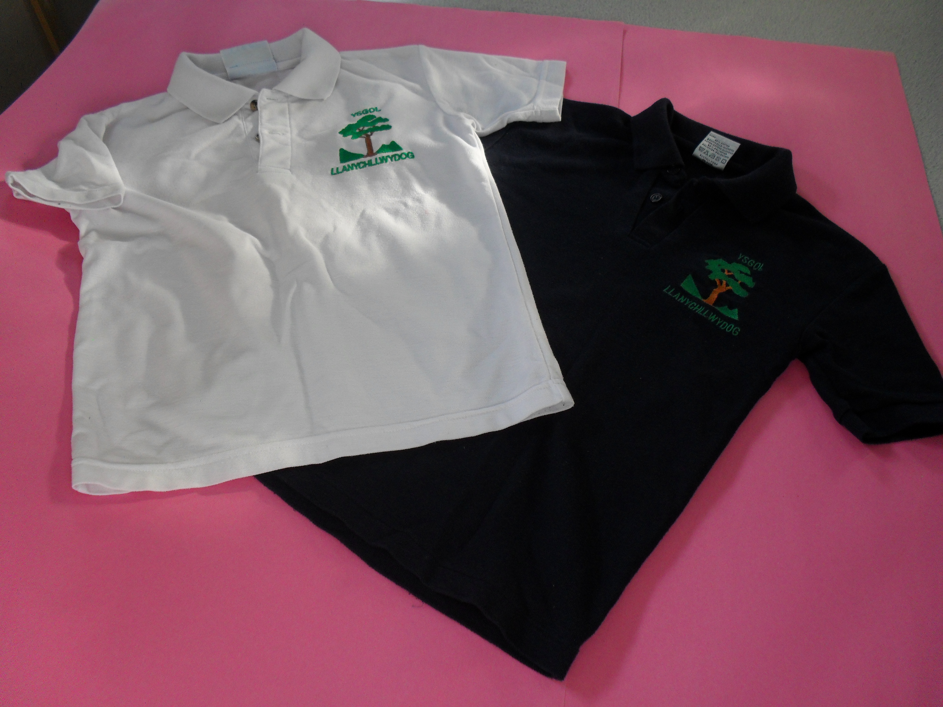

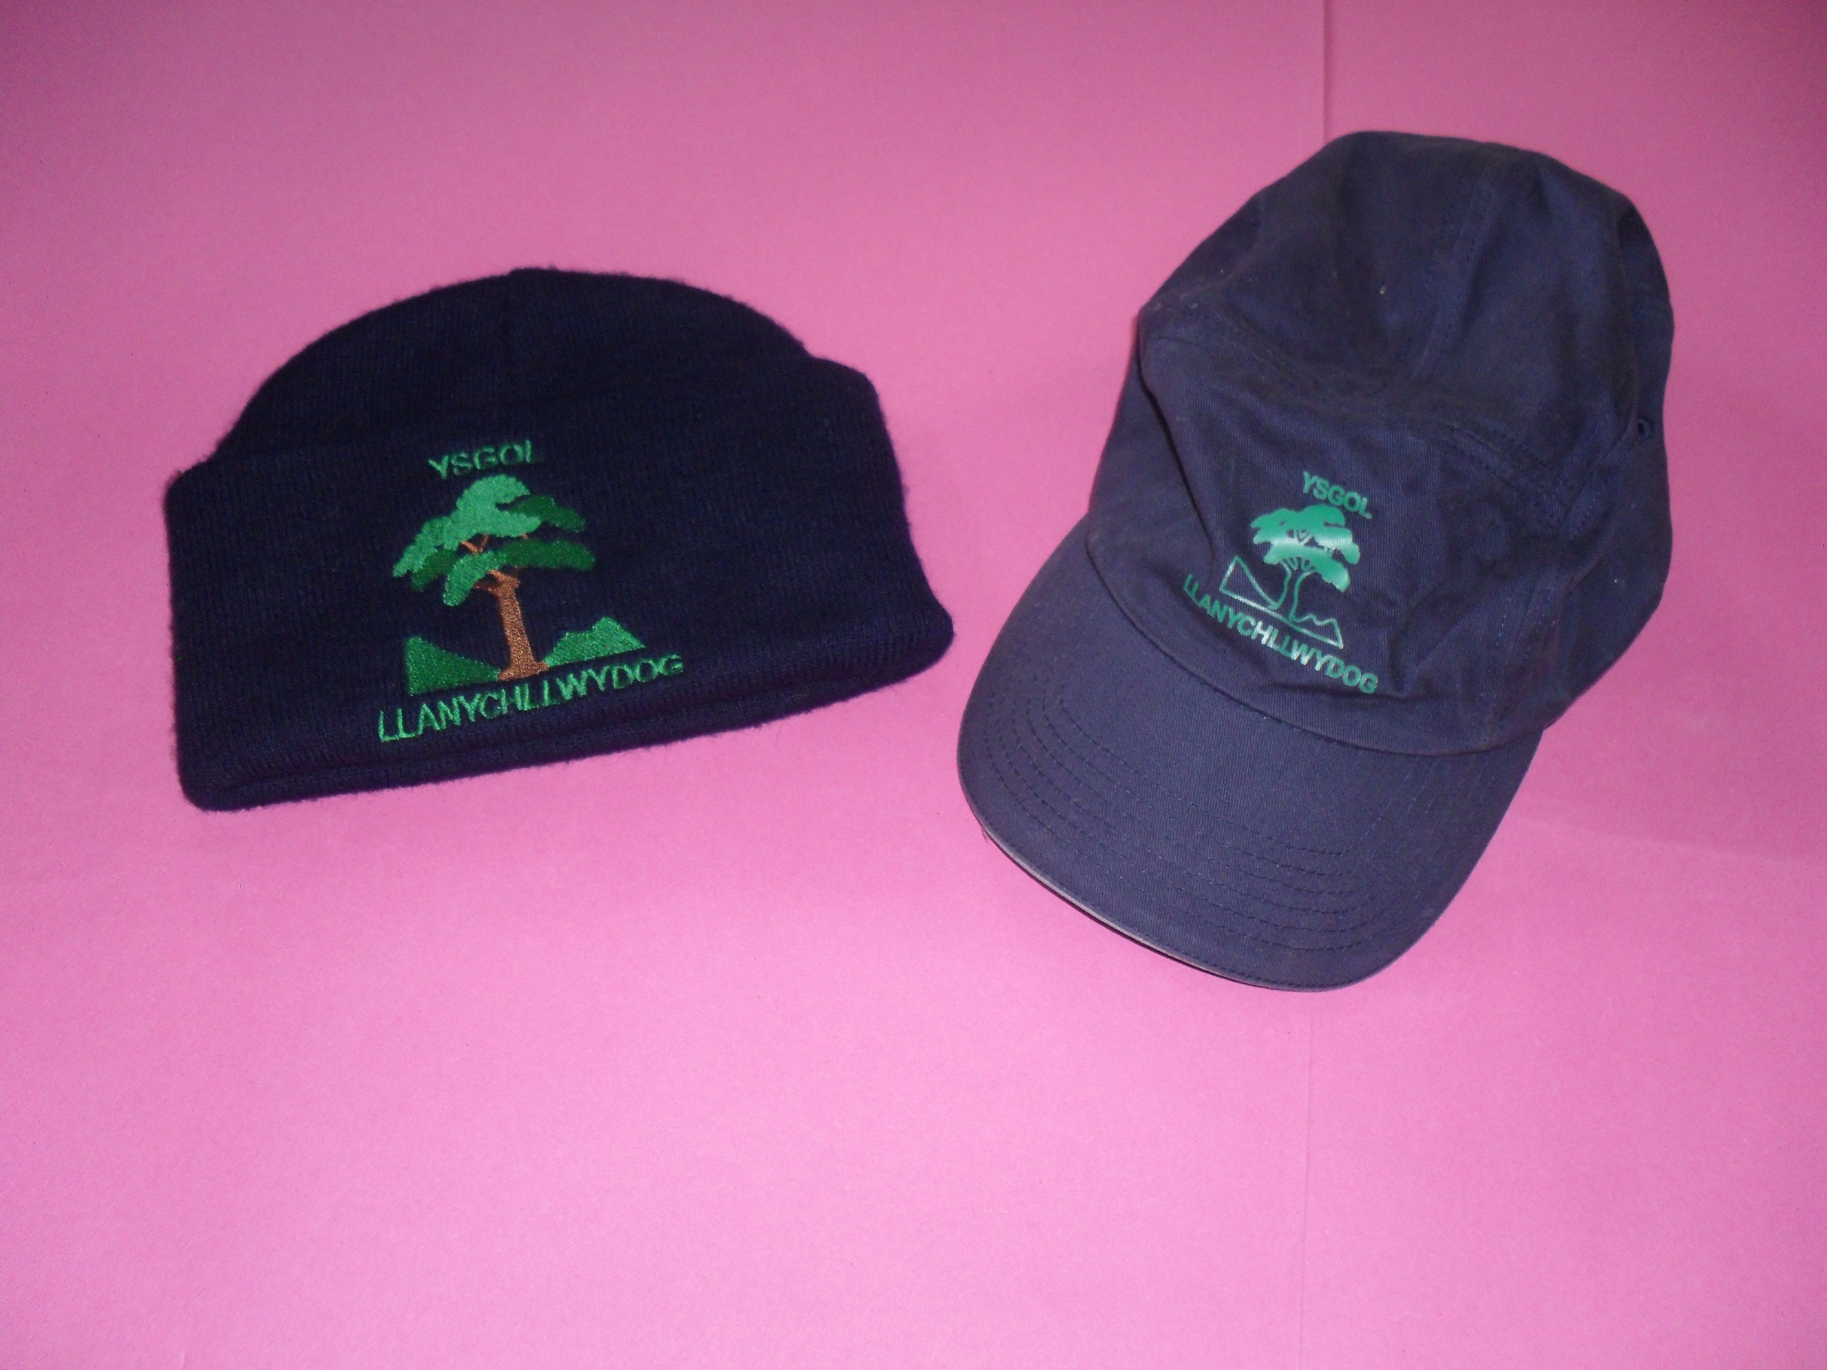
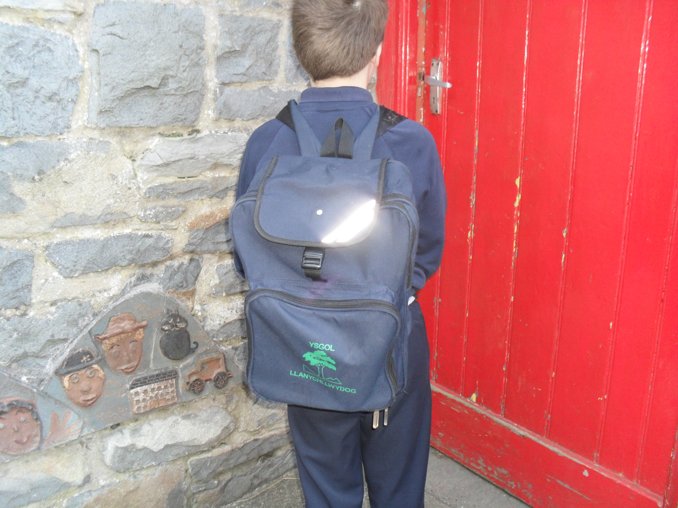

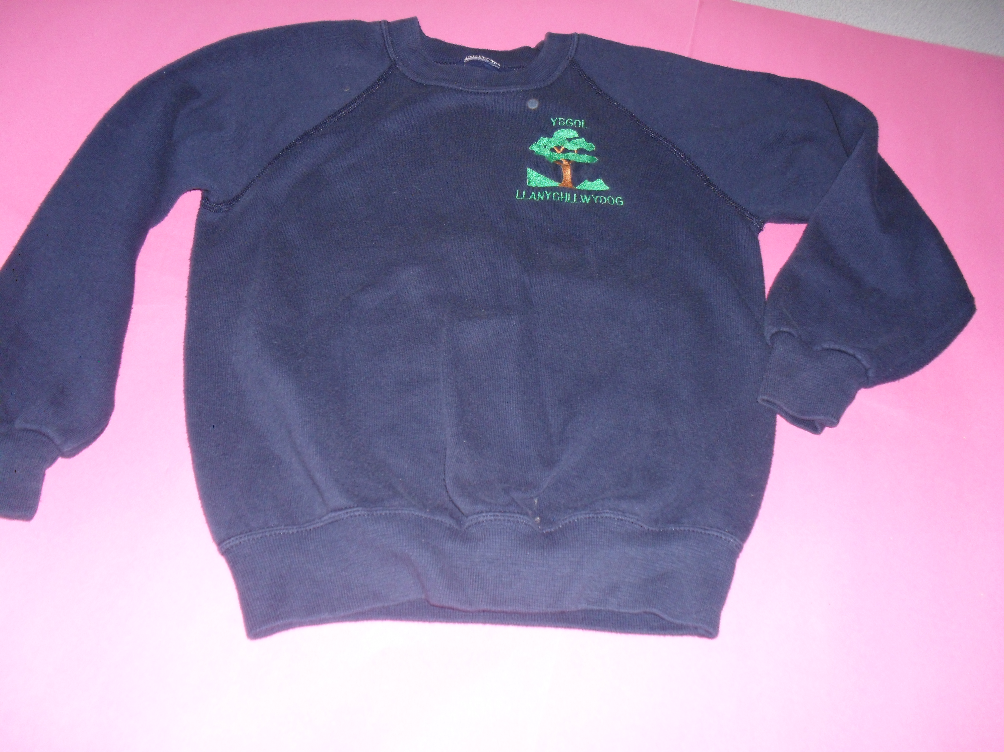
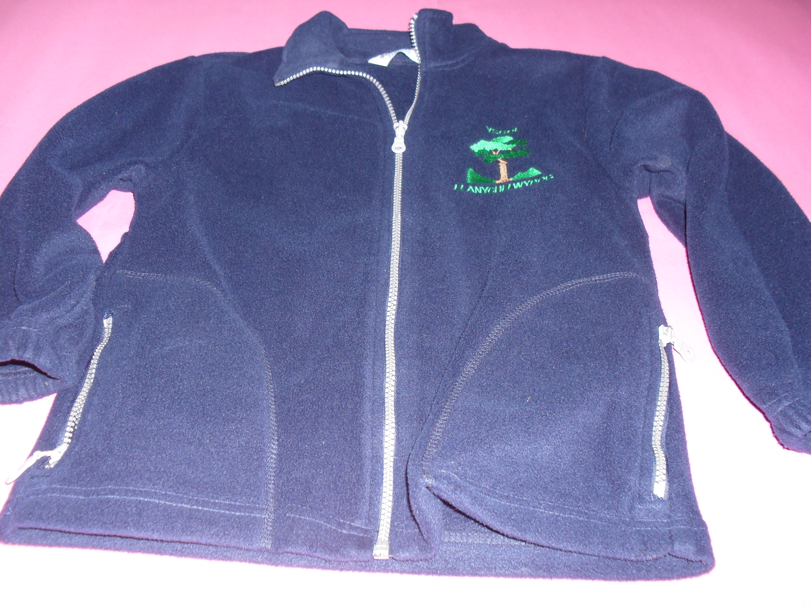

Ysgol Llanychllwydog

Gwreiddiau'r Gorffennol-Canghennau'r Dyfodol

