Friday 12th February.
Today is the CHINESE NEW YEAR – YEAR OF THE OX!
Learn about Chinese New Year here -
https://www.youtube.com/watch?v=1cRMRp9-Z08
https://www.bbc.co.uk/programmes/p07zqjl7
Complete at least 1 of these activities to celebrate Chinese New Year

- On strips of paper (measure them to be 12cm long) use red, orange, yellow and black paint / crayons / felts / decorations to make repeated patterns.
Link them together to make a chain decoration and decorate your house
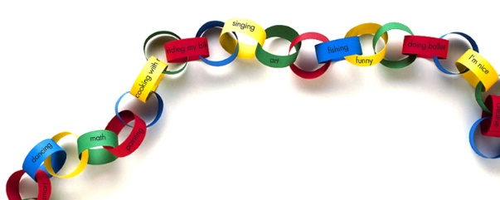

- Use red, green, yellow and black card to cut out rectangles, squares, circles and triangles – use the shapes to design a Chinese dragon!! (or use the template activity attached)
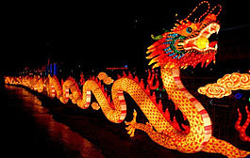

- Make your own money envelope – use you own materials or see attached.
