WALT: make a graph and answer questions about the data recorded.

Ask TEN friends / family how they like to celebrate St David’s day (see my example attached)

A graph to show how people like to celebrate St David’s Day.
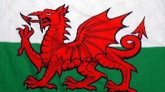
10
9
8
7
6
5
4
3
2
1
0 | Eat Welsh cakes | 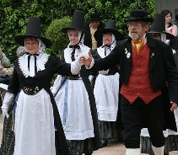  Welsh dancing | Buy or wear daffodils and leeks | 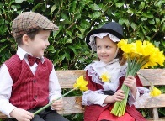  Wear a Welsh costume | 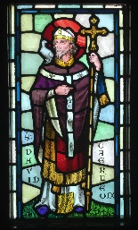  Visit church | Sing the Welsh Anthem
An excellent graph!! Da Iawn! Now look at the information on the graph and answer the questions below -

What is the most popular way to celebrate St David’s day?

What is the least popular way to celebrate St David’s day?

How many people like eating Welsh cakes AND buying daffodils / leeks altogether?

How many people like to sing the Welsh Anthem AND learn a Welsh Dance?

How many people like to wear a Welsh costume and visit church?

Can you think of another way to celebrate St David’s Day?

