WALT: make a graph and answer questions about the data recorded.

Ask TEN friends / family how they like to celebrate St David’s day.

A graph to show how people like to celebrate St David’s Day.
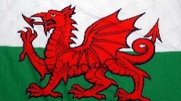
10
9
8
7
6
5
4
3
2
1
0 | Eat Welsh cakes | 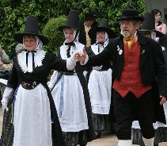  Welsh dancing | Buy or wear daffodils and leeks | 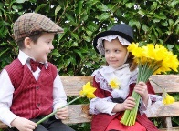  Wear a Welsh costume | 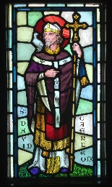  Visit church | Sing the Welsh Anthem

