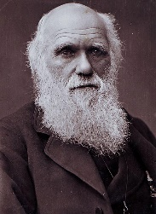
Tuesday 2nd February
Fossil Funday!!!
FACT! Charles Darwin also found Fossils on the Galapagos Islands!
Watch these videos / read the information about fossils!
https://www.funkidslive.com/learn/top-10-facts/top-10-facts-about-fossils/#
https://www.bbc.co.uk/bitesize/topics/z9bbkqt/articles/z2ym2p3
https://www.bbc.co.uk/bitesize/topics/z9bbkqt/articles/z22g7p3
https://www.bbc.co.uk/teach/class-clips-video/geography-ks1-ks2-fossil-hunting-along-the-jurassic-coast/zbbrkmn

Activity 1 - WAL: about how fossils are made, make careful observations.
- Collect between 5 and 10 items - leaves / flowers / small animal toys / gummy sweet snakes and bears.
- Get playdough / clay / a slice of bread.
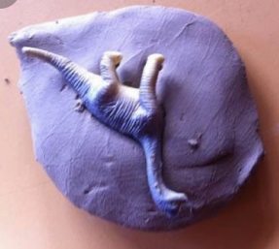
What do you think will happen if you pushed an item LIGHTLY / HEAVILY into the playdough / clay / bread?
Now try it and see what happens!

- REMEMBER - to make a fossil you needed lots of pressure (weight) and heat (from your hand).
- Please send photos of your fossils to Mrs Williams

Activity 2 – recap the information and take the fossil quiz attached …

Activity 3 – WALT: make accurate measurements.

Choose 5 different fossils you made earlier
Measure how long or wide the fossils are using a ruler or measuring tape.
Don’t forget – Always begin measuring from 0cm.
- Measure from one end of the object to the other.
- Year 6- measure in cm and convert your answer into mm-
multiply by 10 (because there are 10mm in 1 cm).

Example –
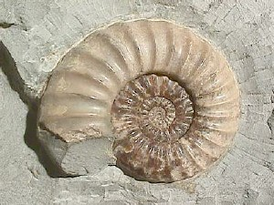
The shell fossil is 5cm long.
The shell fossil is 50mm long
(because 10 mm in 1cm, 20mm in 2cm etc)

Record by printing and writing / typing measurements into the table attached.

