Thursday 28th January

- Activity 1- Maths
WALT: find one hour before and one hour after.
Use your homemade clocks / a clock to help you. Example –
The hour hand one hour before would move backwards – one hour before is 12 o’clock (see pink arrow)

- The hour hand one hour after would move forwards – one hour later is 2 o clock (see green arrow).
Complete the activities attached.

- Activity 2- Welsh.
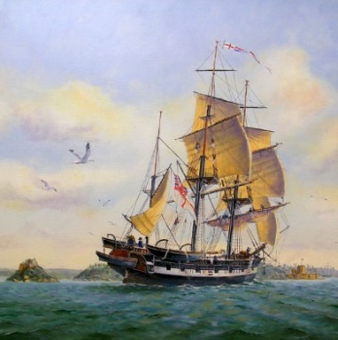
WALT: guess, investigate and record.

Use the attached table to record what you guessed / found out

Charles Darwin travelled to the Galapagos Islands on a boat called the HMS Beagle. It looked like this –-----------------

1st - Make 4 boats using different materials - foil, card, Lego, plastic, sponges etc

2nd - Predict (guess) whether they will float or not- Use the table attached.

3rd - Test them out in the sink /bath! Record in the table.
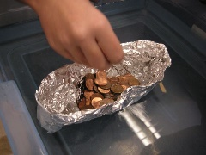
4th - Estimate (guess) how many coins that you think the boat can hold before sinking – record in the table.

5th - Add and count the coins in Welsh as you add them one at a time. Record in the table.

6th - Which boat stays afloat with the most coins?

**Extra optional activity – research images of the HMS Beagle – what do you think it was made from? **

