Thursday 21st January

- Activity 1- Maths
WALT: tell the time.
Recap the clock you make.
- Which is the hour hand?
- Which is the minute hand?
Read the power points attached.
Complete activities- read the clocks and choose the correct times.
Ask an adult to give you a quiz – the adult says a time, you show the correct time on the clock you made last week!
- Some useful information and activities can be found here -
https://www.bbc.co.uk/bitesize/topics/zhk82hv/articles/zcmdwxs
https://www.bbc.co.uk/teach/supermovers/ks1-maths-telling-the-time/zk4t8xs
https://www.bbc.co.uk/bitesize/clips/zqkwmp3

- Activity 2- Welsh
WALT: say Welsh words confidently.
Sialens Charles Darwin!!! Charles Darwin Challenge!!!
Charles Darwin gave Latin names to all of the plants and animals that he found.
We are going to find the Welsh words for the objects you found on Monday.
- Load ‘google translate’.
- Make sure you choose the correct languages

- Type in the English name for the objects here

- The Welsh name for the object will show.

- Press on the speaker to help you say the word.

- Listen to the way each sound is spoken and practise with an adult / brother / sister.
Now, record yourself saying the Welsh names for objects on a recorder / ipad / phone.

Optional activity.
Make a dictionary list using pictures/drawings of the objects and type / write the new Welsh words you have learned
Example below-

Geiriadur Mrs Williams!
(Mrs Williams’ Dictionary)
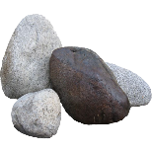
Carreg

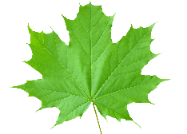
Dail

